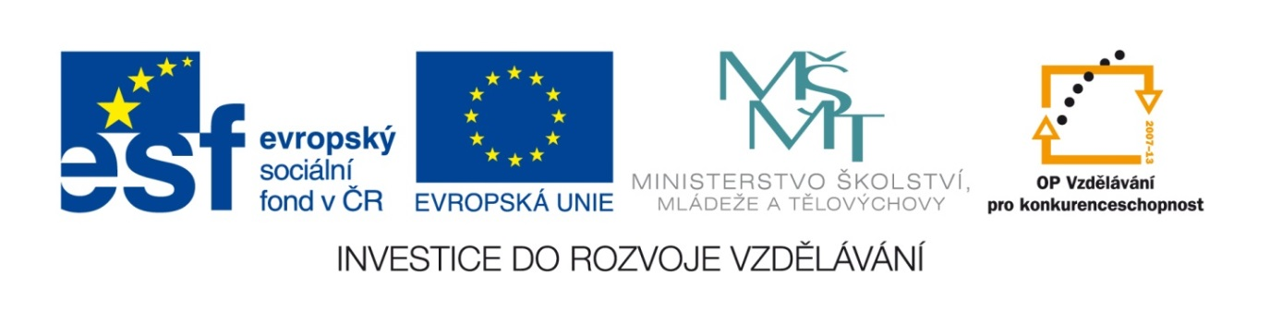
Základní škola a mateřská škola, Šaratice, okres Vyškov

III/2 Inovace a zkvalitnění výuky prostřednictvím ICT
VY_32_INOVACE_192

Jméno autora: Mgr. Zdena Černá
Datum vytvoření: říjen 2011
Ročník: 7. – 9.
Vzdělávací oblast: Jazyk a jazyková komunikace
Vzdělávací obor: Anglický jazyk
Tematický okruh: Anglický jazyk VI. – IX. třída
Číslo projektu: CZ.1.07./1.4.00/21.1996

IDIOMS
I. ANIMAL IDIOMS
Match the parts of these expressions:
- They are plenty more fish …… a) ….. out of water
- Take the bull ….. b) ….. in the sea.
- The black sheep ….. c) ….. eat a horse.
- The straw that broke ….. d) …..by the horns
- I am very hungry. I could ….. e) ….. of the family
- Feel like a fish ….. f) ….. the camel’s back
II. FOOT IDIOMS
Which expressions go together?
- She’s independent. A) To think on somebody’s feet
- I must have a rest. B) To get cold feet
- To be afraid C) I must put my feet up.
- To think quickly D) She stands on her own feet.
III. FACE IDIOMS
Match the parts of the sentences:
- He was very worried ….. a) ….. and not to start laughing.
- I had to keep a straight face….. b) ….. off the face of the earth.
- My keys have disappeared ….. c) ….. but he was putting a brave face.
IV. HAT IDIOMS
Which expressions go together?
1) He’s talking threw his hat. a) old-fashioned, out of date
2) to go at the drop of a hat b) do something miraculous
3) Keep it under your hat. c) He doesn’t know what he’s talking about.
4) to be old hat d) to do it now, without planning
5) I take my hat off to him. e) tell nobody
6) to pull something out of the hat f) admire

ŘEŠENÍ:
I. ANIMAL IDIOMS 1b, 2d, 3e, 4f, 5c, 6a
II. FOOT IDIOMS 1D, 2C, 3B, 4A
III. FACE IDIOMS 1c, 2a, 3a
IV. HAT IDIOMS 1c, 2d, 3e, 4a, 5f, 6b

Zdroj:
WRIGHT, Jon. Idioms organiser: organised by metaphor, topic and key word. Editor Jimmie Hill, Morgan Lewis. Ilustrace Bil Stott. Hove: LTP - Language teaching publications, c1999, 296 s. ISBN 18-993-9606-3.

