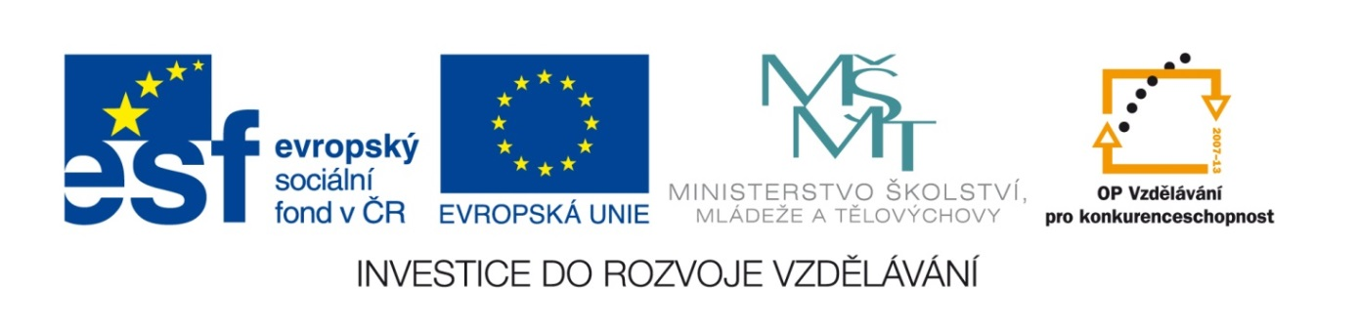
Základní škola a mateřská škola, Šaratice, okres Vyškov

III/2 Inovace a zkvalitnění výuky prostřednictvím ICT
VY_32_INOVACE_193

Jméno autora: Mgr. Zdena Černá
Datum vytvoření: březen 2012
Ročník: 7. – 9.
Vzdělávací oblast: Jazyk a jazyková komunikace
Vzdělávací obor: Anglický jazyk
Tematický okruh: Anglický jazyk VI. – IX. třída
Číslo projektu: CZ.1.07./1.4.00/21.1996

Pracovní list
Postup:
Podle potřeby si ujasněte slovní zásobu.
Cvičení I – doplňte správné výrazy do vět.
Cvičení II – spojte výrazy podle významu
Cvičení III – doplňte správné výrazy do vět.
BIRD IDIOMS
I. Literal meanings – definitions:
nest flap wings swoop peck 2x
1. Birds and aeroplanes both have ...................................... to fly.
2. Birds make a ................................. to lay their eggs.
3. Hens hop around and .................................... the ground to pick up bits of food.
Sometimes they ................................... each other.
4. Big birds’ babies (like swans or geese)first only swim or walk. But later they .................................
their wings and start to fly.
5. When birds suddenly fly down to the ground to catch small animals to eat, they ....................... .
(hnízdo, roztáhnout, křídla, klouzavě klesat, klovat)
II. Some birds became symbols.
Match the birds and the ideas they usually bring:
1. ostrich a) thief
2. dodo b) good eyesight
3. hawk c) waterproof
4. magpie d) pretend that problems don’t exist
5. swan e) dead or extinct
6. duck f) looks superior with its head in the air
(labuť, straka, kachna, jestřáb, pštros, blboun nejapný)
III. Put the birds into the correct gaps:
hawk duck dodo sparrow (vrabec) parrot peacock
1. Priscilla criticises everybody and everything in this company.
I’m OK, it’s like water off a .........................’s back.
2. The teacher watches us like a ........................ to prevent us from making mistakes.
3. Megan is a model and she’s so thin! She eats like a .............................. .
4. What’s wrong with my computer? I switched it on and nothing happened.
It’s as dead as a ............................... .
5. When Mathew won the first price he was as proud as a ............................... .
6. Mark works on his invention. He doesn’t rest or sleep. He’s as sick as a ............................. about it.

IV. Link the parts of these phrases together:
- Birds of a feather ....... in big cars and expensive clothes.
- An early bird ....... under her wings.
- After coming back from Canada they swan around ....... flock together.
- Elisabeth took me ....... with one stone.
- Solving this problem you can kill two birds ....... eats the worm.
__________________________________________________________________________________
Some more useful expressions:
literal meaning – původní význam pretend - předstírat become – stát se
suddenly – najednou sick – nevolnost, nemocný invention – vynález
prevent – předejít superior – nadřazený flock – hejno

ŘEŠENÍ
I. 1.wings 2.nest 3.peck 4.flap 5.swoop
II. 1d 2e 3b 4a 5f 6c
III. 1.duck 2.hawk 3.sparrow 4.dodo 5.peacock 6.parrot
IV. Birds of a feather ......... flock together.
An early bird ........ eats the worm.
After coming back from Canada they swan around ......... in big cars and expensive clothes.
Elisabeth took me ......... under her wings.
Solving this problem you can kill two birds .........with one stone.

Zdroj:
Morgan Lewis. Ilustrace Bil Stott. Hove: LTP - Language teaching publications, c1999, 296 s. ISBN 18-993-9606-3.
WRIGHT, Jon. Idioms organiser: organised by metaphor, topic and key word. Editor Jimmie Hill,

