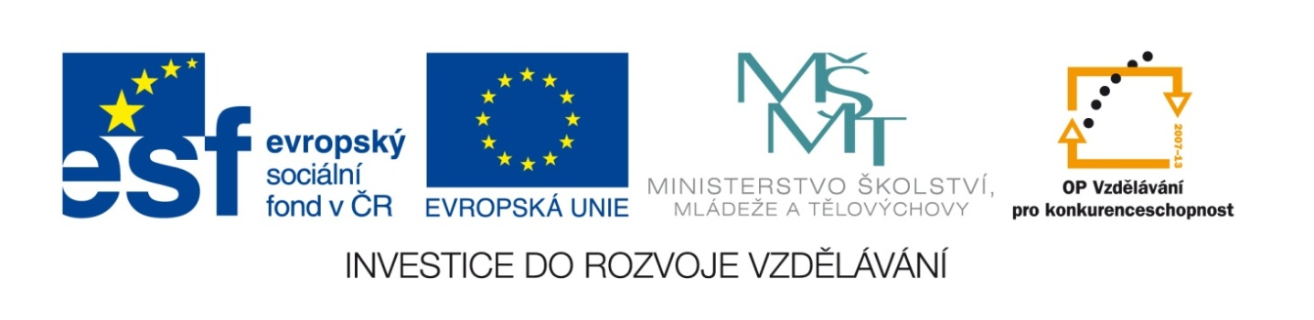

Název školy | Gymnázium, střední odborná škola, střední odborné učiliště a vyšší odborná škola, Hořice
Číslo projektu | CZ.1.07/1.5.00/34.0873
Název materiálu | VY_22_INOVACE_01.01.03  EU1, U1-11, FINAL VOCABULARY TEST
Autor | Mgr. Ivana Chalupová
Tematická oblast | Podpora učebnice Eurolingua English
Ročník | druhý
Datum tvorby | 1.10. 2012
Anotace | Souhrnné opakování slovní zásoby EU1, Units 1-11
Metodický pokyn | Materiál slouží k opakování nebo testování slovní zásoby učebnice EU1, Units 1-11.

FINAL VOCABULARY TEST EUROLINGUA 1, UNITS 1-11 78 POINTS

1. Match the verbs (1-10) with the words (a-j) 5 points
1. get up 6. read a) television f) a village
2. watch 7. listen to b) computer games g) early
3. have 8. go c) a book h) a shower
4. play 9. live in d) school i) German
5. speak 10. go to e) the radio j) home
2. What´s the time? – from the left to the right. 4 points
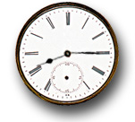
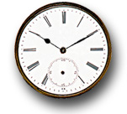
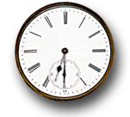
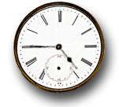
1. 2. 3. 4.

3. Write down the opposites. 10 points
1. sister and … 2. father and … 3. daughter and … 4. husband and … 5. aunt and … 6. expensive and … 7. empty and … 8. hot and … 9. long and … 10. good and …
4. Read the dialogue and fill in the gaps with a suitable sentence. There are more sentences than gaps! 10 points
A/ I´d like to see it. – B/ I have an idea. – C/ I´m sorry, I can´t. – D/ Is 7.30 all right? – E/ Nice to see you. – F/ Oh, I´m great! – G/ See you later. – H/ That sounds nice. – I/ That´s great. – J/ That´s too bad. – K/ We can meet at the pub next to the cinema. – L/ Well, how about you?
Sandra: Hello there, Lorna.
Lorna: Hi Sandra. …1… How are you?
S: …2… I have this wonderful new job at the Hotel International and I love it!
L: Oh really? …3… What do you do?
S: I´m a switchboard operator. It´s very interesting. …4… How are you these days?
L: Oh, just fine, thanks. Listen, …5… . Hugh Grant´s new film is on tonight. …6… Would you like to come with me?
S: …7… Yes, I´d love to come.
L: Let´s have a drink first. …8…
S: Yes, fine. What time?
L: …9… The film starts at 8.30.
S: Okay. …10… Bye, Lorna.
L: Bye, Sandra.
1. … 2. … 3. … 4. … 5. … 6. … 7. … 8. … 9. … 10. …
5. Translate 7 points
1. vedle myčky 2. za ledničkou 3. před pračkou 4. rodinný (= samostatně stojící) dům 5. pod konferenčním stolkem 6. mezi křeslem a knihovnou 7. v obývacím pokoji
6. Put the dialogue into the correct order. 10 points
A/ Yes, and a melon, please. F/ Here you are. Anything else?
B/ Here you are. Bye. G/ Can I have a pound of apples, please?
C/ Yes, love? H/ This one or that one?
D/ 90 pence, please. I/ No, thanks. How much is that?
E/ That one is alright. J/ These, love?
1. … 2. … 3. … 4. … 5. … 6. … 7. … 8. … 9. … 10. …
7. Translate: 1. okurka 2. třešně 3. hruška 4. cibule 5. rajče 6. houby 7. plátek sýra 8. bonboniéra 9. zavařovačka medu 10. láhev minerálky 11. bochník chleba 12. vidlička a nůž 13. talíř a lžíce 14. klobása 15. volské oko/míchaná vejce/vejce natvrdo (vyber si jen jedno) 16. ovesná kaše 17. fazole 18. koláč 19. slanina 20. svačina 20 points
8. Translate:1. základní škola 2. gymnázium 3. střední škola 4. anglická soukromá škola 5.školní jídelna 6. ve věku 5 let 7. chodit do školy 8. svačit 8 points
9. Count the numbers: 1. eighteen + twelve 2. twenty-nine + thirteen 3. ninety-four + eleven 4. two hundred and ten + two hundred and sixty 4 points
KEY TO THE TEST

1. Match the verbs (1-10) with the words (a-j) 5 points
1. G 6. C
2. A 7. E
3. H 8. J
4. B 9. F
5. I 10. D

2. What´s the time? – from the left to the right. 4 points
1. a quarter past eight 2. half past six 3. a quarter to five 4. ten (minutes) past ten

3. Write down the opposites. 10 points
1. brother 2. mother 3. son 4. wife 5. uncle 6. cheap 7. full 8. cold 9. short 10. bad

4. Read the dialogue and fill in the gaps with a suitable sentence. There are more sentences than gaps! 10 points
1. E 2. F 3. H/I 4. L 5. B 6. A 7. I/H 8. K 9. D 10. G

5. Translate 7 points
1. next to the dishwasher 2. behind the fridge 3. in front of the washing machine 4. detached house 5. under the coffee table 6. between the armchair and the bookcase 7. in the living room

6. Put the dialogue into the correct order. 10 points
1. C 2. G 3. J 4. A 5. H 6. E 7. F 8. I 9. D 10. B

7. Translate: 1. cucumber 2. cherries 3. pear 4. onion 5. tomato 6. mushrooms 7. a slice of cheese 8. a box of chocolates 9. a jar of honey 10. a bottle of mineral water 11. a loaf of bread 12. fork and knife 13. plate and spoon 14. sausage 15. fried egg/scrambled eggs/hard-boiled egg (vyber si jen jedno) 16. porridge 17. beans 18. cake 19. bacon 20. snack 20 points

8. Translate:1. primary school 2. grammar school 3. secondary school 4. public school 5.school canteen 6. at the age of five 7. go to school 8. have a snack 8 points

9. Count the numbers: 1. thirty 2. forty-two 3. a hundred and five 4. four hundred and seventy 4 points

EVALUATION
1: 78 – 72
2: 71 – 62
3: 61 – 47
4: 46 – 39
5: 38 - 0

