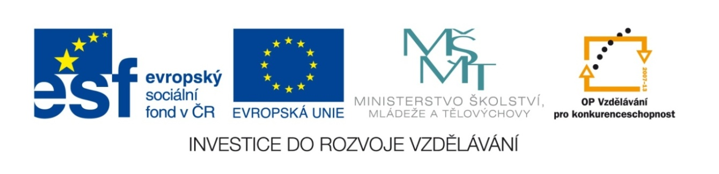

Název školy | Gymnázium, střední odborná škola, střední odborné učiliště a vyšší odborná škola, Hořice
Číslo projektu | CZ.1.07/1.5.00/34.0873
Název materiálu | VY_22_INOVACE_01.01.32  E3, U5 – Life in the Future
Autor | Mgr. Ivana Chalupová
Tematická oblast | Podpora učebnice Eurolingua English
Ročník | třetí
Datum tvorby | 16.4.2013
Anotace | Procvičení slovní zásoby (Life in the 21st century) a will-future.
Metodický pokyn | Křížovka, překlad, řízené psaní – vše lze zadat jako domácí úkol.

EUROLINGUA 3, UNIT 5

EXERCISE 1 - A CROSSWORD

Read the sentences and fill in the missing words to the crossword. Decode the hidden expression and say something more about it.

1
2
3
4
5
6
7
8
9
10
11
12
13
14
15

- There will be a few big …1… companies which will sell their …13… all over the world.
- If …12… doesn´t do anything for small businesses, a lot of them will have to close down because nobody will buy their …13… anymore.
- Genetic engineering will become a big business, so …2… (plural noun) will continue to change genes for …7… .
- There will be …3… (comparative adverb) jobs in manufacturing, because machines will do most of the boring jobs.
- We will have to …4… alternative sources of energy, such as solar …15… and wind …15… .
- Protection of our …5… will become an important political issue.
- This will lead to big changes in our lifestyles. We will have to consume …9… and …14… more.
- …3… people will die of terrible diseases, like …6… and AIDS.
- Our food will be full of …8…
- If there are only a few cars on the road, there will be little …10… and …11…, and the air will be healthier and cleaner.

EXERCISE 2 – TRANSLATION

Translate the following sentences using opinion words and will-future:

1. Doufám, že na ulicích bude méně aut, protože předpokládám, že málo lidí bude do práce jezdit autem.
2. Myslím si, že vzduch nebude tak znečištěný jako je teď.
3. Očekávám, že vláda bude řešit důležité politické problémy, např. ochranu životního prostředí.
4. Věřím, že bude méně hrozných nemocí, jako je rakovina, protože vědci budou schopni najít lék.
5. Jsem si jistá, že budeme muset více využívat alternativní zdroje energie, např. sluneční a větrnou energii.
6. Předpokládám, že lidé budou moci pracovat méně než v dnešní době, protože v továrnách bude více robotů.
7. Doufám, že budeme moci pracovat z domova, protože počítače budou v každé domácnosti. 8. Nevěřím, že spotřebujeme méně.
9. Myslím si, že budeme muset více recyklovat.
10. Očekávám, že více lidí bude pracovat ve službách a zdravotnických/pečovatelských profesích, protože jejich plat bude mnohem vyšší než je teď.

EXERCISE 3 – WRITING

Choose a topic and write an essay of 180-200 words to answer a question ´What will my life be like in 20 (or more) years?

Text 1 – Me and my family
How old will you be? What job do you expect to have? What will you be like – what qualities will be needed for the job? What will your partner be like? Will you be family-oriented or will you pursue your happiness in your career? Will you have children? If so, how many children do yout think you will have?

Text 2 – My house/flat
Where do you think you will live – in the country or in the town? Why? Do you expect you will live in a house or in a flat? How large will it be and what rooms will there be? Design your house/flat or just one room which will be your favourite or the most interesting one and describe it (use the future all the time!) Enclose the design to the essay.

Text 3 – Life in the future
Do you think the world will be better than today? How will we travel? Will we travel to the other planets normally? Will work be the same? Will we be able to protect the environment / peace or will there be pollution / wars? Will we eat genetically modified food? Will there be less hunger? Will medicine get better? Will we wipe out (vymýtit) terrible diseases? What do you suppose people will do in their free time? Will books still exist? Will the communication change?

KEY TO EXERCISE 1 - A CROSSWORD

1 i | n | t | e | r | n | a | t | i | o | n | a | L
2 |  |  |  |  |  |  |  |  |  | s | c | I | e | n | t | i | s | t | s
3 |  |  |  |  |  |  |  |  |  |  |  | F | e | w | e | r
4 |  |  |  |  |  |  |  |  |  |  | d | E | v | e | l | o | p
5 |  |  |  |  |  |  |  |  | e | n | v | I | r | o | n | m | e | n | t
6 |  |  |  |  |  |  |  |  |  | c | a | N | c | e | r
7 |  |  |  |  |  |  | p | r | o | f | i | T
8 |  |  |  |  |  |  |  |  |  |  | c | H | e | m | i | c | a | l | s
9 |  |  |  |  |  |  |  |  |  |  | l | E | s | s
10 |  |  |  |  |  |  |  |  | t | r | a | F | f | i | c
11 |  |  |  |  |  |  |  | p | o | l | l | U | t | i | o | n
12 |  |  | g | o | v | e | r | n | m | e | n | T
13 |  |  |  |  |  |  |  | p | r | o | d | U | c | t | s
14 |  |  |  |  |  |  |  |  |  |  |  | R | e | c | y | c | l | e
15 |  |  |  |  |  |  |  |  | p | o | w | E | r

- There will be a few big INTERNATIONAL companies which will sell their PRODUCTS all over the world.
- If GOVERNMENT doesn´t do anything for small businesses, a lot of them will have to close down because nobody will buy their PRODUCTS anymore.
- Genetic engineering will become a big business, so SCIENTISTS will continue to change genes for PROFIT.
- There will be FEWER jobs in manufacturing, because machines will do most of the boring jobs.
- We will have to DEVELOP alternative sources of energy, such as solar POWER and wind POWER.
- Protection of our ENVIRONMENT will become an important political issue.
- This will lead to big changes in our lifestyles. We will have to consume LESS and RECYCLE more.
- FEWER people will die of terrible diseases, like CANCER and AIDS.
- Our food will be full of CHEMICALS.
- If there are only a few cars on the road, there will be little TRAFFIC and POLLUTION, and the air will be healthier and cleaner.

KEY TO EXERCISE 2

- I hope there will be fewer cars on the roads because I suppose few people wil drive to work.
- I don´t think air will be as polluted as it is now.
- I expect government will solve important political issues such as the protection of the environment.
- I believe there will be fewer terrible diseases like cancer because scientists will be able to find a cure.
- I´m sure we will have to use alternative sources of energy such as solar or wind power more.
- I suppose people will be able to work less than nowadays because there will be more robots in factories.
- I hope we will be able to work from home because computers will be in every household.
- I don´t believe we will consume less.
- I think we will have to recycle more.
- I expect more people will work in service and caring jobs because their salaries will be much higher than now.

