Číslo projektu | CZ.1.07/1.5.00/34.0479
Číslo materiálu | VY_32_INOVACE_IVA_DVORAKOVA_Salon_Small_Talk_04
Název školy | Střední škola služeb, obchodu a gastronomie Hradec Králové
Ročník | Třetí, čtvrtý
Vzdělávací oblast | Anglický jazyk
Vzdělávací obor | Kosmetické služby
Tematický okruh | Odborná terminologie k oboru
Téma | Salon Small Talk
Jméno autora | Mgr. Iva Dvořáková
Vytvořeno dne | 18.3.2013
Metodický popis (anotace) | Pracovní list uvádí a procvičuje novou slovní zásobou a pravidla týkající se konverzace mezi pracovníkem salónu a klientem. Je vytvořen v programu Microsoft Word 2010.
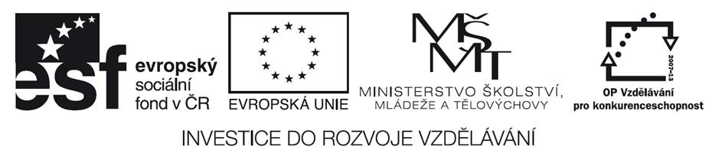
Salon Small Talk

Small Talk in a Beauty Salon

1. In a bussiness enviroment there are topics that are acceptable to talk about. Some of them are NOT suitable to discuss with clients, they are off-limits. Decide which topics from the chart are acceptable and which are off-limits.
religion, hobbies, salary, politics, money, travel plans, hometown, marital status, sex, other clients, music, films, books, fashion
The DOs | The DON´Ts

2. Complete the sentences with these phrases.
small talk off-limits chat favourite gossip marital status
Our colorist does not talk about subjects which are ____________ . She doesn´t want to make anyone uncomfortable.
It´s always nice to ___________ to your clients and learn about them.
Some clients like to _________, but make sure it´s never about another client or your boss.
When I got married, my ________________ changed.
It´s okay to ask about a client´s ____________ music or author.
Conversation about non-serious topics with clients is called _______________.
3. Do the crossword. Number of letters/ puzzle letter
1. appropriate 8/1
2. not single, divorced, widowed 7/1
3. talk about neutral topics 4/3
4. not suitable topics 9/4
5. catholicism 8/3
6. the most popular 9/8
7. earned money per month 6/2
8. cosy, relaxed 11/10
9. speak 4/4
_ _ _ _ _ _ _ _ _

NOW YOU ARE READY TO HAVE A POLITICALLY CORRECT CONVERSATION!
GOOD JOB!

Key:
- DO´s – hobbies, travel plans, hometown, music, films, books, fashion
DON´Ts – salary, religion, politics, money, marital status, sex, other clients
- off-limits, chat, gossip, marital, favourite, small talk
- suitable, married, chat, off-limits, religion, favourite, salary, comfortable,talk
Puzzle: small talk

Použité zdroje:

- DOOLEY, Jenny; EVANS, Virginia. Beauty Salon. Newbury: Express Publishing, 2011, ISBN 978-0-85777-849-9.

Pokud není uvedeno jinak, použitý materiál je z vlastních zdrojů autora



