Hradec Králové – Quiz
Číslo projektu | CZ.1.07/1.5.00/34.0479
Číslo materiálu | VY_32_INOVACE_IVA_DVORAKOVA_Hradec _Kralové_Quiz_18
Název školy | Střední škola služeb, obchodu a gastronomie Hradec Králové
Ročník | Třetí, čtvrtý
Vzdělávací oblast | Anglický jazyk
Vzdělávací obor | Fotograf, Kosmetické služby, Zahradnictví
Tematický okruh | Reálie ČR
Téma | Hradec Králové
Jméno autora | Mgr. Iva Dvořáková
Vytvořeno dne | 08.12. 2013
Metodický popis (anotace) | Kvíz o Hradci Králové prověřuje znalosti studentů. Může navazovat na prezentaci o HK. Tato aktivita je vytvořena v programu Microsoft Word 2010.

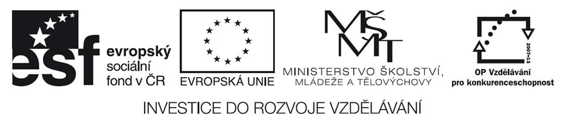

- Complete the text about Hradec Králové.

- Hradec Králové is located in __________ Bohemia on the confluence of the rivers _________ and ___________ .
- There live about __________ people.
- It is also called the _______ of the Republic because of a variety of different architecture you can find here such as G______, B_________, R____________ and A_____ N ________ .
- The first settlers came ________ years BC.
- In the 14 th century it became a ______ town of Bohemian Queens.
- The most famous architects who designed the urban and regulatory face of the modern town were J_____ K_______and J______ G________ .
- There are a lot of historical sights as the Cathedral of H____ S______ , W_______ Tower and P_____ Column in Large Square.
- Hradec Králové belongs to cultural centres of Eastern Bohemia. There are galleries as ____________, ___________; museums as ________________________; theatres as ______________, _______________, cinemas as ___________________, ______________.
- If you want to relax in a park, you can go to _______________, ______________ or ___________________.
- People living in Hradec Králové have a lot of sports opportunities. They can go swimming to ____________, ice –skating to _________ or _______ .
- There are also cultural, music and sports events held here every year as Theatre of European Regions Festival in ________, Rock For People in ________, Hip Hop Camp in ________, Jazz Goes to Town in ___________.
- Identify the places in the pictures and describe them.

Pict.1 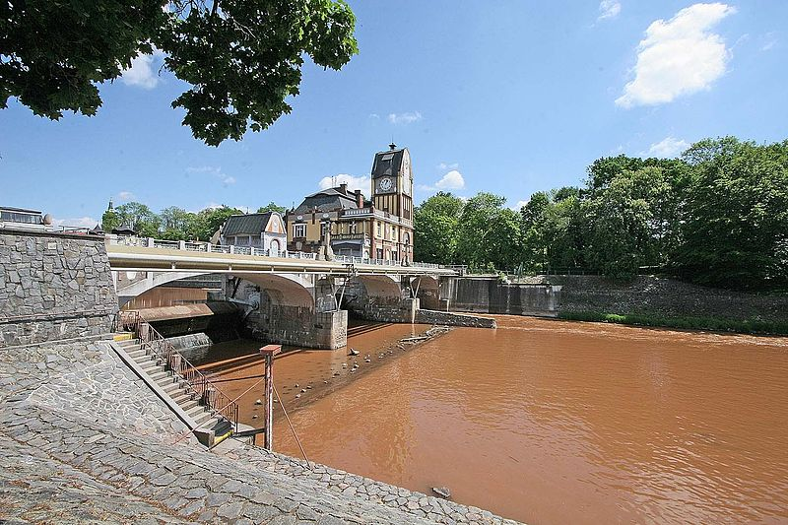

Pict.2 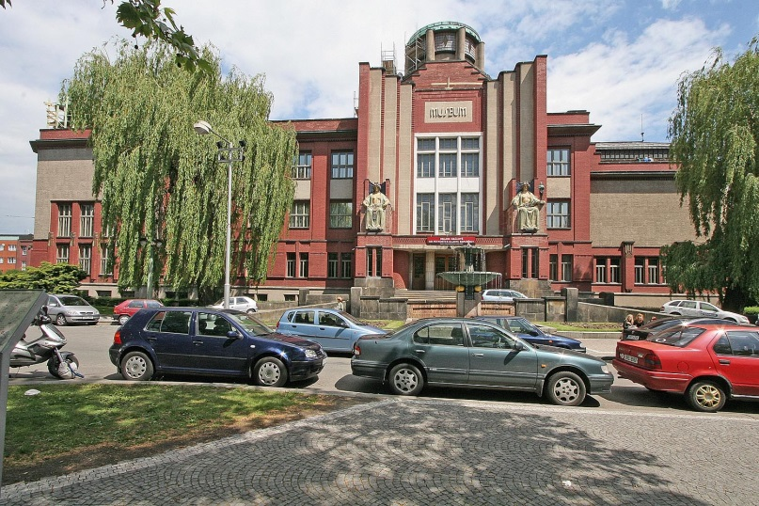

Pict.3 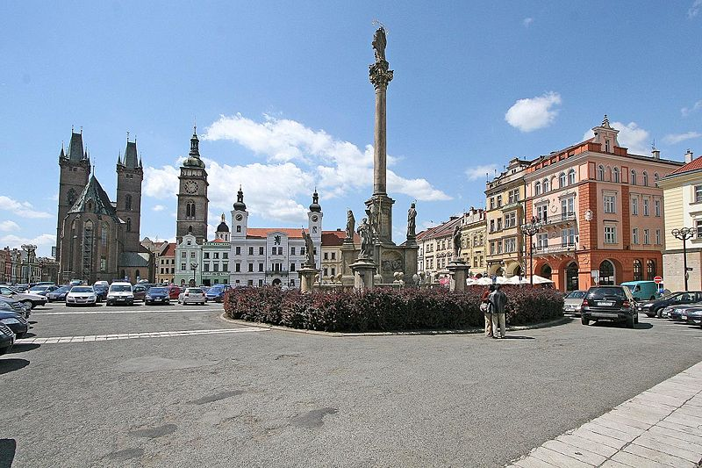

Key:
- Eastern, Elbe, Eagle
- 100 000
- Salon, Gothic, Baroque, Renaissance, Art Nouveau
- 3000
- Dowry
- Jan Kotěra, Josef Gočár
- Holy Spirit, White, Plaque
- Gallery of Modern Art, Rondo, Museum of Eastern Bohemia, Klicpera, Drak, Cinestar, Art Kino Centrál
- Jirasek´s, Žižka´s, Šimek´s Gardens
- City Bath House, winter stadium, cycling
- June, July, August, October

Pict.1
It´s Hučák Weir and Hydroelectric plant on the River Elbe. It is situated next to Jirásek´s Garden.

Pict.2. It´s the Museum of Eastern Bohemia. It was designed by Jan Kotěra and then bulit in 1909-1912.It is an example of Art Nouveau architecture. It is located on the Eliska´s Embankment.

Pict.3. It´s Large Square in the historical centre of HK. In the background you can see the Holy Spirit Cathedral in Gothic style, Renaissance White Tower and Baroque Plaque Column in the middle of the square.

Použité obrázky:
Pict.1. PRAZAK. commons.wikimedia.org [online]. [cit. 8.12.2013]. Dostupný na WWW: http://commons.wikimedia.org/wiki/File:Hradec_Kr%C3%A1lov%C3%A9_-_jez_Hu%C4%8D%C3%A1k.jpg
Pict.2. PRAZAK. commons.wikimedia.org [online]. [cit. 8.12.2013]. Dostupný na WWW: http://upload.wikimedia.org/wikipedia/commons/e/e5/Hradec_Kr%C3%A1lov%C3%A9_-_Muzeum_V%C3%BDchodn%C3%ADch_%C4%8Cech.jpg
Pict.3. PRAZAK. commons.wikimedia.org [online]. [cit. 8.12.2013]. Dostupný na WWW: http://commons.wikimedia.org/wiki/File:Hradec_Kr%C3%A1lov%C3%A9_-_Velk%C3%A9_n%C3%A1m%C4%9Bst%C3%AD.jpg

Pokud není uvedeno jinak, použitý materiál je z vlastních zdrojů autora.

