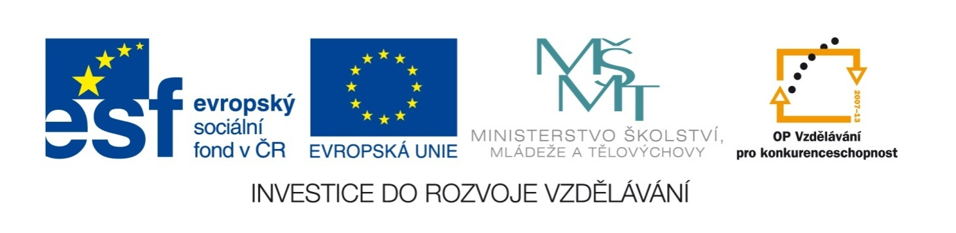

Název školy | ZÁKLADNÍ ŠKOLA, JIČÍN, HUSOVA 170
Číslo projektu | CZ.1.07/1.4.00/21.2862
Číslo a název klíčové aktivity | 3.2 Inovace a zkvalitnění výuky prostřednictvím ICT

Název DUM: | VY_32_INOVACE_XIV_1_19_GREAT BRITAIN
Šablona číslo: | XIV. |  | Sada číslo: | 1 | Pořadové číslo DUM: | 19
Autor: |  | Mgr. Lucie Velešovská
Anotace: |  | Reálie anglicky mluvících zemí – Velká Británie
Očekávaný výstup: |  | Žáci jsou schopni si na internetu vyhledat a osvojit informace o životě ve Velké Británii.
Druh učebního materiálu: |  | pracovní list
Typická věková skupina: |  | 8. ročník, 13 – 14 let
Klíčová slova: |  | Great Britain
Pomůcky a materiál: |  | pracovní list, psací potřeby, internet
Potřebný čas pro výuku DUM: |  | 45 minut
Metodické zhodnocení a popis práce s digitálním učebním materiálem:
- Žáci využívají anglickou Wikipedii a jiné zdroje k doplnění chybějících informací a k vyřešení kvízu.
Zdroje:

GREAT BRITAIN

I. Complete the text with the missing words:
Great Britain is an ________________ speaking country which lies in the ________________ of Europe. It lies between the North Sea and ________________ Ocean. The English Channel is between England and ________________ . There are ________________ countries in Great Britain: England, ________________ and Wales. The ________________ of Britain is London which lies on the river ________________ . Great Britain together with Northern Ireland is a part of the ________________ Kingdom or U.K. The British Queen is ________________ . The people who live in Britain are called the ________________ or just the Brits. They ________________ English, pay with ________________ and pence and drive on the ________________.

II. Choose the correct answer:
- Britain is originally
- English name
- Latin name
- Celtic name

- In Great Britain there isn’t
- Northern Ireland
- Wales
- Scotland

- The name of the British flag is
- Union Flag
- Union Jack
- Union Blue

- The capital of Scotland is
- Edinburgh
- Glasgow
- Aberdeen

- There isn’t a national football team of
- Great Britain
- England
- Wales

- The English policemen
- carry a gun
- don’t carry a gun

- The Beatles come from
- London
- Manchester
- Liverpool

- The Queen lives in
- the Tower of London
- Buckingham Palace
- Westminster Abbey

- Prince William is the Queen’s
- son
- grandson
- great grandson

- And his wife’s name is
- Kate
- Susan
- Diana

- Patron of England is
- St. John
- St. George
- St. James

- The first King of England spoke
- English
- French
- Latin

- The England’s national flower is
- a red rose
- a yellow rose
- a red tulip

- Golf comes from
- England
- Scotland
- Ireland

- The Scottish flag has
- a red cross on the white background
- a blue cross on the white background
- a white cross on the blue background

III. Complete the sentences:
- Typical English drink is:
- Typical English meal is:
- Typical English weather is:
- Typical English car is:
- Typical English sport is:
- Typical English surname is:
- Typical English Christmas meal is:
- The oldest English universities are:
- Mr. Bean’s real name is:
- Famous English music band is:

IV. Correct the spelling of the English towns:
Mancester Cembridge Shefield Birminham
Liwerpool Brigthon Yorck Lieds

GREAT BRITAIN

I. Complete the text with the missing words:
Great Britain is an English speaking country which lies in the north west of Europe. It lies between the North Sea and Atlantic Ocean. The English Channel is between England and France. There are three countries in Great Britain: England, Scotland and Wales. The capital of Britain is London which lies on the river Thames. Great Britain together with Northern Ireland is a part of the United Kingdom or U.K. The British Queen is Elisabeth II. The people who live in Britain are called the British or just the Brits. They speak English, pay with pounds and pence and drive on the left.

II. Choose the correct answer:
- Britain is originally
- English name
- Latin name
- Celtic name

- In Great Britain there isn’t
- Northern Ireland
- Wales
- Scotland

- The name of the British flag is
- Union Flag
- Union Jack
- Union Blue

- The capital of Scotland is
- Edinburgh
- Glasgow
- Aberdeen

- There isn’t a national football team of
- Great Britain
- England
- Wales

- The English policemen
- carry a gun
- don’t carry a gun

- The Beatles come from
- London
- Manchester
- Liverpool

- The Queen lives in
- the Tower of London
- Buckingham Palace
- Westminster Abbey

- Prince William is the Queen’s
- son
- grandson
- great grandson

- And his wife’s name is
- Kate
- Susan
- Diana

- Patron of England is
- St. John
- St. George
- St. James

- The first King of England spoke
- English
- French
- Latin

- The England’s national flower is
- a red rose
- a yellow rose
- a red tulip

- Golf comes from
- England
- Scotland
- Ireland

- The Scottish flag has
- a red cross on the white background
- a blue cross on the white background
- a white cross on the blue background

III. Complete the sentences (sometimes more possible answers):
- Typical English drink is: tea
- Typical English meal is: fish and chips, roast beef
- Typical English weather is: rainy, wet
- Typical English car is: Rolls Royce
- Typical English sport is: football, tennis, cricket, field hockey, rugby
- Typical English surname is: Smith, Black …
- Typical English Christmas meal is: roast turkey, Christmas pudding
- The oldest English universities are: Oxford, Cambridge
- Mr. Bean’s real name is: Rowan Atkinson
- Famous English music band is: more possible answers

IV. Correct the spelling of the English towns:
Manchester Cambridge Sheffield Birmingham
Liverpool Brighton York Leeds

