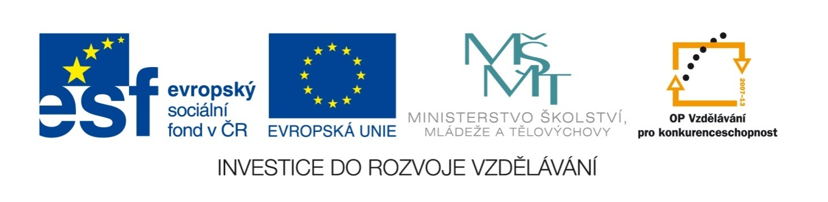

Název školy | ZÁKLADNÍ ŠKOLA, JIČÍN, HUSOVA 170
Číslo projektu | CZ.1.07/1.4.00/21.2862
Číslo a název klíčové aktivity | 3.2 Inovace a zkvalitnění výuky prostřednictvím ICT

Název DUM: | VY_32_INOVACE_XIV_1_20_CAN, MUST, HAVE TO, SHOULD
Šablona číslo: | XIV. |  | Sada číslo: | 1 | Pořadové číslo DUM: | 20
Autor: |  | Mgr. Lucie Velešovská
Anotace: |  | Procvičení používání modálních sloves a opisné formy slovesa must.
Očekávaný výstup: |  | Žáci dokážou vyjádřit, co mohou, musí a mají dělat v různých situacích.
Druh učebního materiálu: |  | pracovní list
Typická věková skupina: |  | 8. ročník, 13 – 14 let
Klíčová slova: |  | modal verbs, must, should, can, have to
Pomůcky a materiál: |  | pracovní list, psací potřeby
Potřebný čas pro výuku DUM: |  | 45 minut
Metodické zhodnocení a popis práce s digitálním učebním materiálem:
- Žáci vymýšlejí věty z vlastního života za použití jednotlivých modálních sloves.
- Žáci opravují typické chyby ve formě modálních sloves.
Zdroje:

CAN, MUST, HAVE TO, SHOULD

I. Write five things that you can/can’t do:
I can I can’t
______________________ ______________________
______________________ ______________________
______________________ ______________________
______________________ ______________________
______________________ ______________________

II. Write five things that you have to do at school:
- ______________________________________________________________
- ______________________________________________________________
- ______________________________________________________________
- ______________________________________________________________
- ______________________________________________________________

III. Write five things that you should do at home:
- ______________________________________________________________
- ______________________________________________________________
- ______________________________________________________________
- ______________________________________________________________
- ______________________________________________________________

IV. Correct the mistakes in the following sentences:
- He’s a brilliant tennis player, but his son can’t playing tennis.
- I really don’t can work with that machine.
- You must to do it very carefully.
- We don’t must do everything now.
- Does your parents can work with a computer?
- They haven’t to get up so early.
- How much you have to pay for it?
- Her children don’t should stay up so late.

V. Fill in the correct form of have to/don’t have to, should/shouldn’t:
- At weekends we _____________________ get up so late.
- I think you _____________________ do some sports to be fit.
- We _____________________ be at school in time.
- You _____________________ spend so much money or you will have nothing soon.
- Yesterday I missed the bus so I _____________________ run to school.
- He’s lost his job, so he _____________________ find a new one, but it’s difficult.
- You _____________________ study English harder if you want to work abroad.
- We _____________________ pay there, everything was paid by our company.
- She _____________________ wear better clothes to look more attractive.
- My father_____________________ wear a suit in his job.

VI. Match the lines and fill in a suitable verb:
- A cheetah can______________ faster a) can’t ______________ music.
- You can ______________ all information b) you can’t _________ after that.
- People can’t ______________ c) on the Internet.
- You can______________ alcohol, but d)sometimes dangerous.
- You can’t ______________ flowers e) without oxygen.
- Some famous rock stars f) than any other animal.
- Nobody can ______________ g) during driving.
- About one billion people h) to other galaxies.
- The Internet can______________ i) can ______________ English.
- Drivers can’t ______________ their phones j) without water.

CAN, MUST, HAVE TO, SHOULD

I. Write five things that you can/can’t do:
I can I can’t
More possible answers

II. Write five things that you have to do at school:

More possible answers

III. Write five things that you should do at home:

More possible answers

IV. Correct the mistakes in the following sentences:
- He’s a brilliant tennis player, but his son can’t play tennis.
- I really can’t work with that machine.
- You must do it very carefully.
- We don’t have to do everything now.
- Can your parents work with a computer?
- They don’t have to get up so early.
- How much do you have to pay for it?
- Her children shouldn’t stay up so late.

V. Fill in the correct form of have to/don’t have to, should/shouldn’t:
- At weekends we don’t have to get up so late.
- I think you should do some sports to be fit.
- We have to be at school in time.
- You shouldn’t spend so much money or you will have nothing soon.
- Yesterday I missed the bus so I had to run to school.
- He’s lost his job, so he has to find a new one, but it’s difficult.
- You should study English harder if you want to work abroad.
- We didn’t have to pay there, everything was paid by our company.
- She should wear better clothes to look more attractive.
- My father doesn’t have to wear a suit in his job.

VI. Match the lines and fill in a suitable verb:
- A cheetah can run faster f) a) can’t read music.
- You can get/find all information c) b) you can’t drive after that.
- People can’t go/fly/get h) c) on the Internet.
- You can drink alcohol, but b) d) sometimes dangerous.
- You can’t grow flowers j) e) without oxygen.
- Some famous rock stars a) f) than any other animal.
- Nobody can live/be e) g) during driving.
- About one billion people i) h) to other galaxies.
- The Internet can be d) i) can speak English.
- Drivers can’t use their phones g) j) without water.

