


Název školy: | Střední škola sociální PERSPEKTIVA a Vyšší odborná škola, s.r.o.
Adresa: | Mírová 218/6, Dubí III Pozorka
Název projektu | KLÍČE K POZNÁVÁNÍ
Registrační číslo projektu: | CZ.1.07/1.5.00/34.0928
Šablona: | II/2 Inovace a zkvalitnění výuky cizích jazyků na středních školách
Název a číslo materiálu: | VY_32_INOVACE_AJ3A_18
Vytvořeno: | 7. 8. 2013
Autor: | Mgr. Jaroslava Jelínková
Vyučovací předmět: | Anglický jazyk
Ročník: | I.-IV.
Anotace: | Didaktický učební materiál je určen pro žáky maturitních oborů SOŠ. Je zaměřen na procvičení slovní zásoby a tvoření otázek týkající se denního režimu.
Klíčová slova: | Daily regime
Výsledky vzdělávání dle RVP: | Žák ovládá slovní zásobu na téma „daily regime“, dokáže ji správně použít a umí se zeptat na určité informace.
Typ interakce: | aktivita
Druh výukového zdroje: | Pracovní list

- Try to make up questions that you can ask a client? Make questions using the pictures.



Would you like to

?

today?
What do you want to




would you like to
What
?

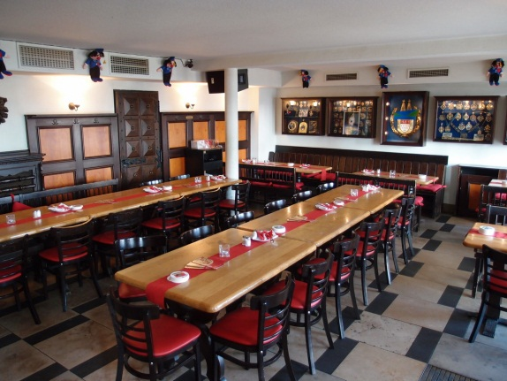

Do you want to

in

?



Shall I
?




Would you like

of

?

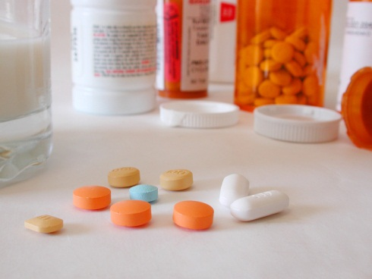
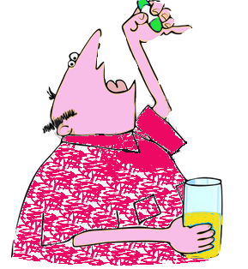
Have you
?

Would you like to
?

Have you got
?

- What can a client ask you? Make the sentences according to the information in brackets.

- Little time – have – you? (a client would like to speak to you)

- You – would - go – dining room – me? (a client would like to go for lunch but cannot go himself/herself)

- Shall – the red dress – I – wear – the blue one? (a client needs your advice what to wear)

- I – a cup of coffee – could – have? (a client feels like a coffee)

- headache – have – terrible – I, get – can - painkillers – I - please? (a client needs medicine)

- My son – call – today? (předpřít.čas)

- feel – I – tired – so. have to – I – get up? (a client wishes to stay in bed)

- Hello – need – go – at once – toilet! (a client needs to go to the toilet)

Sources:

http://commons.wikimedia.org/wiki/File:Im_Roten_Ochsen_7.JPG (Speiseraum)
www.office.microsoft.com

Solution:

Ex 1

- Would you like to read newspapers?
- What do you want to wear today?
- What time would you like to get up?
- Do you want to eat in the dining room?
- Shall I turn on/off the TV?
- Would you like a glass of water?
- Have you taken your pills?
- Would you like to go walking in the park/go to the park?
- Have you got a headache?

Ex 2

- Have you got a little time for me?
- Would you go to the dining room with me?
- Shall I wear the red dress of the blue one today?
- Could I have a cup of coffee?
- I have a terrible headache. Can I get painkillers, please?
- Has my son called today?
- I feel so tired. Do I have to get up?
- Hello, I need to go to the toilet at once!

