


Název školy: | Střední škola sociální PERSPEKTIVA a Vyšší odborná škola, s.r.o.
Adresa: | Mírová 218/6, Dubí III Pozorka
Název projektu | KLÍČE K POZNÁVÁNÍ
Registrační číslo projektu: | CZ.1.07/1.5.00/34.0928
Šablona: | II/2 Inovace a zkvalitnění výuky cizích jazyků na středních školách
Název a číslo materiálu: | VY_22_INOVACE_AJ2A_30
Vytvořeno: | 7. 8. 2013
Autor: | Mgr. Jaroslava Jelínková
Vyučovací předmět: | Anglický jazyk
Ročník: | II.
Anotace: | Pracovní list sloužící k osvojení sl. zásoby
Klíčová slova: | shopping
Výsledky vzdělávání dle RVP: | Vhodně používá odbornou slovní  zásobu vztahující se ke studijnímu oboru.  Vyjadřuje ústně i písemně svůj názor k danému tématu.
Typ interakce: | Aktivita
Druh výukového zdroje: | Pracovní list

- Finish the sentences. Use the words given. (+:

a greengrocer´s | a baker´s/bakery | the off-licence | a shoe shop
A supermarket | the bookshop | A shopping mall | a greengrocer´s
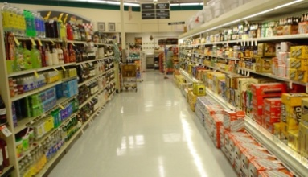

- We need something for dinner let´s go to ………………………….
- What shall we have for breakfast? Let´s go to ..................
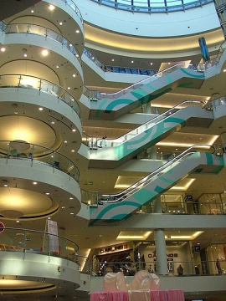
- I need new trainers. I have to go to ..........................
- There´s a new .............................. in the centre. There are millions of boutiques.
- Why don´t we make a salad for dinner tonight. OK, fine. Then we need to go to .................................... for some fresh vegetables.
- Oh my God! You´ve got a fever and there are no pills. I need to go to ...............................!
- Liz has got a birthday tomorrow and I wanted to buy her the new bestseller. Will you go with me to .......................................?
- Shall we bring some wine to the party too? Yes, let´s drop in at .......................................... and buy some quality wine.

A | B | C | D
E | F | G | H

- Order the sentences to make a proper conversation.

Shop assistant:

Customer:

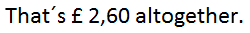

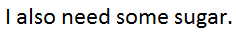
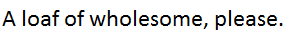
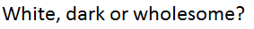


- Fill in proper words

Afford | Charge | Cost | Lend | Save | Borrow | Earn | Spend

1. | How much did it ..........? – Almost sixty euros.
2. | You can ............ 10% if you book online.
3. | I don´t have any money on me. Can you .............. me some?
4. | I can´t ..................... £300. That´s far too expensive.
5. | How much does a shop assistant/cashier ....................? – Not much.
6. | How much money do you ................... on clothes?
7. | I didn´t have the money so I had to ....................... it from my parents.
8. | They ................... extra for delivery.

Solution:

Ex. 1

A | B | C | D
supermarket | Baker´s | A shoe shop | A shopping mall
E | F | G | H
a greengrocer´s | the chemist´s | the bookshop | the off-licence

Ex. 2

Shop assistant: Hello, how can I help you?
A customer: Hello, can I have a loaf of bread?
Shop assistant: White, dark or wholesome?
A customer: A loaf of wholesome, please.

Shop assistant: Here you are. Anything else?
A customer: I also need some sugar.

Shop assistant: How many packets?
A customer: Just one, thank you. Have you got any milk?

Shop assistant: Yes, sure. How many bottles?
A customer: Two bottles, please.

Shop assistant: Anything else?
A customer: No, thank you. That´s all.
Shop assistant: How would you like to pay?
A customer: (In) cash.

Shop assistant: That´s £ 2,60 altogether.
A customer: Here you are. Thank you.

Shop assistant: Thanks a lot. Bye, bye.

Ex. 3

1. | How much did it COST? – Almost sixty euros.
2. | You can SAVE 10% if you book online.
3. | I don´t have any money on me. Can you LEND me some?
4. | I can´t AFFORD £300. That´s far too expensive.
5. | How much does a shop assistant/cashier EARN? – Not much.
6. | How much money do you SPEND on clothes?
7. | I didn´t have the money so I had to BORROW it from my parets.
8. | They CHARGE extra for delivery.

Sources:

- www.office.microsoft.com
- RONLINE. Wikimedia UK [online]. 30.3.2005 [cit. 18.6.2013]. Dostupný na WWW: http://commons.wikimedia.org/wiki/File:Supermarket_beer_and_wine_aisle.jpg
- ZIENOWIC, Alina. Wikimedia UK [online]. [cit. 18.6.2013]. Dostupný na WWW: http://commons.wikimedia.org/wiki/File:Warsaw_ochota_Blue_City01.JPG

