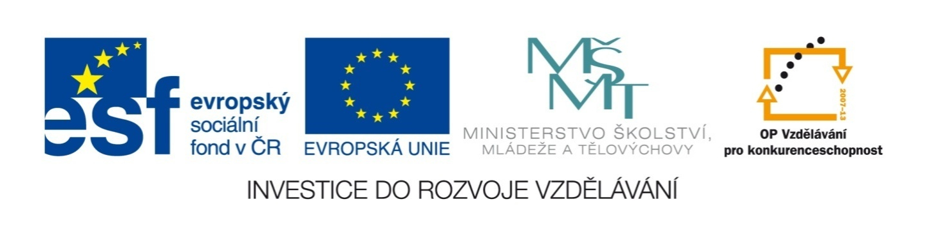

Název školy | ZÁKLADNÍ ŠKOLA, JIČÍN, HUSOVA 170
Číslo projektu | CZ.1.07/1.4.00/21.2862
Číslo a název klíčové aktivity | 3.2 Inovace a zkvalitnění výuky prostřednictvím ICT

Název DUM: | VY_32_INOVACE_XIV_3_11_THE UNITED KINGDOM
Šablona číslo: | XIV. |  | Sada číslo: | 3 | Pořadové číslo DUM: | 11
Autor: |  | Mgr. Zdeněk Jareš
Anotace: |  | Reálie anglicky mluvících zemí – Velká Británie
Očekávaný výstup: |  | Žáci jsou schopni dohledat na internetu odpovědi na otázky z reálií o Velké Británii.
Druh učebního materiálu: |  | pracovní list
Typická věková skupina: |  | 8. - 9. ročník, 13 – 15 let
Klíčová slova: |  | Great Britain
Pomůcky a materiál: |  | pracovní list, psací potřeby
Potřebný čas pro výuku DUM: |  | 60 minut
Metodické zhodnocení a popis práce s digitálním učebním materiálem:
- Žáci odpovídají v týmech na soubor zejména historických a zeměpisných otázek. Některé vyřeší snadno i bez potřeby informace hledat. Odpovědi na náročnější otázky si musí dohledat například na anglické Wikipedii. V této aktivitě jde o rychlou orientaci v anglickém textu. Bod za každou z otázek získá tým, který odpoví přesně a nejrychleji.
- Některé odpovědi je nutné průběžně aktualizovat!
Zdroje: http://en.wikipedia.org/wiki/File:Flag_of_the_United_Kingdom.svg

THE UNITED KINGDOM CROSSWORD

1 |  |  |  |  |  | P | U | D | D | I | N | G
2 |  |  |  |  |  |  |  | O | X | F | O | R | D
3 |  |  |  |  |  |  |  |  | Q | U | E | E | N
4 |  |  |  |  |  |  |  |  |  | S | H | A | K | E | S | P | E | A | R | E
5 |  |  |  |  |  |  |  |  | L | E | F | T
6 |  |  |  |  |  |  |  |  |  |  |  | B | E | A | T | L | E | S
7 | D | O | U | B | L | E | D | E | C | K | E | R
8 |  |  |  |  |  |  |  |  |  |  | P | I | P | E | S
9 |  |  |  |  |  |  |  |  |  |  |  | T | E | A
10 |  |  |  |  |  |  |  |  | I | S | L | A | N | D
11 |  |  |  |  |  |  |  | E | N | G | L | I | S | H
12 |  |  |  |  |  |  |  |  | P | O | U | N | D

- a hot sweet dish, made from cake, rice, bread etc with fruit, milk or other sweet things added
- city in central south England, the home of the oldest and most famous university in English-speaking world
- the head of this country
- the most famous English poet and playwright (1564 – 1616)
- when you travel in England by car you have to drive on the __________
- a famous pop group from the 1960s
- a kind of bus which is used in London
- a traditional Scottish musical instrument
- popular hot drink in England
- the UK is not part of continental Europe, it lies on the __________
- the official language in the UK
- currency used in the UK

THE UNITED KINGDOM CROSSWORD

1
2
3
4
5
6
7
8
9
10
11
12

- a hot sweet dish, made from cake, rice, bread etc with fruit, milk or other sweet things added
- city in central south England, the home of the oldest and most famous university in English-speaking world
- the head of this country
- the most famous English poet and playwright (1564 – 1616)
- when you travel in England by car you have to drive on the __________
- a famous pop group from the 1960s
- a kind of bus which is used in London
- a traditional Scottish musical instrument
- popular hot drink in England
- the UK is not part of continental Europe, it lies on the __________
- the official language in the UK
- currency used in the UK

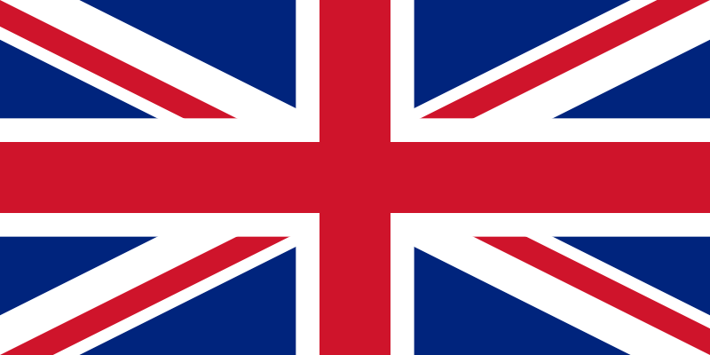
USE THE INTERNET, MAPS AND TEXTBOOKS IN THE CLASSROOM TO ANSWER THESE QUESTIONS ABOUT THE HISTORY, GEOGRAPHY, POLITICS AND EVERYDAY LIFE OF THE UNITED KINGDOM OF GREAT BRITAIN AND NORTHERN IRELAND:
1 | WHAT IS THE POPULATION OF THIS COUNTRY?
2 | WHO IS THE HEAD OF THE COUNTRY?
3 | WHAT IS THE HIGHEST MOUNTAIN OF THE COUNTRY?
4 | WHAT IS THE CAPITAL CITY OF WALES?
5 | WHAT IS THE CAPITAL CITY OF SCOTLAND?
6 | WHAT IS THE CAPITAL CITY OF NORTHERN IRELAND?
7 | WHAT IS THE AREA OF THIS COUNTRY?
8 | WHAT IS THE NAME OF THE NATIONAL ANTHEM OF THIS COUNTRY?
9 | WHAT IS UNION JACK?
10 | WHAT IS THE LONGEST RIVER OF THIS COUNTRY?
11 | WHAT SEPERATES SOUTHERN ENGLAND FROM NORTHERN FRANCE?
12 | WHERE DOES THE ROYAL FAMILY LIVE?
13 | WHO IS THE PRIME MINISTER OF THIS COUNTRY?
14 | WHERE DOES THE PRIME MINISTER LIVE?
15 | IN WHICH PALACE CAN YOU FIND THE HOUSES OF PARLIAMENT?
16 | WHERE CAN YOU FIND THE CROWN JEWELS?
17 | IN WHICH SQUARE IN LONDON CAN YOU FIND NELSON’S COLUMN?
18 | WHEN DID LONDON HOST THE SUMMER OLYMPIC GAMES?
19 | WHICH ROCK ARE THE WHITE CLIFFS IN DOVER MADE OF?
20 | WHO INVADED BRITAIN IN AD 43?
21 | WHICH EMPEROR PLANNED A SYSTEM OF FORTIFICATION AGAINST THE CELTS?
22 | WHICH PART OF BRITAIN WAS CALLED CALEDONIA?
23 | WHICH THREE MIGHTY GERMANIC TRIBES INVADED BRITAIN IN THE 5TH CENTURY?
24 | WHO DID ALFRED THE GREAT FIGHT AGAINST?
25 | WHO WON THE BATTLE OF HASTINGS IN 1066?
26 | WHICH ENGLISH KING WAS KILLED ON HIS WAY BACK FROM THE HOLY LAND IN 1199?
27 | WHAT WAS THE NAME OF HIS GREEDY BROTHER?
28 | WHAT WAS THE NAME OF THE MAIN LEADER DURING THE WAR OF SCOTTISH INDEPENDENCE? HE WAS CAPTURED AND EXECUTED IN 1305.
29 | WHAT WAS THE NAME OF THE WAR BETWEEN THE HOUSE OF YORK AND THE HOUSE OF LANCASTER?
30 | WHERE WAS SHAKESPEARE BORN?
31 | WHAT HAPPENED IN LONDON IN 1666?

ANSWER KEY
1 | 63,181,775 (census in 2011)
2 | The British Queen – Elizabeth II
3 | Ben Nevis (1, 344 meters above the sea level)
4 | Cardiff
5 | Edinburgh
6 | Belfast
7 | 243,610 km²
8 | God Save The Queen
9 | The National Flag of the UK
10 | The River Severn
11 | The English Channel
12 | Buckingham Palace
13 | David Cameron
14 | 10 Downing Street, London
15 | The Palace of Westminster
16 | The Tower of London
17 | Trafalgar Square
18 | 1908, 1948, 2012
19 | chalk
20 | the Romans
21 | Hadrianus (Roman Emperor from 117 to 138)
22 | Scotland
23 | the Saxons, the Jutes, the Angles
24 | against the Viking invasion
25 | William the Conqueror, Duke of Normandy
26 | Richard I. the Lionhearted
27 | John Lackland
28 | William Wallace
29 | The Wars of the Roses
30 | Stratford-upon-Avon
31 | The Great Fire of London

