

Název školy | ZÁKLADNÍ ŠKOLA, JIČÍN, HUSOVA 170
Číslo projektu | CZ.1.07/1.4.00/21.2862
Číslo a název klíčové aktivity | 3.2 Inovace a zkvalitnění výuky prostřednictvím ICT

Název DUM: | VY_32_INOVACE_XIV_3_12_THE UNITED STATES OF AMERICA
Šablona číslo: | XIV. |  | Sada číslo: | 3 | Pořadové číslo DUM: | 12
Autor: |  | Mgr. Zdeněk Jareš
Anotace: |  | Reálie anglicky mluvících zemí – Spojené Státy Americké
Očekávaný výstup: |  | Žáci jsou schopni dohledat na internetu odpovědi na otázky z reálií o USA.
Druh učebního materiálu: |  | pracovní list
Typická věková skupina: |  | 8. - 9. ročník, 13 – 15 let
Klíčová slova: |  | the USA
Pomůcky a materiál: |  | pracovní list, psací potřeby
Potřebný čas pro výuku DUM: |  | 60 minut
Metodické zhodnocení a popis práce s digitálním učebním materiálem:
- Žáci odpovídají v týmech na soubor zejména historických a zeměpisných otázek. Některé vyřeší snadno i bez potřeby informace hledat. Odpovědi na náročnější otázky si musí dohledat například na anglické Wikipedii. V této aktivitě jde o rychlou orientaci v anglickém textu. Bod za každou z otázek získá tým, který odpoví přesně a nejrychleji.
- Některé odpovědi je nutné průběžně aktualizovat!
Zdroje: http://en.wikipedia.org/wiki/File:Flag_of_the_United_States.svg

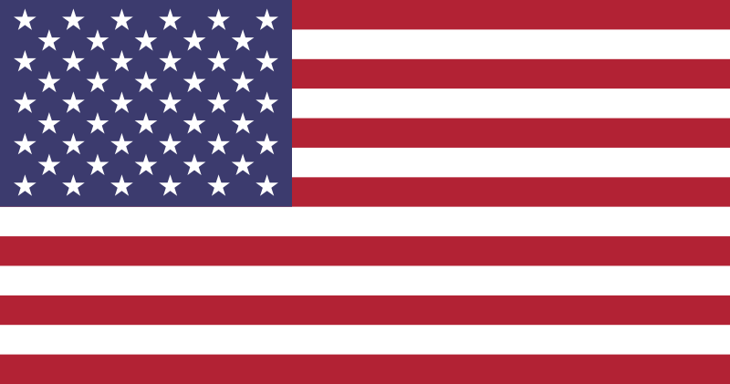
USE THE INTERNET, MAPS AND TEXTBOOKS IN THE CLASSROOM TO ANSWER THESE QUESTIONS ABOUT THE HISTORY, GEOGRAPHY, POLITICS AND EVERYDAY LIFE OF THE UNITED STATES OF AMERICA:
1 | HOW MANY STATES ARE THERE IN THE USA?
2 | WHAT IS THE AMERICAN NATIONAL FLAG CALLED?
3 | WHAT IS THE NAME OF THE NATIONAL ANTHEM OF THE USA?
4 | WHAT IS THE NAME OF THE US PRESIDENT?
5 | WHERE DOES HE LIVE?
6 | WHAT IS THE CAPITAL CITY OF THE USA?
7 | WHAT IS THE AREA OF THIS COUNTRY?
8 | WHAT IS THE POPULATION OF THIS COUNTRY?
9 | WHAT IS THE LARGEST CITY IN THE USA?
10 | WHAT ARE THE NEIGHBOURING COUNTRIES OF THE USA?
11 | WHAT IS THE HIGHEST MOUNTAIN IN THE USA?
12 | WHAT IS THE SECOND HIGHEST MOUNTAIN IN THE USA?
13 | WHAT IS THE NATIONAL BIRD OF THE USA?
14 | WHO WERE THE NATIVE INHABITANTS IN AMERICA?
15 | WHAT IS THE POPULATION OF NEW YORK CITY?
16 | WHAT WAS ITS PREVIOUS NAME?
17 | WHAT IS THE SECOND LARGEST CITY IN THE USA?
18 | IN WHICH AMERICAN CITY CAN YOU FIND THE STATUE OF LIBERTY?
19 | IN WHICH AMERICAN CITY CAN YOU FIND HOLLYWOOD?
20 | IN WHICH AMERICAN CITY CAN YOU FIND WILLIS TOWER?
21 | IN WHICH AMERICAN CITY CAN YOU FIND THE GOLDEN GATE?
22 | IN WHICH AMERICAN CITY CAN YOU FIND FORD, CHRYSLER AND GENERAL MOTORS FACTORIES?
23 | WHAT ARE THE NAMES OF NEW YORK’S FIVE BOROUGHS (NEIGHBORHOODS)?
24 | WHAT ARE THE TWO BEST UNIVERSITIES IN THE USA (AND ALSO IN THE WORLD) ACCORDING TO QS WORLD UNIVERSITY RANKINGS 2013?
25 | WHEN DID CHRISTOPHER COLUMBUS DISCOVER AMERICA?
26 | WHEN WAS VIRGINIA COLONY FOUNDED?
27 | WHICH TWO EUROPEAN COUNTRIES FOUGHT OVER CANADA FROM 1754 – 1763?
28 | WHEN DID THE AMERICAN WAR FOR INDEPENDENCE START?
29 | WHO WROTE THE DECLARATION OF INDEPENDENCE?
30 | WHEN WAS THE DECLARATION OF INDEPENDENCE ADOPTED?
31 | WHO WAS THE COMMANDER-IN-CHIEF OF CONTINENTAL ARMY?
32 | WHEN DID THE AMERICAN CIVIL WAR START?
33 | WHO WAS THE MOST SUCCESSFUL MILITARY OFFICER OF CONFEDERATE ARMY?
34 | WHICH US PRESIDENT WAS ASSASSINATED ON 14TH APRIL 1865?
35 | WHAT HAPPENED ON „BLACK TUESDAY“ IN 1929?
36 | WHICH AMERICAN PRESIDENT STARTED THE NEW ECONOMIC PROGRAMS CALLED „THE NEW DEAL“?
37 | WHAT WAS THE NAME OF THE LEADER IN THE AFRICAN-AMERICAN CIVIL RIGHTS MOVEMENT? HE GAVE A FAMOUS SPEECH CALLED „I HAVE A DREAM“.
38 | WHEN DID AMERICANS FIRST FLY TO THE MOON?
39 | WHAT WAS THE NAME OF THE MAIN ASTRONAUT?
40 | WHAT WAS THE NAME OF THEIR SPACECRAFT?

ANSWER KEY
1 | 50
2 | The Stars and Stripes
3 | The Star-Spangled Banner
4 | Barack Obama
5 | the White House
6 | Washington D.C.
7 | 9,826,675 km
8 | 317,559,000 (2013 estimate)
9 | New York
10 | Canada, Mexico
11 | Mount McKinley (6, 168 m) in Alaska
12 | Mount Saint Elias (5, 489 m)
13 | Bald Eagle
14 | Indians
15 | 8,336,697 (2012)
16 | New Amsterdam
17 | Los Angeles
18 | New York
19 | Los Angeles
20 | Chicago
21 | San Francisco
22 | Detroit
23 | The Bronx, Brooklyn, Manhattan, Queens, and Staten Island
24 | MIT and Harward University (both in Cambridge)
25 | 12th October 1492
26 | 1607
27 | Great Britain and France
28 | 1775
29 | Thomas Jefferson
30 | 4th July 1776
31 | George Washington
32 | 15th April 1861
33 | Robert Edward Lee
34 | Abraham Lincoln
35 | devastating crash in stock market in Wall Street
36 | Franklin D. Roosevelt
37 | Martin Luther King
38 | 20th July 1969
39 | Neil Armstrong
40 | Apollo

