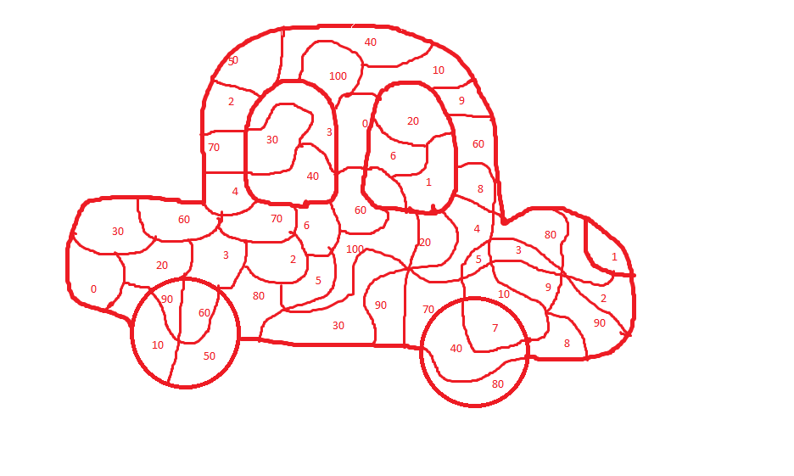
SVĚTLE MODRÁ | 0 |  | TMAVĚ ČERVENÁ | 30 |  | TMAVĚ ZELENÁ | 60 |  | ORANŽOVÁ | 90
SVĚTLE ZELENÁ | 10 |  | ŽLUTÁ | 40 |  | TMAVĚ MODRÁ | 70 |  | TMAVĚ MODRÁ | 100
SVĚTLE MODRÁ | 20 |  | RŮŽOVÁ | 50 |  | SVĚTLE ČERVENÁ | 80 |  | SVĚTLE HNĚDÁ | 7
TMAVĚ HNĚDÁ | 1 |  | SVĚTLE FIALOVÁ | 3 |  | TMAVĚ FIALOVÁ | 5 |  | TMAVĚ ŽLUTÁ | 8
ŠEDÁ | 2 |  | ČERNÁ | 4 |  | BÍLÁ | 6 |  | PUNTÍKATÁ | 9

60 | + | 20 | = |  |  |  | 100 | - | 10 | = |  |  |  | 60 | + | 40 | =
40 | + | 30 | = |  |  |  | 80 | - | 30 | = |  |  |  | 10 | - | 10 | =
30 | + | 40 | = |  |  |  | 70 | - | 50 | = |  |  |  | 20 | + | 50 | =
20 | + | 50 | = |  |  |  | 60 | - | 20 | = |  |  |  | 50 | + | 0 | =
10 | + | 10 | = |  |  |  | 90 | - | 70 | = |  |  |  | 70 | - | 40 | =
40 | + | 50 | = |  |  |  | 50 | - | 10 | = |  |  |  | 60 | + | 20 | =
80 | + | 10 | = |  |  |  | 30 | - | 20 | = |  |  |  | 20 | - | 10 | =
70 | + | 20 | = |  |  |  | 70 | - | 30 | = |  |  |  | 100 | - | 40 | =
90 | + | 0 | = |  |  |  | 80 | - | 60 | = |  |  |  | 30 | + | 30 | =
10 | + | 60 | = |  |  |  | 100 | - | 100 | = |  |  |  | 70 | - | 50 | =
Zdroj: Vlastní tvorba autora.

