

ŠKOLA: Městská střední odborná škola, Klobouky u Brna
nám. Míru 6, příspěvková organizace
ČÍSLO PROJEKTU: CZ.1.07/1.5.00/34.1020
NÁZEV PROJEKTU: Peníze do škol
ČÍSLO ŠABLONY: II/2 Inovace a zkvalitnění výuky cizích jazyků
na středních školách
AUTOR: Mgr. Veronika Krůzová
REALIZACE: Pracovní listy k maturitním otázkám
TÉMATICKÁ OBLAST: Všeobecná témata
NÁZEV DUMu: At the doctor
POŘADOVÉ ČÍSLO DUMu: 03
KÓD DUMu: VY_22_INOVACE_3_1_03_KRU
DATUM TVORBY: 2012/2013
ANOTACE: Pracovní list je určen pro použití v předmětu anglický jazyk. Je zaměřen na procvičení slovní zásoby týkající se návštěvy u lékaře. Studenti spojují obrázky s názvy předmětů a tvoří příkladový rozhovor „u lékaře“. Tento pracovní list je studentům kopírován pro samostatnou práci, která je následně kontrolována v rámci třídy za pomoci vyučujícího.

3. At the doctor
A) Put the dialogue in the correct order

1. Bye.
2. Good morning.
3. I did, about 37⁰C.
4. I don´t feel very well. I have got a terrible headache and a sore throat.
5. It was the evening.
6. No, I don´t, it´s just the sore throat.
7. Shall I come for a check up?
8. Thank you very much.
9. Bye.
10. Did you have a fever?
11. Did you have the fever in the morning or in the evening?
12. Good morning. What´s wrong with you?
13. OK, let me have a look in your throat. Hmm… do you also have a bad cough?
14. Ok, so it isn´t that bad. I´ll give you these pills which you´ll take twice a day. You´ll also have to stay in bed for a week.
15. Yes, of course.

B) Match the pictures with the correct words

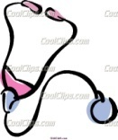 | drops
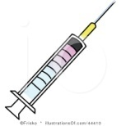 | thermometer
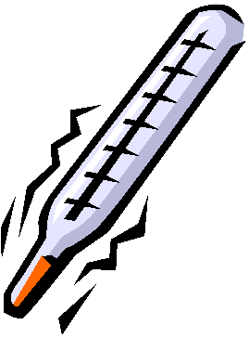 | tongue depressor
 | stethoscope
 | blood pressure
 | pills
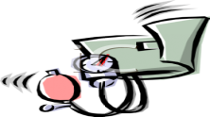 | prescription
 | injection

C) What are the things in the pictures used for?

The doctor uses this to measure the blood pressure. | This is used to listen to the heart beat. | This is used to give the patient a vaccination. | You need this to take the pills from the pharmacy. | These are used when you are ill and you have a fever or bad cough. | These are used for full nose or for eyes. | This is used to look the patient in his throat. | This is used to measure the temperature.

Zdroje:
1. Doctor. Bestclipartblog [online]. [cit. 2012-10-01]. Dostupné z: <http://bestclipartblog.com/23-doctor-clip-art.html/doctor-clip-art-5>

2. Nurse reading to patient. Clipartheaven [online]. [cit. 2012-10-01]. Dostupné z: <http://www.clipartheaven.com/show/clipart/health_&_medical/cartoons/nurse_reading_topatient-gif.html>

3. Stethoscope. Coolclips [online]. [cit. 2012-10-01]. Dostupné z:
<http://dir.coolclips.com/Healthcare/Medical_Equipment_and_Supplies/Stethoscopes/stethoscope_vc040234.html>

4. Syringe. Illustrationsof [online]. [cit. 2012-10-01]. Dostupné z: <http://www.illustrationsof.com/44410-royalty-free-syringe-clipart-illustration>

5. Thermometer. Bestclipartblog [online]. [cit. 2012-10-01]. Dostupné z: <http://bestclipartblog.com/25-thermometer-clip-art.html/thermometer-clipart-2>

6. Cartoon of an african american american doctor writing a prescription. Clipartguide [online]. [cit. 2012-10-01]. Dostupné z: <http://www.clipartguide.com/_pages/0511-0906-0920-2205.html>

7. Eye drops. Coolclips [online]. [cit. 2012-10-01]. Dostupné z:
<http://dir.coolclips.com/Healthcare/Medical_Equipment_and_Supplies/Eye_Droppers/eye_drops,_ear_drops_vc009802.html>

8. Small prescription bottle and pills. Clipartguide [online]. [cit. 2012-10-01]. Dostupné z: <http://www.clipartguide.com/_pages/0511-0902-1117-2156.html>

9. Blood pressure cuff. Clipartguide [online]. [cit. 2012-10-01]. Dostupné z: <http://www.clipartguide.com/_pages/0511-0811-1717-0431.html>

10. Mouth with tongue depressor. Fotosearch [online]. [cit. 2012-10-01]. Dostupné z: <http://www.fotosearch.com/illustration/tongue-depressor.html#comp.asp?recid=647066&xtra=>

2, 12, 4, 13, 6, 10, 3, 11, 5, 14, 7, 15, 8, 1, 9
A: Good morning.
B: Good morning. What´s wrong with you?
A: I don´t feel very well. I have got a terrible headache and a sore throat.
B: OK, let me have a look in your throat. Hmm… do you also have a bad cough?
A: No, I don´t, it´s just the sore throat.
B: Did you have a fever?
A: I did, about 37⁰C.
B: Did you have the fever in the morning or in the evening?
A: It was the evening.
B: Ok, so it isn´t that bad. I´ll give you these pills which you´ll take twice a day. You´ll also have to stay in bed for a week.
A: Shall I come for a check up?
B: Yes, of course.
A: Thank you very much.
B: Bye.
A: Bye.

