

ŠKOLA: Městská střední odborná škola, Klobouky u Brna
nám. Míru 6, příspěvková organizace
ČÍSLO PROJEKTU: CZ.1.07/1.5.00/34.1020
NÁZEV PROJEKTU: Peníze do škol
ČÍSLO ŠABLONY: II/2 Inovace a zkvalitnění výuky cizích jazyků
na středních školách
AUTOR: Mgr. Veronika Krůzová
REALIZACE: Pracovní listy k maturitním otázkám
TÉMATICKÁ OBLAST: Všeobecná témata
NÁZEV DUMu: Diseases
POŘADOVÉ ČÍSLO DUMu: 12
KÓD DUMu: VY_22_INOVACE_3_1_12_KRU
DATUM TVORBY: 2012/2013
ANOTACE: Pracovní list je určen pro použití v předmětu anglický jazyk. Je zaměřen na procvičení slovní zásoby týkající se nemocí. Studenti používají anglické výrazy pro vybrané nemoci a popisují jejich příznaky, léčbu a prevenci. Tento pracovní list je studentům kopírován pro samostatnou práci, která je následně kontrolována v rámci třídy za pomoci vyučujícího.

12. Diseases

A) Match the pictures with the diseases

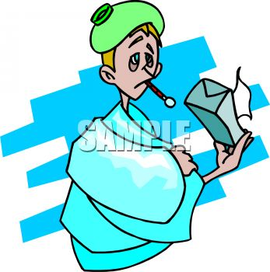 | cold
 | toothache
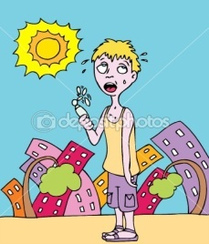 | flu
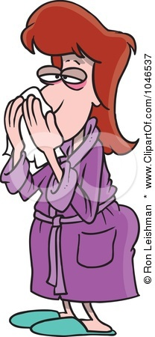 | sore throat
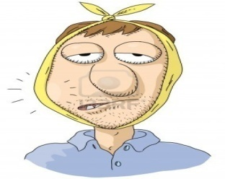 | backache
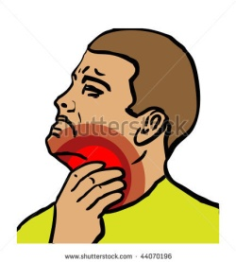 | sunstroke

B) Match the symptoms, treatment and prevention with the diseases

flu | sore throat | toothache | cold | sunstroke | backache

You can´t sleep at night because it really hurts. You are afraid of the doctor but in the end you find out that they are your only hope. It really hurts and it´s difficult for you to eat or drink hot or cold. | You can´t stand up easily because it hurts you. | You have a fever and you feel sick. Your eyes are red and swollen and you have got a full or running nose. You usually have a headache. | You have a headache and you also feel sick. Your skin may be burned and you also may have a fever. | You have a full nose and red eyes. You also may have a slight fever | It really hurts when you want to eat something. It is difficult to swallow. You usually have a fever and feel sick.

You should stay in bed and keep warm. Drink hot tea with lemon. Buy drops for your full nose. | Don´t go to the sun and put a cold cloth on the head. Drink a lot of water. | You must go to the doctor who probably gives you some pills. You should stay in bed until you feel better. | The doctor is your only hope. They probably give you an injection and pull the tooth out. Then you probably receive some painkillers. | Keep your throat warm and don´t drink anything cold. You may need to go to the doctor. | You should probably visit a doctor who gives you an injection otherwise you won´t be able to move for a long time.

You shouldn´t go to the sun and if you go you should wear a cap or a hat. You should drink a lot of water. | You should clean your teeth and go to the doctor regularly. | You should wear warm clothes and eat a lot of vitamins. You should also keep fit. | You should wear warm and long sweaters and don´t lift up heavy objects. | You should wear warm clothes and eat a lot of vitamins. You should also keep fit. If possible you should avoid places with a lot of people. | You should wear warm clothes and don´t drink cold drinks.

Zdroje:
1. Boy sick with the flu. Clipartguide [online]. [cit. 2012-09-23]. Dostupné z: <http://www.clipartguide.com/_pages/0511-0810-2315-2012.html>

2. Baseball player with back pain. Clipartof [online]. [cit. 2012-09-23]. Dostupné z: <http://www.clipartof.com/portfolio/toonaday/illustration/cartoon-baseball-player-with-back-pain-1047200.html>

3. So hot. Depositphotos [online]. [cit. 2012-09-23]. Dostupné z: <http://depositphotos.com/3990817/stock-illustration-So-Hot.html>

4. Woman with a cold. Clipartof [online]. [cit. 2012-09-23]. Dostupné z: <http://www.clipartof.com/portfolio/toonaday/illustration/cartoon-woman-with-a-cold-1046537.html>

5. Toothache. 123rf [online]. [cit. 2012-09-23]. Dostupné z: <http://www.123rf.com/photo_12479938_toothache.html>

6. Shutterstock [online]. [cit. 2012-09-23]. Dostupné z: <http://www.shutterstock.com/pic-44070196/stock-vector-medical-icon-cold-sore-throat-ill-human-season-health.html>

