

ŠKOLA: Městská střední odborná škola, Klobouky u Brna
nám. Míru 6, příspěvková organizace
ČÍSLO PROJEKTU: CZ.1.07/1.5.00/34.1020
NÁZEV PROJEKTU: Peníze do škol
ČÍSLO ŠABLONY: II/2 Inovace a zkvalitnění výuky cizích jazyků
na středních školách
AUTOR: Mgr. Veronika Krůzová
REALIZACE: Pracovní listy k maturitním otázkám
TÉMATICKÁ OBLAST: Všeobecná témata
NÁZEV DUMu: Food
POŘADOVÉ ČÍSLO DUMu: 15
KÓD DUMu: VY_22_INOVACE_3_1_15_KRU
DATUM TVORBY: 2012/2013
ANOTACE: Pracovní list je určen pro použití v předmětu anglický jazyk. Je zaměřen na procvičení slovní zásoby týkající se jídla. Studenti spojují obrázky s názvy jídla, jmenují ingredience potřebné pro vybraná jídla a používají výrazy spojené s vařením. Tento pracovní list je studentům kopírován pro samostatnou práci, která je následně kontrolována v rámci třídy za pomoci vyučujícího.

15. Food
A) Match the pictures with the food

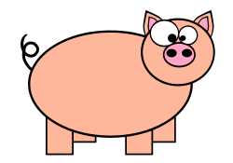 |  | 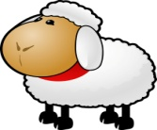 |  | 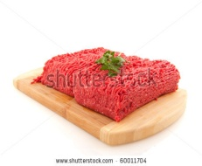
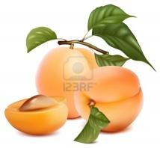 |  | 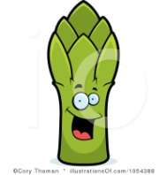 | 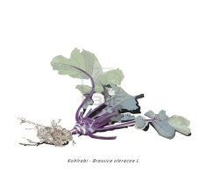 | 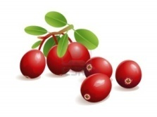
 | 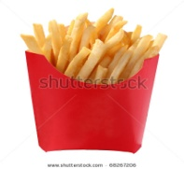 | 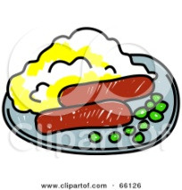 | 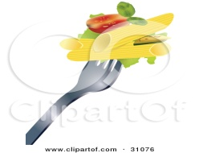 | 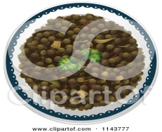
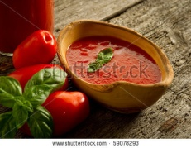 | 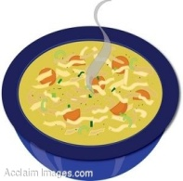 | 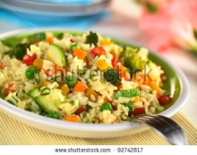 | 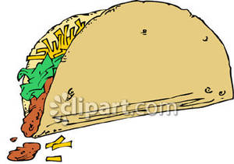 | 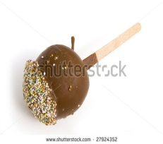

1. asparagus | 2. lentil | 3. apricot | 4. beef | 5. pasta
6. chips | 7. pork | 8. coated apple | 9. soup | 10. minced meat
11. lamb | 12. risotto | 13. mashed potatoes | 14. sausage | 15. stuffing
16. cranberries | 17. radish | 18. kohlrabi | 19. sauce | 20. dumplings

B) Match the ingredients with the meals

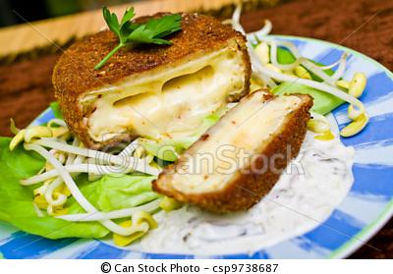fried cheese | potatoes  eggs  carrot  cucumber  peas  celery  mayo  pepper
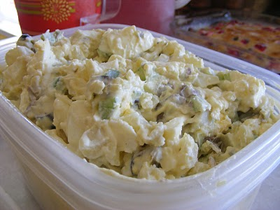potato salad | eggs  sugar  oil  flour  cinnamon  baking powder  soda  nuts  raisin  apples  milk
pancake | eggs  pickled peas, carrots, celery, onion, pepper  salami  mayo  gelatine
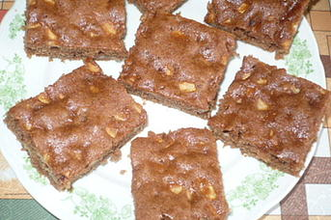cake | fish  onion  butter  mayo  mustard  whipping cream  salt  pepper
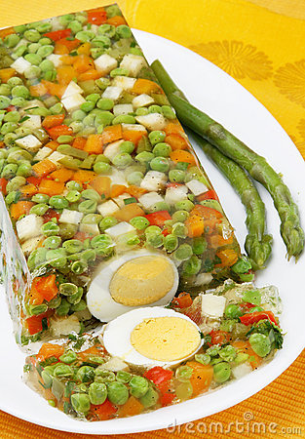aspic | cheese  flour  eggs  breadcrumbs  oil
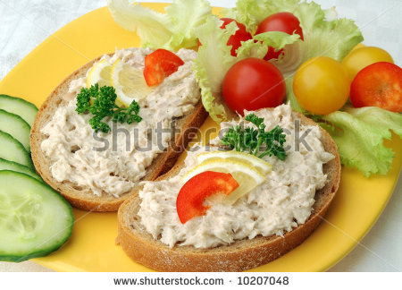 fish spread | eggs  flour  milk  a pinch of salt  a pinch of sugar  jam

C) Match the verbs with the pictures

slice | 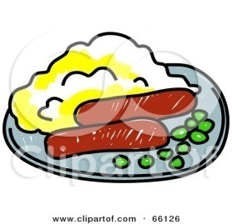
grate | 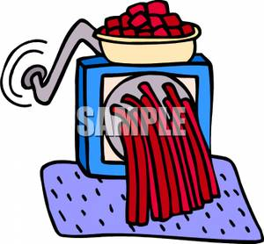
mash | 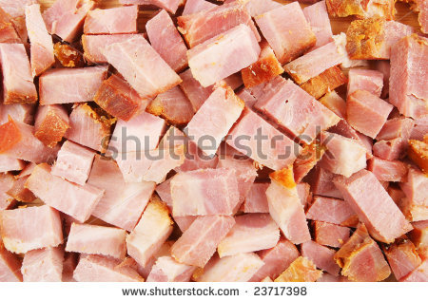
squeeze | 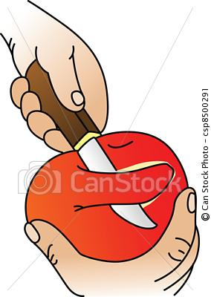
chop | 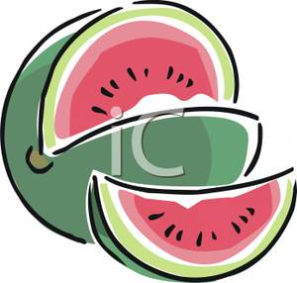
grind | 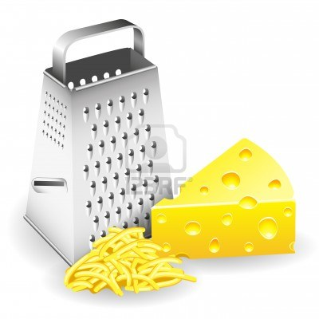
peel | 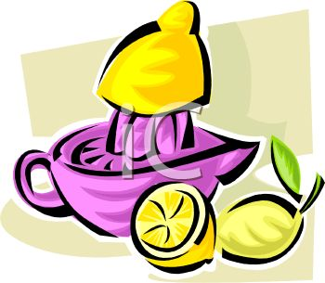

Zdroje:
1. Adams, C. Orange pig with big eyes. Openclipart [online]. 2010 [cit. 2012-11-19]. Dostupné z: <http://openclipart.org/detail/93265/piggie-by-candyadams>

2. Cow. Clipartof [online]. [cit. 2012-11-19]. Dostupné z: <http://free.clipartof.com/details/49-Free-Cartoon-Cow-Clip-Art>

3. Sheep. Clipartof [online]. [cit. 2012-11-19]. Dostupné z: <http://free.clipartof.com/details/54-Free-Cartoon-Sheep-Clipart-Illustration>

4. Thoman, C. Sausage. Illustrationsof [online]. [cit. 2012-11-19]. Dostupné z: <http://www.illustrationsof.com/94470-royalty-free-sausage-clipart-illustration>

5. Wiering, I. Minced meat with parsley. Shutterstock [online]. [cit. 2012-11-19]. Dostupné z: <http://www.shutterstock.com/pic-60011704/stock-photo-minced-meat-with-parsley-isolated-over-white.html>

6. Ivanova, E. Apricots with leaves. 123rf [online]. [cit. 2012-11-19]. Dostupné z: <http://www.123rf.com/photo_10053550_vector-illustration-apricots-with-leaves.html>

7. Thoman, C. Radish. Illustrationsof [online]. [cit. 2012-11-19]. Dostupné z: <http://www.illustrationsof.com/1084131-royalty-free-radish-clipart-illustration>

8. Thoman, C. Asparagus. Illustrationsof [online]. [cit. 2012-11-19]. Dostupné z: <http://www.illustrationsof.com/1054388-royalty-free-asparagus-clipart-illustration>

9. Lesjak, Z. Organic kohlrabi tuber with roots and leaves. 123rf [online]. [cit. 2012-11-19]. Dostupné z: <http://www.123rf.com/photo_18373137_illustration-of-organic-kohlrabi-tuber-with-roots-and-leaves.html>
10. Fresh cranberries, with leaves. 123rf [online]. [cit. 2012-11-19]. Dostupné z: <http://www.123rf.com/photo_10661881_realistic-vector-illustration-of-fresh-cranberries-with-leaves.html>

11. Cho, D. Dumpling. 123rf [online]. [cit. 2012-11-19]. Dostupné z: <http://www.123rf.com/photo_15995628_vector-icon-dumpling.html>

12. French fries. Shutterstock [online]. [cit. 2012-11-19]. Dostupné z: <http://www.shutterstock.com/pic.mhtml?id=68267206>

13. Plate of peas, bangers and mash. Clipartof [online]. [cit. 2012-11-19]. Dostupné z: <http://www.clipartof.com/portfolio/prawny/illustration/plate-of-peas-bangers-and-mash-66126.html>

14. Pasta, tomato and lettuce on the tip of a fork. Clipartof [online]. [cit. 2012-11-19]. Dostupné z: <http://www.clipartof.com/portfolio/upstudio/illustration/pasta-tomato-and-lettuce-on-the-tip-of-a-fork-31076.html>

15. A lentil dish. Clipartof [online]. [cit. 2012-11-19]. Dostupné z: <http://www.clipartof.com/portfolio/colematt/illustration/lentil-dish-1143777.html>

16. Bowl with tomato sauce. Shutterstock [online]. [cit. 2012-11-19]. Dostupné z: <http://www.shutterstock.com/pic.mhtml?id=59078293>

17. A bowl of chicken noodle soup. Clipartguide [online]. [cit. 2012-11-19]. Dostupné z: <http://www.clipartguide.com/_pages/1386-0807-0914-4503.html>

18. Vegetable risotto made of zucchini, pea, carrot, red bell pepper, broccoli and pumpkin. Shutterstock [online]. [cit. 2012-11-19]. Dostupné z: <http://www.shutterstock.com/pic-92742817/stock-photo-vegetable-risotto-made-of-zucchini-pea-carrot-red-bell-pepper-broccoli-and-pumpkin-selective.html>

19. A Taco With the Stuffing Falling Out. Picturesof [online]. [cit. 2012-11-19]. Dostupné z: <http://www.picturesof.net/pages/090428-124303-629009.html>

20. Westmacott, E. Chocolate coated apple on a stick. Shutterstock [online]. [cit. 2012-11-19]. Dostupné z: <http://www.shutterstock.com/pic-27924352/stock-photo-chocolate-coated-apple-on-a-stick.html>

21. Fried cheese with tatar sauce. Canstockphoto [online]. 2012 [cit. 2012-11-19]. Dostupné z: <http://www.canstockphoto.com/fried-cheese-with-tatar-sauce-9738687.html>

22. Potato salad on a paper plate. Canstockphoto [online]. 2011 [cit. 2012-11-19]. Dostupné z: <http://www.canstockphoto.com/illustration/potato.html#file_view.php?id=5938565>

23. Pancake flipping over a frying pan. Clipartof [online]. [cit. 2012-11-19]. Dostupné z: <http://www.clipartof.com/portfolio/sajem/illustration/pancake-flipping-over-a-frying-pan-1146426.html>

24. Vildová, V. Americká buchta. Receptynakazdyden [online]. [cit. 2012-11-19]. Dostupné z: <http://www.receptynakazdyden.cz/recept/americka-buchta>

25. Vegetable aspic. Dreamstime [online]. 2010 [cit. 2012-11-19]. Dostupné z: <http://www.dreamstime.com/royalty-free-stock-photos-vegetable-aspic-image14789778>

26. Stejskalová, M. Tuna fish spread snack. Shutterstock [online]. [cit. 2012-11-19]. Dostupné z: <http://www.shutterstock.com/pic-10207048/stock-photo-tuna-fish-spread-snack.html>

27. A watermelon with a slice cut out of it. Picturesof [online]. [cit. 2012-11-19]. Dostupné z: <http://www.picturesof.net/pages/090911-118754-781054.html>

28. A piece of cheese grater and grated cheese. 123rf [online]. [cit. 2012-11-19]. Dostupné z: <http://www.123rf.com/photo_12992547_a-piece-of-cheese-grater-and-grated-cheese.html>
29. Lemon juicer. Clipartguide [online]. [cit. 2012-11-19]. Dostupné z: <http://www.clipartguide.com/_pages/0511-0906-1204-2040.html>

30. Griffin, R. Chopped ham. Shutterstock [online]. [cit. 2012-11-19]. Dostupné z: <http://www.shutterstock.com/pic-23717398/stock-photo-chopped-ham-as-a-background-and-texture.html>

31. Meat grinder. Best-of-web [online]. [cit. 2012-11-19]. Dostupné z: <http://www.best-of-web.com/pages/100618-003904-943042.html>

32. Apple peel. Canstockphoto [online]. 2012 [cit. 2012-11-19]. Dostupné z: <http://www.canstockphoto.com/apple-peel-extract-8500291.html>

