

ŠKOLA: Městská střední odborná škola, Klobouky u Brna
nám. Míru 6, příspěvková organizace
ČÍSLO PROJEKTU: CZ.1.07/1.5.00/34.1020
NÁZEV PROJEKTU: Peníze do škol
ČÍSLO ŠABLONY: II/2 Inovace a zkvalitnění výuky cizích jazyků
na středních školách
AUTOR: Mgr. Veronika Krůzová
REALIZACE: Pracovní listy k maturitním otázkám
TÉMATICKÁ OBLAST: Všeobecná témata
NÁZEV DUMu: Character
POŘADOVÉ ČÍSLO DUMu: 20
KÓD DUMu: VY_22_INOVACE_3_1_20_KRU
DATUM TVORBY: 2012/2013
ANOTACE: Pracovní list je určen pro použití v předmětu anglický jazyk. Je zaměřen na procvičení slovní zásoby týkající se povahových vlastností. Studenti používají slovní zásobu týkající se povahových vlastností a rozpoznávají a popisují povahové vlastnosti. Tento pracovní list je studentům kopírován pro samostatnou práci, která je následně kontrolována v rámci třídy za pomoci vyučujícího.

20. Character
A) Match the opposites

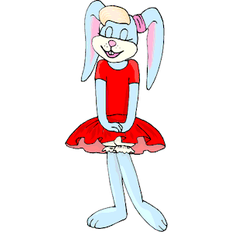 SHY |  TALKATIVE
 RELIABLE |  DULL
 QUIET |  CALM
 OUTGOING | 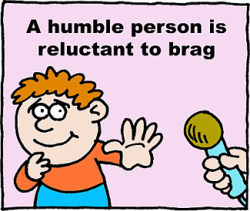 RELUCTANT
 HOT-TEMPERED |  NICE
 LIVELY |  CONFIDENT
 WEIRD |  SOLITARY
 WILLING | 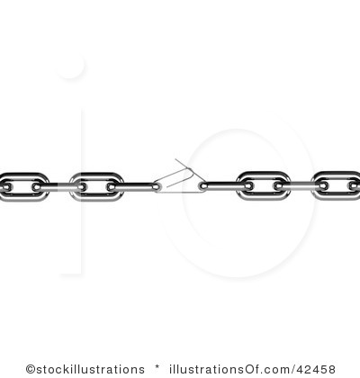 UNRELIABLE

B) Complete the sentences with the correct word

jealous friendly lax envious hardworking boring ambitious lazy

1. My sister is a very ____________ person. She works fourteen hours a day.
2. I was always ____________. I didn´t want to go to school and learn.
3. A lot of my friends are very ____________. They have their own companies and always try to be the best.
4. My aunt has been ____________ all her life and that is why she is so evil.
5. Is your wife ____________? Yes, she is. She always follows me secretly when I go out.
6. My friend Peter is really ____________. He likes telling jokes which aren´t funny at all.
7. Our head is ____________. He doesn´t care about students´ problems at all.
8. Is your brother a ____________ person? Yes, he is. He loves helping his friends.

C) Match the descriptions with the correct words

pig-headed | People who like talking about your problems although you don´t want to. They do it to harm you.
tight-fisted | People who love their money above all. They spend all their lives earning money and the more they have the more they want to have.
sarcastic | People who are able to make a lot of things themselves. They don´t need a serviceman they can repair a lot of things.
phlegmatic | People who don´t want to listen to any advice. They are sure they manage everything themselves and they don´t want to receive help.
greedy | People who live a very happy life because they don´t care about anything. They are never nervous... why should they...?
skillful | People who don´t want to give or lend anything to anybody.
smart | People who usually learn very easy, they know a lot of things and are intelligent.
clever | People who have answers to everything and they are always funny. They are usually very popular among others.

Zdroje:
1. Rabbit shy. Cliparts101 [online]. 2012 [cit. 2013-01-15]. Dostupné z: <http://cliparts101.com/free_clipart/53065/Rabbit_Shy>

2. Leishman, R. A confident school boy holding a thumb up. Clipartof [online]. 2012 [cit. 2013-01-15]. Dostupné z: <http://www.clipartof.com/portfolio/toonaday/illustration/cartoon-confident-school-boy-holding-a-thumb-up-1046237.html>

3. Reliable Worker with a Wind-Up Key in His Back. Acclaimclipart [online]. [cit. 2013-01-15]. Dostupné z: <http://www.acclaimclipart.com/free_clipart_images/reliable_worker_with_a_windup_key_in_his_back_0521-1012-0921-2701.html>
4. Chain. Illustrationsof [online]. [cit. 2013-01-15]. Dostupné z: <http://www.illustrationsof.com/42458-royalty-free-chain-clipart-illustration>

5. Quiet. Openclipart [online]. 2010 [cit. 2013-01-15]. Dostupné z: <http://openclipart.org/detail/76609/quiet-line-art-by-gammillian>

6. Leishman, R. Talking. Illustrationsof [online]. [cit. 2013-01-15]. Dostupné z: <http://www.illustrationsof.com/433566-royalty-free-talking-clipart-illustration>

7. Group of ladies dancing at a party. Clipartof [online]. [cit. 2013-01-15]. Dostupné z: <http://www.clipartof.com/interior_wall_decor/details/Group-Of-Ladies-Dancing-At-A-Party-Poster-Art-Print-1064662>

8. A solitary blue man. 123rf [online]. [cit. 2013-01-15]. Dostupné z: <http://www.123rf.com/photo_2450926_a-solitary-blue-man.html>

9. Nortnik, A. An angry granny in a robe, dropping curlers while chasing someone with a broom. Clipartof [online]. [cit. 2013-01-15]. Dostupné z: <http://www.clipartof.com/portfolio/anortnik/illustration/angry-granny-in-a-robe-dropping-curlers-while-chasing-someone-with-a-broom-41817.html>

10. Pan, T. A jade woman meditating in the lotus pose with her chakras illuminated in different colors. Clipartof [online]. [cit. 2013-01-15]. Dostupné z: <http://www.clipartof.com/portfolio/a-papantoniou/illustration/jade-woman-meditating-in-the-lotus-pose-with-her-chakras-illuminated-in-different-colors-over-a-black-background-32409.html>

11. Silhouetted a young man enjoy music in swirl wave background. 123rf [online]. [cit. 2013-01-15]. Dostupné z: <http://www.123rf.com/photo_6508461_silhouetted-a-young-man-enjoy-music-in-swirl-wave-background-vector-illustration.html>

12. Stupidity. Easyvectors [online]. [cit. 2013-01-15]. Dostupné z: <http://www.easyvectors.com/browse/other/stupidity-clip-art>

13. Leishman, R. A weird man on a pogo stick. Clipartof [online]. [cit. 2013-01-15]. Dostupné z: <http://www.clipartof.com/portfolio/toonaday/illustration/cartoon-weird-man-on-a-pogo-stick-1047370.html>

14. Woman. Illustrationsof [online]. [cit. 2013-01-15]. Dostupné z: <http://www.illustrationsof.com/223039-royalty-free-woman-clipart-illustration>

15. A Teacher Asking A Child If They Need Help With Homework. Picturesof [online]. [cit. 2013-01-15]. Dostupné z: <http://www.picturesof.net/pages/090918-162641-254042.html>

16. Gunther, R. Reluctant to brag. Christart [online]. [cit. 2013-01-15]. Dostupné z: <http://www.christart.com/clipart/image/reluctant-to-brag>

