

ŠKOLA: Městská střední odborná škola, Klobouky u Brna
nám. Míru 6, příspěvková organizace
ČÍSLO PROJEKTU: CZ.1.07/1.5.00/34.1020
NÁZEV PROJEKTU: Peníze do škol
ČÍSLO ŠABLONY: II/2 Inovace a zkvalitnění výuky cizích jazyků
na středních školách
AUTOR: Mgr. Veronika Krůzová
REALIZACE: Pracovní listy k maturitním otázkám
TÉMATICKÁ OBLAST: Všeobecná témata
NÁZEV DUMu: Jobs
POŘADOVÉ ČÍSLO DUMu: 22
KÓD DUMu: VY_22_INOVACE_3_1_22_KRU
DATUM TVORBY: 2012/2013
ANOTACE: Pracovní list je určen pro použití v předmětu anglický jazyk. Je zaměřen na procvičení slovní zásoby týkající se zaměstnání. Studenti spojují obrázky s jednotlivými zaměstnáními a stručně tato zaměstnání popisují. Tento pracovní list je studentům kopírován pro samostatnou práci, která je následně kontrolována v rámci třídy za pomoci vyučujícího.

22. Jobs

A) What jobs are these?

1.
a) shop assistant b) waitress c) air hostess
2.
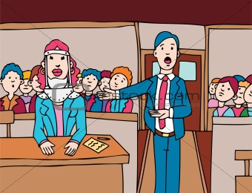 a) coal miner b) lawyer c) steward
3.
a) teacher b) building engineer c) manager
4.
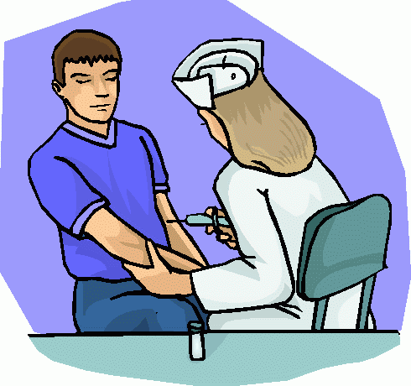 a) doctor b) surgeon c) nurse

5.
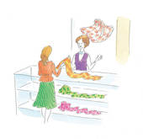 a) shop assistant b) hairdresser c) barber
6.
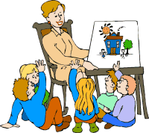 a) secretary b) teacher c) barber
7.
 a) builder b) coalminer c) carpenter
8.
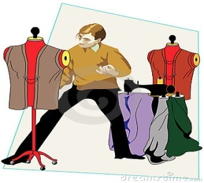 a) photographer b) fashion designer c) shoemaker
9.
a) breeder b) farmer c) builder
10.
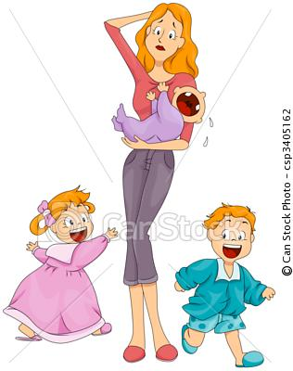 a) babysitter b) nurse c) dressmaker

B) Match the descriptions with the correct pictures

1. ____________________
The person has to study a university. The job is very demanding but if you are good at it you can earn a lot of money. You have to be smart and clever. These people are intelligent and they seem to be cold which is a part of their job.

2. ____________________
You need need to be strong and hard-working. The job is really hard but you can earn a lot of money. However, it is really dangerous and you can´t suffer from claustrophobia.

3. ____________________
The person has to study at least a high school. Two foreign languages are usually demanded with this job. You have to be smart, flexible and nice to people even if they aren´t very nice to you. On the other hand, you can earn quite a lot of money and visit foreign countries.

4. ____________________
You have to study a special high school. You have to work day and night shifts and you can´t have an aversion to blood. However, this job isn´t very well paid.

5. ____________________
The person has to work out and they have to study a special school. They must know a lot about agriculture and their work depends on the weather conditions. If it is a good year they can earn quite good money.

6. ____________________
You have to study a university. You should like work with a lot of people and you should be resitant to noise. You should also be optimistic and you should really love this job because it isn´t among the best-paid jobs.

7. ____________________
The person has to study a university and they are responsible for people´s lives. They have to be very precise at their work because if they weren´t a lot of people could die in a minute. This is a well-paid job.

8. ____________________
The person has to love children and be really responsible. They should also know to cook and clean a bit. They don´t earn a lot of money, however, this is usually taken as a job for students.

9. ____________________
You should be able to sew a bit and to make cuts. This person is also interested in the last trends and tries to make new clothes which are showed at fashion shows.

10. ____________________
The person doesn´t have to study a high school or a university but they should be good at counting. They should also be nice to people. On the other hand, they don´t earn a lot of money and they work quite long hours.

Zdroje:

1. Air hostess presenting her company’s services. 123rf [online]. [cit. 2012-11-03]. Dostupné z: <http://www.123rf.com/photo_6981070_air-hostess-presenting-her-company-s-services-no-transparency-used-basic-linear-gradients-used-for-t.html>
2. Lawsuit in court. Crestock [online]. [cit. 2012-11-03]. Dostupné z: <http://www.crestock.com/image/2245055-Lawsuit-in-Court.aspx>

3. Eine Karikatur Ingenieur Umfragen seinen build site. 123rf [online]. [cit. 2012-11-03]. Dostupné z: <http://de.123rf.com/photo_15219657_eine-karikatur-ingenieur-umfragen-seinen-build-site-illustrator-eps-v10-contains-einige-transparenz-.html>
4. Nurse giving shot. Clipartheaven [online]. [cit. 2012-11-03]. Dostupné z: <http://www.clipartheaven.com/show/clipart/health_&_medical/professionals/nurse_giving_shot-gif.html>

5. A sales assistant helping a shopper. Fotosearch [online]. [cit. 2012-11-03]. Dostupné z: <http://www.fotosearch.com/illustration/shop-assistant.html#comp.asp?recid=3790760&xtra=>

6. Students and teacher. Free-clipart-pictures [online]. [cit. 2012-11-03]. Dostupné z: <http://www.free-clipart-pictures.net/teacher_clipart.html>

7. Coal miner. Occupations.phillipmartin [online]. [cit. 2012-11-03]. Dostupné z: <http://occupations.phillipmartin.info/occupations_coal_miner.htm>

8. Fashion designer. Dreamstime [online]. 2007 [cit. 2012-11-03]. Dostupné z: <http://www.dreamstime.com/stock-images-fashion-designer-image2106284>

9. Tsankov, Ch. Outlined farmer. 123rf [online]. [cit. 2012-11-03]. Dostupné z: <http://de.123rf.com/photo_16386971_clipart-illustration-of-an-outlined-farmer.html>

10. Babysitter. Canstockphoto [online]. 2010 [cit. 2012-11-03]. Dostupné z: <http://www.canstockphoto.com/babysitter-3405162.html>

