Autor: | Mgr. Vít Klimeš
Název materiálu: | VY_32_INOVACE_4_ANGLICKY_JAZYK_REALIE_02  Spojené království Velké Británie a Severního Irska – pracovní list
Téma sady: | ANJ - Reálie
Obor, ročník: | Ekonomické lyceum, Obchodní akademie, Veřejnosprávní činnost, Sociální činnost, 4. ročník
Datum vytvoření: | listopad 2013
Anotace: | Spojené království Velké Británie a Severního Irska – pracovní list, základní fakta, geografie, fauna, významná města, vláda a politický systém
Metodický obsah: | Ověření osvojení si učiva

Dílo smí být dále šířeno pod licencí CC BY-SA.
Materiály jsou určeny pro bezplatné používání pro potřeby výuky a vzdělávání na všech typech škol a školských zařízení. Jakékoliv další využití podléhá autorskému zákonu.
Všechna neocitovaná autorská díla jsou dílem autora.
Všechny neocitované kliparty a další grafické objekty jsou součástí prostředků výukového sw Smart Notebook a MS Office.

Cílem tohoto pracovního listu je procvičení vědomostí a ověření si osvojení informací prezentovaných v powerpointové prezentaci „Spojené království Velké Británie a Severního Irska“. Žáci v pracovním listu převážně doplňují vynechaný text tak, aby informace v něm byly fakticky i gramaticky správné. Pracovní list metodicky navazuje na prezentaci.
In all exercises fill in the gaps so that all the sentences are grammatically correct and true.

The UK – Basic Facts
- The UK is located between the North Sea and the ___________________.
- It is a part of Europe, but it lies on an archipelago called the ______________.
- The _____________ of the UK is 63 million.
- English is _____________ language in the UK.
The UK – Politics
- The UK is a part of the British _________________.
- It is a constitutional _____________.
- The ____________________ is the monarch Queen Elizabeth II.
- The head of the government is the ____________________.
- The parliament of the UK consists of the House of ________ and the House of ________.
The UK – Cities
- The United Kingdom of Great Britain and Northern Ireland consists of 4 countries: __________, __________, __________ and __________.
- The capital city of the UK is _____________.
- _____________ is the capital of Scotland.
- _____________ is the capital of Wales.
- _____________ is the capital of Northern Ireland.
[Write names for the four countries and their capital cities on the map bellow]
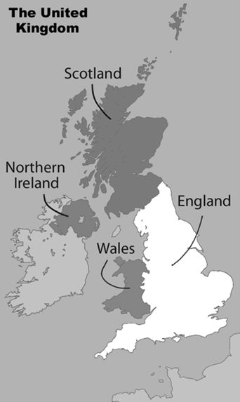
Obr. 1 a Map of the UK [1]
The UK – Geography
- The country occupies the island of _____________, approximately one-sixth of the island of _____________ and several minor islands such as the Shetland Islands, the Orkney Islands and the Isle of _____________.
- There are stunning national parks such as the _____________ National Park in England, the _____________ national park in Scotland and the _____________ National Park in Wales.
- The UK has _____________ climate and there is a lot of _____________ all year round.
- _____________ in Scotland, with its 1,344 metres above sea level, is the highest point in the UK.
The people of The UK
- __________, __________, _____________, __________ and __________ were the peoples who successively settled the British Isles.
- The population of the UK mostly consists of the __________, then
the __________, __________ and __________.
The UK – Wildlife
[Fill in the gaps and match sentences to the pictures]
- The _____ is a bird which occupies the Scottish coasts in spring and summer.
- The _____________ is a large ruminant which is abundant in the UK, particularly in Scotland.
- The _____________ is another ruminant which is plentiful in the UK.
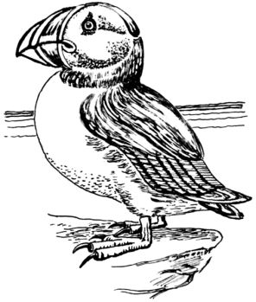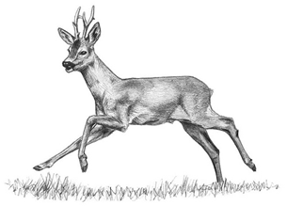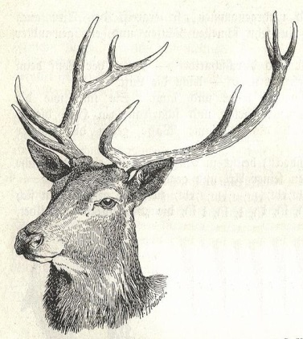
Obr. 3 an animal [3]
Obr. 2 an animal [2]
Obr. 4 an animal [4]

Popular sports and famous people
- _____________ is a popular boy band which comes from the UK.
- _____________ is a famous actor and comedian best known as Mr Bean.
- Football, which was ____________ there, is the most popular sport in the UK.
KEY TO EXERCISES (ŘEŠENÍ)

The UK – Basic Facts
- The UK is located between the North Sea and the North Atlantic Ocean.
- It is a part of Europe, but it lies on an archipelago called the British Isles.
- The population of the UK is 63 million.
- English is the major language in the UK.
The UK – Politics
- The UK is a part of the British Commonwealth.
- It is a constitutional monarchy.
- The head of state is the monarch Queen Elizabeth II.
- The head of the government is the Prime Minister.
- The parliament of the UK consists of the House of Lords and the House of Commons.
The UK – Cities
- The United Kingdom of Great Britain and Northern Ireland consists of 4 countries: England, Scotland, Wales and Northern Ireland.
- The capital city of the UK is London.
- Edinburgh is the capital of Scotland.
- Cardiff is the capital of Wales.
- Belfast is the capital of Northern Ireland.
[Write names for the four countries and their capital cities on the map bellow]
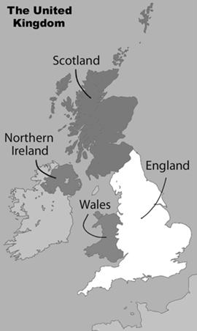
Edinburgh
Cardiff
London
Belfast
Northern Ireland
England
Scotland
Wales
Obr. 1 a Map of the UK [1]
The UK – Geography
- The country occupies the island of Great Britain, approximately one-sixth of the island of Ireland and several minor islands such as the Shetland Islands, the Orkney Islands and the Isle of Man.
- There are stunning national parks such as the Lake District National Park in England, the Loch Lomond national park in Scotland and the Snowdonia National Park in Wales.
- The UK has temperate climate and there is a lot of rainfall all year round.
- Ben Nevis in Scotland, with its 1,344 metres above sea level, is the highest point in the UK.
The people of The UK
- Celts, Romans, Anglo-Saxons, Vikings and Normans were the peoples who successively settled the British Isles.
- The population of the UK mostly consists of the English, then the Scottish, Welsh and Irish.
The UK – Wildlife
[Fill in the gaps and match sentences to the pictures]

- The puffin is a bird which occupies the Scottish coasts in spring and summer.

- The red deer is a large ruminant which is abundant
in the UK, particularly in Scotland.

- The roe deer is another ruminant which is plentiful
in the UK.
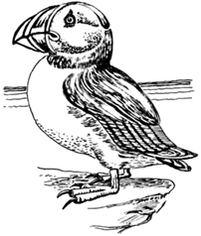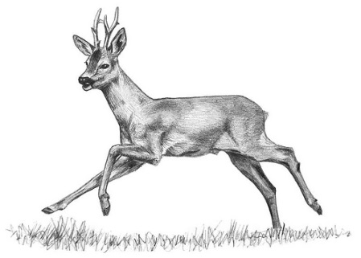
Obr. 4 an animal [4]
Obr. 3 an animal [3]
Obr. 2 an animal [2]

Popular sports and famous people
- One Direction is a popular boy band which comes from the UK.
- Rowan Atkinson is a famous actor and comedian best known as Mr Bean.
- Football, which was invented there, is the most popular sport in the UK.

References – Pictures (Zdroje obrázků):

- LEWIS, Matt. Wikimedia [online]. 2013 [cit. 2013-11-15]. Dostupné z: http://commons.wikimedia.org/wiki/File:United_Kingdom_labelled_map7.png
- FORESMAN, Pearson Scott. Wikimedia [online]. 2008 [cit. 2013-11-22]. Dostupné z: http://commons.wikimedia.org/wiki/File:Puffin_2_%28PSF%29.png
- HEUBACH, Walter. Wikimedia [online]. 2007 [cit. 2013-11-22]. Dostupné z: http://commons.wikimedia.org/wiki/File:Heubach_red_deer_head.jpg
- MEAD, Ann. Flickr [online]. 2009 [cit. 2013-11-22]. Dostupné z: http://www.flickr.com/photos/15494309@N00/3198953959/sizes/m/in/photostream/

References and Copyright (Zdroje a autorská práva):

- BBC [online]. 2013 [cit. 2013-11-15]. Dostupné z: http://www.bbc.co.uk/news/world-europe-18027954
- Nationsonline [online]. 2013 [cit. 2013-11-15]. Dostupné z: http://www.nationsonline.org/oneworld/map/united-kingdom-map.htm
- Wikipedia [online]. 2013 [cit. 2013-11-16]. Dostupné z: http://en.wikipedia.org/wiki/United_Kingdom

