Autor: | Mgr. Vít Klimeš
Název materiálu: | VY_32_INOVACE_4_ANGLICKY_JAZYK_REALIE_06  Města Spojeného království Velké Británie a Severního Irska – pracovní list
Téma sady: | ANJ - Reálie
Obor, ročník: | Ekonomické lyceum, Obchodní akademie, Veřejnosprávní činnost, Sociální činnost, 4. ročník
Datum vytvoření: | leden 2014
Anotace: | Města Spojeného království Velké Británie a Severního Irska - pracovní list, základní fakta, významná města a zajímavosti
Metodický obsah: | Ověření osvojení si učiva

Dílo smí být dále šířeno pod licencí CC BY-SA.
Materiály jsou určeny pro bezplatné používání pro potřeby výuky a vzdělávání na všech typech škol a školských zařízení. Jakékoliv další využití podléhá autorskému zákonu.
Všechna neocitovaná autorská díla jsou dílem autora.
Všechny neocitované kliparty a další grafické objekty jsou součástí prostředků výukového sw Smart Notebook a MS Office.

Cílem tohoto pracovního listu je procvičení vědomostí a ověření si osvojení informací prezentovaných v powerpointové prezentaci „Spojené království Velké Británie a Severního Irska“. Žáci v pracovním listu převážně doplňují vynechaný text tak, aby informace v něm byly fakticky i gramaticky správné. Pracovní list metodicky navazuje na prezentaci.
In all exercises fill in the gaps so that all the sentences are grammatically correct and true.

The UK – London
- London is the ______________of the UK.
- It is also the capital of__________.
- It is in the __________–east of the UK.
- The population of London is about __million.
- It is the largest city in __________.
- London lies on the River __________.
- ______________and the _________________ are two of the most displayed symbols of London.
[Fill in the gaps and match both sights to the pictures]
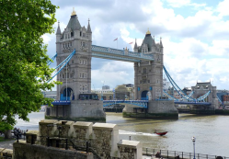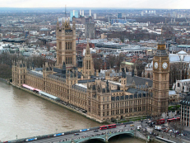
Obr. 2 a sight [2]
Obr. 1 a sight [1]

The UK – Liverpool
- Liverpool is one of the most successful __________in the North of England.
- Perhaps the most famous boy band ever “__________” came from Liverpool.
- It is on the __________coast in the northern part of the UK.
The UK – Edinburgh
- Edinburgh is the capital of __________.
- It is on the __________coast in the northern part of the UK.
- Edinburgh __________is Edinburgh's most famous attraction.
- Edinburgh __________Festival, or just “the __________,” is the largest arts festival in the world.
The UK – Glasgow
- Glasgow is the __________city in Scotland.
- It is an __________city with a rich nightlife.
- It is in the __________–west of Scotland.

The UK – Cardiff
- Cardiff is the capital of __________.
- Cardiff __________is the most popular tourist attraction in Cardiff.
- It is in the south–__________of the island of Great Britain.
The UK – Belfast
- Belfast is the capital of ______________.
- It was the scene of ______attacks, or as they themselves called it “freedom fighting”, in an attempt to leave the UK in the 20th century.
- It is in the north–east of the island of __________.

[Write names for the six cities on the lines on the map bellow]
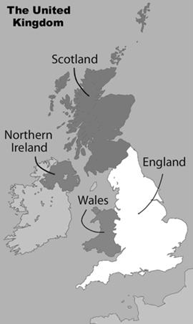

Obr. 3 a Map of the UK [3]

KEY TO EXERCISES (ŘEŠENÍ)

The UK – London
- London is the capital city of the UK.
- It is also the capital of England.
- It is in the south–east of the UK.
- The population of London is about 8 million.
- It is the largest city in Europe.
- London lies on the River Thames.
- Tower Bridge and the Houses of Parliament are two of the most often pictured symbols of London.
[Fill in the gaps and match both sights to the pictures]
Obr. 2 a sight [2]
Obr. 1 a sight [1]

The UK – Liverpool
- Liverpool is one of the most successful ports in the North of England.
- Perhaps the most famous boy band ever “The Beatles” came from Liverpool.
- It is on the west coast in the North of England.
The UK – Edinburgh
- Edinburgh is the capital of Scotland.
- It is on the east coast in the northern part of the UK.
- Edinburgh Castle is Edinburgh's most famous attraction.
- Edinburgh Fringe Festival, or just “the Fringe,” is the largest arts festival in the world.
The UK – Glasgow
- Glasgow is the largest city in Scotland.
- It is an industrial city with a rich nightlife.
- It is in the south–west of Scotland.

The UK – Cardiff
- Cardiff is the capital of Wales.
- Cardiff Castle is the most popular tourist attraction in Cardiff.
- It is in the south–west of the island of Great Britain.
The UK – Belfast
- Belfast is the capital of Northern Ireland.
- It was the scene of IRA attacks, or as they themselves called it “freedom fighting”, in an attempt to leave the UK in the 20th century.
- It is in the north–east of the island of Ireland.

[Write the names for the six cities on the lines on the map below]
Glasgow

Liverpool

Edinburgh
Cardiff
London
Belfast
Obr. 3 a Map of the UK [3]

References – Pictures (Zdroje obrázků):

- DANIKAUF. Wikimedia [online]. 2005 [cit. 2014-01-03]. Dostupné z: http://commons.wikimedia.org/wiki/File:Westminster_palace.jpg
- DUDVA. Wikimedia [online]. 2013 [cit. 2014-01-03]. Dostupné z: http://commons.wikimedia.org/wiki/File:The_Tower_Bridge_in_London.jpg
- LEWIS, Matt. Wikimedia [online]. 2013 [cit. 2013-11-15]. Dostupné z: http://commons.wikimedia.org/wiki/File:United_Kingdom_labelled_map7.png

References and Copyright (Zdroje a autorská práva):

- Victorianweb [online]. 2010 [cit. 2014-01-03]. Dostupné z: http://www.victorianweb.org/history/hist4.html
- Nationsonline [online]. 2013 [cit. 2013-11-15]. Dostupné z: http://www.nationsonline.org/oneworld/map/united-kingdom-map.htm
- Edfringe [online]. 2014 [cit. 2014-01-25]. Dostupné z: https://www.edfringe.com/

