Autor: | Mgr. Vít Klimeš
Název materiálu: | VY_32_INOVACE_4_ANGLICKY_JAZYK_REALIE_08  Spojené státy americké – pracovní list
Téma sady: | ANJ - Reálie
Obor, ročník: | Ekonomické lyceum, Obchodní akademie, Veřejnosprávní činnost, Sociální činnost, 4. ročník
Datum vytvoření: | listopad 2013
Anotace: | Spojené státy americké - pracovní list, základní fakta, geografie, fauna, významná města, vláda a politický systém
Metodický obsah: | Ověření osvojení si učiva

Dílo smí být dále šířeno pod licencí CC BY-SA.
Materiály jsou určeny pro bezplatné používání pro potřeby výuky a vzdělávání na všech typech škol a školských zařízení. Jakékoliv další využití podléhá autorskému zákonu.
Všechna neocitovaná autorská díla jsou dílem autora.
Všechny neocitované kliparty a další grafické objekty jsou součástí prostředků výukového sw Smart Notebook a MS Office.

Cílem tohoto pracovního listu je procvičení vědomostí a ověření si osvojení informací prezentovaných v powerpointové prezentaci „Spojené království Velké Británie a Severního Irska“. Žáci v pracovním listu převážně doplňují vynechaný text tak, aby informace v něm byly fakticky i gramaticky správné. Pracovní list metodicky navazuje na prezentaci.
In all exercises fill in the gaps so that all the sentences are grammatically correct and true.

The USA – Basic Facts
- The USA is located in the southern part of _____________, except _____________, which is in the north-east.
- It borders _____________ to the north and _____________ to the south.
- The USA consists of _____________.
- The _____________ the USA is 316 million.
- English is the major _____________ in the USA.
The USA – Politics
- The USA is a _____________.
- The head of state is the _____________.
- The ____________ consists of the Senate and the House of Representatives.
- The Senate has _______ members and the House of Representatives has _______ members.
The USA – Cities
- The capital city of the USA is _____________ D.C.
- _____________ is the largest city in the USA.
- _____________ is famous for its film industry.
- The Golden Gate Bridge made _____________ famous to the world.
- _____________ is the city famous for lots of casinos.
[Write names for the five cities on the map below]
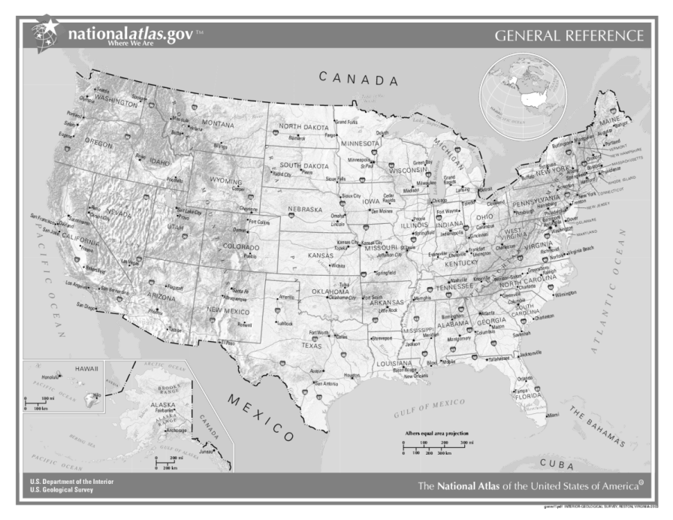

Obr. 1 a Map of the USA [1]
The USA – Geography
- It is the _____________ largest country in the world.
- There are a lot of national parks, of which _____________ National Park is possibly the most well-known.
- The _____________ is the mountain range which spreads from the north to the south across the country.
- _____________ in Alaska, with its 6,168 m metres above sea level, is the highest peak in the USA.
- The _____________ river is the longest river in North America.
The people of The USA
- The _____________ (often called Indians) are the people who occupied the continent before the colonization of the continent by the _____________ (white European) started at the end of the 15th century.
The USA – Wildlife
[Fill in the gaps and match sentences to the pictures]
- Both _____________ and _____________ bears are plentiful in the USA.
- ________ and ________ are both even-toed hoofed animals living in the USA.
- _____________ and _____________ are well-known predators of the USA.
- The _____________ is the national bird of the USA.
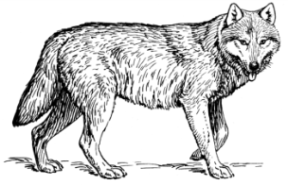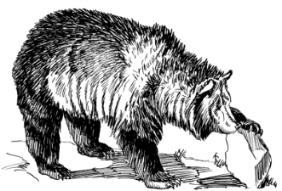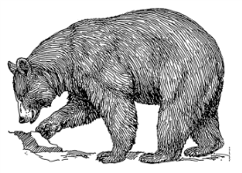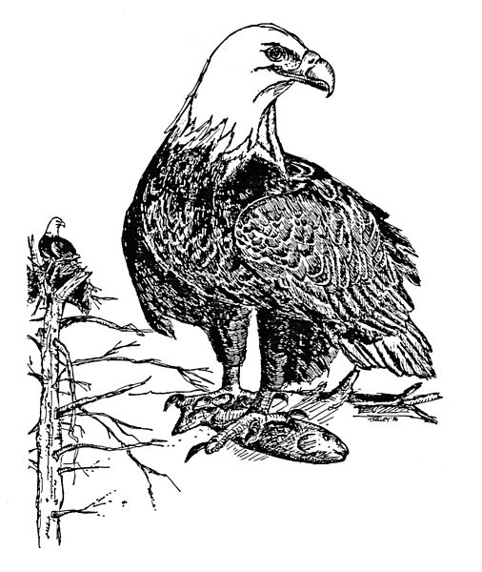
Obr. 5 an animal [5]
Obr. 3 an animal [3]
Obr. 4 an animal [4]
Obr. 2 an animal [2]
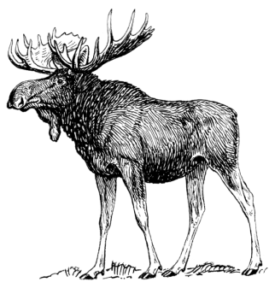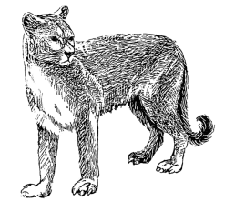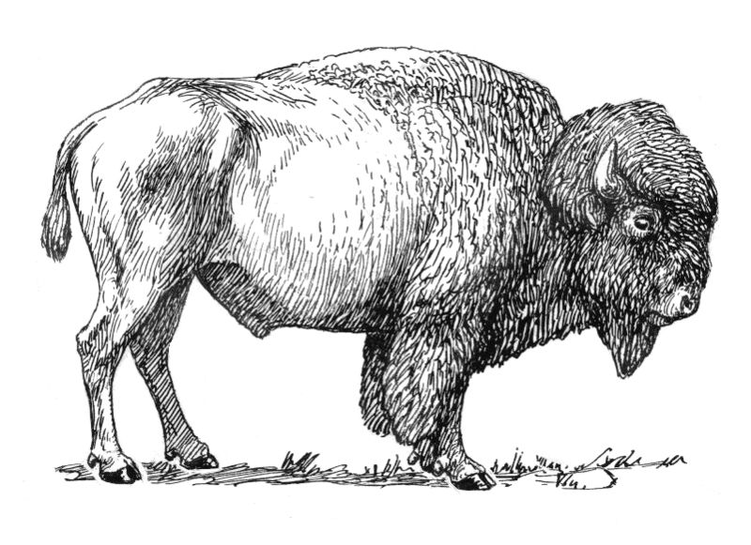
Obr. 7 an animal [7]
Obr. 8 an animal [8]
Obr. 6 an animal [6]

Popular sports and famous people
- _____________ is the current chairman and a co-founder
of Microsoft.
- _____________ is an American film director and screenwriter.
- _____________ and _____________ are the most popular sports in the USA.
- Americans also enjoy _____________, _____________, golf, tennis, etc.
KEY TO EXERCISES (ŘEŠENÍ)

The USA – Basic Facts
- The USA is located in the southern part of North America, except Alaska, which is in the north-east.
- It borders Canada to the north and Mexico to the south.
- The USA consists of 50 states.
- The population of the USA is 316 million.
- English is the major language in the USA.
The USA – Politics
- The USA is a federal republic.
- The head of state is the president.
- The Congress consists of the Senate and the House of Representatives.
- The Senate has 100 members and the House of Representatives has 435 members.
The USA – Cities
- The capital city of the USA is Washington D.C.
- New York is the largest city in the USA.
- Los Angeles is famous for its film industry.
- The Golden Gate Bridge made San Francisco famous to the world.
- Las Vegas is the city famous for lots of casinos.
[Write names for the five cities on the map below]
New York
Washington D.C.
Los Angeles
San Francisco
Las Vegas

Obr. 1 a Map of the USA [1]

The USA – Geography
- It is the fourth largest country in the world.
- There are a lot of national parks, of which Yellowstone National Park is possibly the most well-known.
- The Rocky Mountains is the mountain range which spreads from the north to the south across the country.
- Mount McKinley in Alaska, with its 6,168 m metres above sea level, is the highest peak in the USA.
- The Mississippi river is the longest river in North America.
The people of The USA
- The Native Americans (often called Indians) are the people who occupied the continent before the colonization of the continent by the Caucasians (white European) started at the end of the 15th century.
The USA – Wildlife
[Fill in the gaps and match sentences to the pictures]
- Both grizzly and black bears are plentiful in the USA.
- Bison and moose are both even-toed hoofed animals living in the USA.
- Cougars and wolves are well-known predators of the USA.
- The Bald Eagle is the national bird of the USA.
Obr. 5 an animal [5]
Obr. 3 an animal [3]
Obr. 4 an animal [4]
Obr. 2 an animal [2]
Obr. 7 an animal [7]
Obr. 8 an animal [8]
Obr. 6 an animal [6]

Popular sports and famous people
- Bill Gates is the current chairman and a co-founder
of Microsoft.
- Steven Allan Spielberg is an American film director and screenwriter.
- American football and baseball are the most popular sports in the USA.
- Americans also enjoy basketball, ice-hockey, golf, tennis, etc.

References – Pictures (Zdroje obrázků):

- Wikipedia [online]. 2004 [cit. 2013-12-14]. Dostupné z: http://cs.wikipedia.org/wiki/Soubor:US_map_-_geographic.png
- Wikimedia [online]. 2009 [cit. 2013-10-19]. Dostupné z: http://commons.wikimedia.org/wiki/File:Wolf_(PSF).png
- Wikimedia [online]. 2008 [cit. 2013-10-19]. Dostupné z: http://commons.wikimedia.org/wiki/File:Grizzly_bear_(PSF).png
- Wikimedia [online]. 2008 [cit. 2013-10-19]. Dostupné z: http://commons.wikimedia.org/wiki/File:Black_bear_(PSF).png
- KELLEY, Tom. Wikimedia [online]. 2013 [cit. 2013-12-16]. Dostupné z: http://commons.wikimedia.org/wiki/File:Bald_eagle_hand_drawing_haliaeetus_leucocephalus.jpg
- Wikimedia [online]. 2009 [cit. 2013-10-19]. Dostupné z: http://commons.wikimedia.org/wiki/File:Moose_(PSF).png
- Wikimedia [online]. 2008 [cit. 2013-10-19]. Dostupné z: http://commons.wikimedia.org/wiki/File:Cougar_(PSF).png
- Wikimedia [online]. 2007 [cit. 2013-10-19]. Dostupné z: http://commons.wikimedia.org/wiki/File:Bison_(PSF).jpg

References and Copyright (Zdroje a autorská práva):

- BBC [online]. 2013 [cit. 2013-12-14]. Dostupné z: http://www.bbc.co.uk/news/world-us-canada-16759230
- Wikipedia [online]. 2013 [cit. 2013-12-14]. Dostupné z: http://en.wikipedia.org/wiki/United_States

