Autor: | Mgr. Vít Klimeš
Název materiálu: | VY_32_INOVACE_4_ANGLICKY_JAZYK_REALIE_10  New York – pracovní list
Téma sady: | ANJ - Reálie
Obor, ročník: | Ekonomické lyceum, Obchodní akademie, Veřejnosprávní činnost, Sociální činnost, 4. ročník
Datum vytvoření: | leden 2014
Anotace: | New York - pracovní list, základní fakta, historie, důležitá místa, zajímavosti
Metodický obsah: | Ověření osvojení si učiva

Dílo smí být dále šířeno pod licencí CC BY-SA.
Materiály jsou určeny pro bezplatné používání pro potřeby výuky a vzdělávání na všech typech škol a školských zařízení. Jakékoliv další využití podléhá autorskému zákonu.
Všechna neocitovaná autorská díla jsou dílem autora.
Všechny neocitované kliparty a další grafické objekty jsou součástí prostředků výukového sw Smart Notebook a MS Office.

Cílem tohoto pracovního listu je procvičení vědomostí a ověření si osvojení informací prezentovaných v powerpointové prezentaci „Spojené království Velké Británie a Severního Irska“. Žáci v pracovním listu převážně doplňují vynechaný text tak, aby informace v něm byly fakticky i gramaticky správné. Pracovní list metodicky navazuje na prezentaci.

In all exercises fill in the gaps so that all the sentences are grammatically correct and true.
New York
- New York is the __________ city in the USA.
- It is located in the state of __________.
- It is in the north–_______of the USA.
[Mark New York in the correct box on the map below]
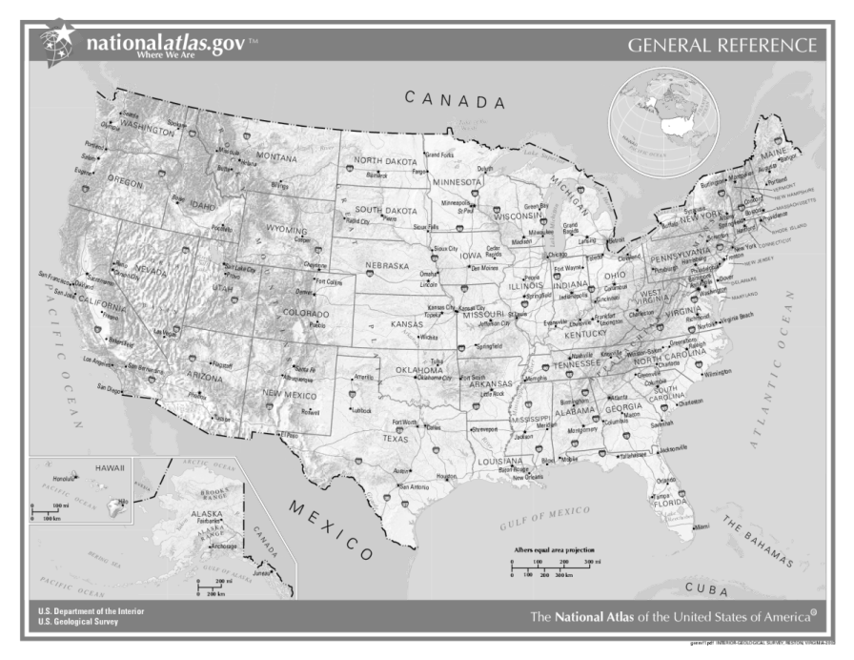
Obr. 1 a Map of the USA [1]

New York – Basic Facts - History
- It was founded by Dutch settlers in 1626 when they bought the island of __________ from the Native Americans for $24.
- It was first called __________ .
- English gained New Amsterdam in the second half of the _______century and renamed it New York.
New York – Basic Facts
- The population of New York is over __million.
- New York lies on the __________ River.
- Its nickname is the __________.

New York – Basic Facts
- New York is divided into five boroughs: __________, the _______, ________, __________ and __________.
[Write names for the five boroughs on the map below]
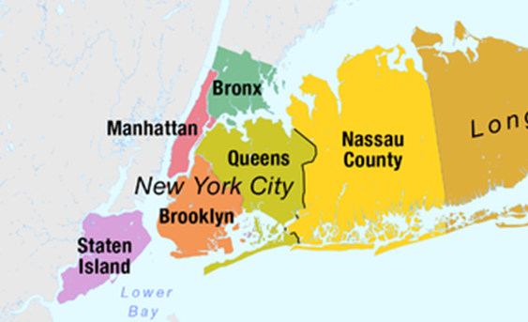
Obr.2 the five boroughs of New York on a map [2]

Island

New York – Famous Places
- __________ in Manhattan is a famous financial centre.
- The ______International Airport is located in the borough of Queens.
- __________ is a prominent residential area located in Brooklyn.
- __________ , especially the part between 49th Street and 60th Street, is one of the most expensive shopping streets in the world.
New York – Other Places to Visit
- The __________ , located on ______Island, was a gift to the United States from France in 1886.
- The __________ which is 381 metres high, is located in Manhattan.
- __________ is a large public urban park located in the borough of Manhattan.

KEY TO EXERCISES (ŘEŠENÍ)
New York
- New York is the largest city in the USA.
- It is located in the state of New York.
- It is in the north–east of the USA.
[Mark New York in the correct box on the map below]
Obr. 1 a Map of the USA [1]
New York

New York – Basic Facts - History
- It was founded by Dutch settlers in 1626 when they bought the island of Manhattan from the Native Americans for $24.
- It was first called New Amsterdam.
- English gained New Amsterdam in the second half of the 17th century and renamed it New York.
New York – Basic Facts
- The population of New York is over 8 million.
- New York lies on the Hudson River.
- Its nickname is the Big Apple.

New York – Basic Facts
- New York is divided into five boroughs: Manhattan, the Bronx, Queens, Brooklyn and Staten Island.
[Write names for the five boroughs on the map below]
Obr.2 the five boroughs of New York on a map [2]
Manhattan
Bronx
Queens
Brooklyn
Staten Island Island

New York – Famous Places
- Wall Street in Manhattan is a famous financial centre.
- The J.F.K. International Airport is located in the borough of Queens.
- Brooklyn Heights is a prominent residential area located in Brooklyn.
- Fifth Avenue, especially the part between 49th Street and 60th Street, is one of the most expensive shopping streets in the world.
New York – Other Places to Visit
- The Statue of Liberty, located on Liberty Island, was a gift to the United States from France in 1886.
- The Empire State Building, which is 381 metres high, is located in Manhattan.
- Central Park is a large public urban park located in the borough of Manhattan.

References – Pictures (Zdroje obrázků):

- Wikipedia [online]. 2004 [cit. 2013-12-14]. Dostupné z: http://cs.wikipedia.org/wiki/Soubor:US_map_-_geographic.png
- DÖRRBECKER, Maximilian. <i>Wikimedia</i> [online]. 2013 [cit. 2014-01-01]. Dostupné z: http://commons.wikimedia.org/wiki/File:Map_of_the_Boroughs_of_New_York_City_and_the_counties_of_Long_Island.png

References and Copyright (Zdroje a autorská práva):

- Newyork [online]. 2014 [cit. 2014-01-01]. Dostupné z: http://www.newyork.com/resources/history-new-york-city/
- Wikipedia [online]. 2014 [cit. 2014-01-01]. Dostupné z: http://en.wikipedia.org/wiki/New_York_City
- <i>Statueofliberty</i> [online]. 2012 [cit. 2014-01-01]. Dostupné z: http://www.statueoflibertytickets.com/Statue-Of-Liberty/?show=history
- EL-HMOUDOVÁ, Dagmar. <i>Angličtina maturitní témata</i>. Třebíč: Petra Velanová, 2006. ISBN 978-80-86873-04-6

