Autor: | Mgr. Vít Klimeš
Název materiálu: | VY_32_INOVACE_4_ANGLICKY_JAZYK_REALIE_12  Města USA - pracovní list
Téma sady: | ANJ - Reálie
Obor, ročník: | Ekonomické lyceum, Obchodní akademie, Veřejnosprávní činnost, Sociální činnost, 4. ročník
Datum vytvoření: | leden 2014
Anotace: | Města USA - pracovní list, základní fakta, významná města a zajímavosti
Metodický obsah: | Ověření osvojení si učiva

Dílo smí být dále šířeno pod licencí CC BY-SA.
Materiály jsou určeny pro bezplatné používání pro potřeby výuky a vzdělávání na všech typech škol a školských zařízení. Jakékoliv další využití podléhá autorskému zákonu.
Všechna neocitovaná autorská díla jsou dílem autora.
Všechny neocitované kliparty a další grafické objekty jsou součástí prostředků výukového sw Smart Notebook a MS Office.

Cílem tohoto pracovního listu je procvičení vědomostí a ověření si osvojení informací prezentovaných v powerpointové prezentaci „Spojené království Velké Británie a Severního Irska“. Žáci v pracovním listu převážně doplňují vynechaný text tak, aby informace v něm byly fakticky i gramaticky správné. Pracovní list metodicky navazuje na prezentaci.
In all exercises fill in the gaps so that all the sentences are grammatically correct and true.

The USA – cities
- Washington D.C. is located in the District of ______________.
- The ______________is the official residence and workplace of the President of the United States, located in Washington D.C..
- The __________________, in Washington D.C., was built in honour of the first American president – George Washington.
The USA – Cities
- The capital city of the USA is ______________ .
- ______________is the largest city in the USA.
- The Statue of ______________is the most famous symbol of New York.
- ______________ is a famous suspension bridge connecting the boroughs of Manhattan and Brooklyn.
The USA – Cities
- ______________is famous for its film industry and it is the second largest city in the USA.
- It is located in the state of ______________.
- ______________ is a famous part of Los Angeles and home of the entertainment industry.
- ____________________, on Hollywood Boulevard, is known for having stars with the names of famous people from the entertainment industry embedded in its pavement.
The USA – Cities
- San Francisco is located in the state of ______________.
- The San Francisco ____________car system is one of the symbols of the city.
- _________Prison, on the island of _______, is notorious all around the world.
The USA – Cities
- ______________is the city famous for having lots of casinos.
- It is located in the state of ______________.

The USA – Cities
- ______________is the city where the Declaration of Independence was signed in 1776.
- It is located in the state of ______________.
- [Write names for the six cities on the map below]
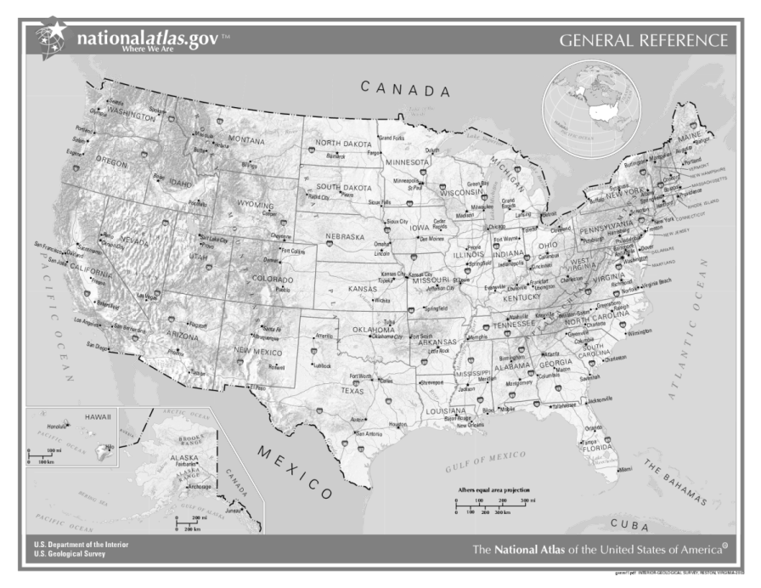

Obr. 1 a Map of the USA [1]

- [Write names for the sights in the boxes below the pictures]
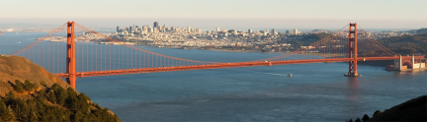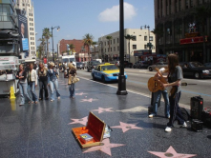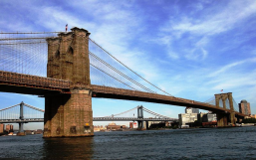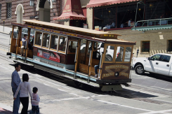

Obr. 5 a sight [5]
Obr. 4 a sight [4]
Obr. 3 a sight [3]
Obr. 2 a sight [2]

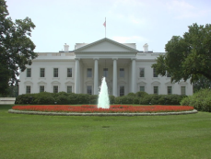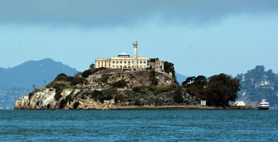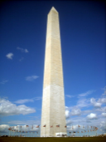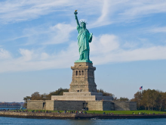

Obr. 9 a sight [9]
Obr. 8 a sight [8] ht [2]
Obr. 6 a sight [6]
Obr. 7 a sight [7]

KEY TO EXERCISES (ŘEŠENÍ)

The USA – cities
- Washington D.C. is located in the District of Columbia.
- The White House is the official residence and workplace of the President of the United States, located in Washington D.C..
- The Washington Monument, in Washington D.C., was built in honour of the first American president – George Washington.
The USA – Cities
- The capital city of the USA is Washington D.C.
- New York is the largest city in the USA.
- The Statue of Liberty is the most famous symbol of New York.
- The Brooklyn Bridge is a famous suspension bridge connecting the boroughs of Manhattan and Brooklyn.
The USA – Cities
- Los Angeles is famous for its film industry and it is the second largest city in the USA.
- It is located in the state of California.
- Hollywood is a famous part of Los Angeles and home of the entertainment industry.
- The Walk of Fame, on Hollywood Boulevard, is known for having stars with the names of famous people from the entertainment industry embedded in its pavement.
The USA – Cities
- San Francisco is located in the state of California.
- The San Francisco cable car system is one of the symbols of the city.
- Alcatraz Prison, on the island of Alcatraz, is notorious all around the world.
The USA – Cities
- Las Vegas is the city famous for having lots of casinos.
- It is located in the state of Nevada.

The USA – Cities
- Philadelphia is the city where the Declaration of Independence was signed in 1776.
- It is located in the state of Pennsylvania.
- [Write names for the six cities on the map below]
Philadelphia

New York
Washington D.C.
Los Angeles
San Francisco
Las Vegas

Obr. 1 a Map of the USA [1]

- [Write names for the sights in the boxes below the pictures]
the Cable Car System
the Brooklyn Bridge
the Walk of Fame
the Golden Gate Bridge
Obr. 5 a sight [5]
Obr. 4 a sight [4]
Obr. 3 a sight [3]
Obr. 2 a sight [2]

the Statue of Liberty
the Washington Monument
the White House
Alcatraz Prison
Obr. 9 a sight [9]
Obr. 8 a sight [8] ht [2]
Obr. 6 a sight [6]
Obr. 7 a sight [7]

References – Pictures (Zdroje obrázků):

- Wikipedia [online]. 2004 [cit. 2013-12-14]. Dostupné z: http://cs.wikipedia.org/wiki/Soubor:US_map_-_geographic.png
- MEHLFÜHRER, Christian. Fotopedia [online]. 2009 [cit. 2014-01-13]. Dostupné z: http://www.fotopedia.com/items/chmehl-DRYFAoyGolY
- LLOYD, Owen. Wikipedia [online]. 2006 [cit. 2014-01-11]. Dostupné z: http://en.wikipedia.org/wiki/File:Hollywood_Walk_of_Fame.jpg
- AGRAWAL, Ankur. Wikimedia [online]. 2012 [cit. 2014-01-11]. Dostupné z:http://commons.wikimedia.org/wiki/File:Brooklyn_Bridge_as_seen_from_FDR_Drive_in_Manhattan.JPG
- BACHMANN, Thomas. Wikimedia [online]. 2005 [cit. 2014-01-11]. Dostupné z: http://commons.wikimedia.org/wiki/File:Cable_Car.jpg
- Wikimedia [online]. 2005 [cit. 2014-01-11]. Dostupné z: http://commons.wikimedia.org/wiki/File:White_House_Northern_Side.jpg
- WPPILOT. Wikipedia [online]. 2013 [cit. 2014-01-11]. Dostupné z: http://en.wikipedia.org/wiki/File:Alcatraz_Island_photo_D_Ramey_Logan.jpg
- AGNOSTICPREACHERSKID. Wikimedia [online]. 2009 [cit. 2014-01-11]. Dostupné z: http://commons.wikimedia.org/wiki/File:Washington_Monument_-_Washington,_D.C..jpg
- WARBY, William. Wikimedia [online]. 2009 [cit. 2014-01-01]. Dostupné z: http://commons.wikimedia.org/wiki/File:Statue_of_Liberty,_NY.jpg

References and Copyright (Zdroje a autorská práva):

- Wikipedia [online]. 2014 [cit. 2014-01-20]. Dostupné z: http://en.wikipedia.org/wiki/Brooklyn_Bridge
- Wikipedia [online]. 2014 [cit. 2014-01-20]. Dostupné z: http://en.wikipedia.org/wiki/Hollywood_Walk_of_Fame
- Wikipedia [online]. 2014 [cit. 2014-01-20]. Dostupné z: http://en.wikipedia.org/wiki/Philadelphia

