Autor: | Mgr. Vít Klimeš
Název materiálu: | VY_32_INOVACE_4_ANGLICKY_JAZYK_REALIE_18  New Zealand – pracovní list
Téma sady: | ANJ - Reálie
Obor, ročník: | Veřejnosprávní činnost/Sociální činnost, 4. ročník
Datum vytvoření: | Únor 2013
Anotace: | Nový Zéland, základní fakta, geografie, fauna, významná města, vláda a politický systém
Metodický obsah: | Ověření osvojení si učiva

Dílo smí být dále šířeno pod licencí CC BY-SA.
Materiály jsou určeny pro bezplatné používání pro potřeby výuky a vzdělávání na všech typech škol a školských zařízení. Jakékoliv další využití podléhá autorskému zákonu.
Všechna neocitovaná autorská díla jsou dílem autora.
Všechny neocitované kliparty a další grafické objekty jsou součástí prostředků výukového sw Smart Notebook a MS Office.

Cílem tohoto pracovního listu je procvičení vědomostí a ověření si osvojení informací prezentovaných v powerpointové prezentaci „New Zealand“. Žáci v pracovním listu převážně doplňují vynechaný text tak, aby informace v něm byly fakticky i gramaticky správné. Pracovní list metodicky navazuje na prezentaci.

In all exercises fill in the gaps so that all the sentences are grammatically correct and true.

New Zealand – Basic Facts
- New Zealand is _____________ in the South Pacific.
- It lies 2.000 km from _____________.
- The _____________ of New Zealand is about 4 million.
- Both _____________ and _____________ are official languages in New Zealand.
New Zealand – Politics
- New Zealand is a part of the British _________________.
- It is a constitutional _____________.
- The ____________________ is the monarch of the United Kingdom.
- Her/His representative is the _____________________.
- The head of the government is the ____________________.
New Zealand – Cities
- The capital city of New Zealand is _____________.
- _____________ is New Zealand’s largest city.
- _____________ is the largest city on the South Island.
- _____________ is a university town.
[Write names for the four cities on the map bellow]
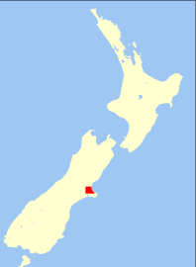
Obr. 1 a Map of New Zealand [1]
New Zealand – Geography
- New Zealand ________________ two main islands and several minor islands.
- The _____________ Island is warmer than the _____________ Island.
- The _____________ Island is more mountainous.
- The North Island is smaller than the South Island but has _____________ of the country’s population.
- Winter lasts from __________ to __________ and summer from _____________ to _____________.
The people of New Zealand
- The _____________ settled in New Zealand in the 13th century.
- The first Europeans started settling New Zealand in the ____century.
New Zealand – Wildlife
[Fill in the gaps and match sentences to the pictures]
- The _____________ is a parrot which can’t fly.
- The _____________ is a unique kind of reptile.
- The _____________ is the symbol of the country.
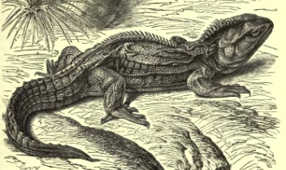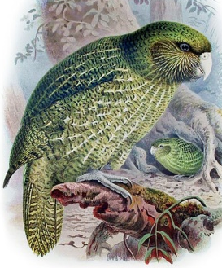
Obr. 4 a bird [4]
Obr. 3 a bird [3]
Obr. 2 an animal [2]

Popular sports and famous people
- The actor Russell _____________ comes from New Zealand.
- _________________was a mountaineer who was the first to climb Mount Everest.
- _________________is the most popular sport.
- _____________ is a popular summer sport.

KEY TO EXERCISES (ŘEŠENÍ)

New Zealand – Basic Facts
located
- New Zealand is _____________ in the South Pacific.
Australia
- It lies 2.000 km from _____________.
population
- The _____________ of New Zealand is about 4 million.
Maori
English
- Both _____________ and _____________ are official languages in New Zealand.
New Zealand – Politics
Commonwealth
- New Zealand is a part of the British _________________.
monarchy
- It is a constitutional _____________.
head of state
- The ____________________ is the monarch of the United Kingdom.
Governor General
- Her/His representative is the _____________________.
Prime Minister
- The head of the government is the ____________________.
New Zealand – Cities
Wellington
- The capital city of New Zealand is _____________.
Auckland
- _____________ is New Zealand’s largest city.
Christchurch
- _____________ is the largest city on the South Island.
Dunedin
- _____________ is a university town.
[Write names for the four cities on the map bellow]
Christchurch
Dunedin
Wellington
Auckland
Obr. 1 a Map of New Zealand [1]
New Zealand – Geography
consists of
- New Zealand ________________ two main islands and several minor islands.
South
North
- The _____________ Island is warmer than the _____________ Island.
South
- The _____________ Island is more mountainous.
three quarters
- The North Island is smaller than the South Island but has _____________ of the country’s population.
August
June
- Winter lasts from __________ to __________ and summer from _____________ to _____________.
February
December
The people of New Zealand
Maori
- The _____________ settled in New Zealand in the 13th century.
19th hhh
- The first Europeans started settling New Zealand in the ____century.
New Zealand – Wildlife
[Fill in the gaps and match sentences to the pictures]
kakapo
- The _____________ is a parrot which can’t fly.
tuatara
- The _____________ is a unique kind of reptile.

kiwi
- The _____________ is the symbol of the country.

Obr. 4 a bird [4]
Obr. 3 a bird [3]
Obr. 2 an animal [2]

Popular sports and famous people
Crowe
- The actor Russell _____________ comes from New Zealand.
Edmund Hillary
- _________________was a mountaineer who was the first to climb Mount Everest.
Rugby Union
- _________________is the most popular sport.
Cricket
- _____________ is a popular summer sport.

References – Pictures (Zdroje obrázků):

- Wikimedia [online]. 2011 [cit. 2013-03-16]. Dostupné z: http://commons.wikimedia.org/wiki/File:Christchurch,_New_Zealand_map.svg
- Wikimedia [online]. 2009 [cit. 2013-03-16]. Dostupné z: http://commons.wikimedia.org/wiki/File:TuataraLyd.jpg
- Pixabay [online]. 2013 [cit. 2013-03-16]. Dostupné z: http://pixabay.com/cs/nov%C3%A9-skica-silueta-kreslen%C3%BD-film-33884/
- Wikimedia [online]. 2012 [cit. 2013-03-16]. Dostupné z: http://commons.wikimedia.org/wiki/File:Buller_Kakapo.jpg

References and Copyright (Zdroje a autorská práva):

- NewScientist [online]. 2008 [cit. 2013-03-13]. Dostupné z: http://www.newscientist.com/article/mg19826595.200-rat-remains-help-date-new-zealands-colonisation.html
- Wikipedia [online]. 2013 [cit. 2013-03-13]. Dostupné z: http://en.wikipedia.org/wiki/M%C4%81ori_people#cite_ref-7
- BBC [online]. 2013 [cit. 2013-03-13]. Dostupné z: http://www.bbc.co.uk/news/world-asia-pacific-15370160

