Autor: | Mgr. Vít Klimeš
Název materiálu: | VY_32_INOVACE_4_ANGLICKY_JAZYK_REALIE_20  Commonwealth - pracovní list
Téma sady: | ANJ - Reálie
Obor, ročník: | Ekonomické lyceum, Obchodní akademie, Veřejnosprávní činnost, Sociální činnost, 4. ročník
Datum vytvoření: | leden 2014
Anotace: | Commonwealth - pracovní list – základní fakta, členské státy a oblasti působnosti
Metodický obsah: | Ověření osvojení si učiva

Dílo smí být dále šířeno pod licencí CC BY-SA.
Materiály jsou určeny pro bezplatné používání pro potřeby výuky a vzdělávání na všech typech škol a školských zařízení. Jakékoliv další využití podléhá autorskému zákonu.
Všechna neocitovaná autorská díla jsou dílem autora.
Všechny neocitované kliparty a další grafické objekty jsou součástí prostředků výukového sw Smart Notebook a MS Office.

Cílem tohoto pracovního listu je procvičení vědomostí a ověření si osvojení informací prezentovaných v powerpointové prezentaci „Spojené království Velké Británie a Severního Irska“. Žáci v pracovním listu převážně doplňují vynechaný text tak, aby informace v něm byly fakticky i gramaticky správné. Pracovní list metodicky navazuje na prezentaci.
In all exercises fill in the gaps so that all the sentences are grammatically correct and true.

The Commonwealth of Nations – Basic Facts
- The Commonwealth of Nations is an _________________ organisation that consists of ______ member states, mostly former territories of the past British Empire.
- It was constituted by the _________________ Declaration in 1949.
- It works by intergovernmental _________________.
- The _________________ the Commonwealth is Queen Elizabeth II.
- Her role includes a number of _________________ functions.
The Commonwealth of Nations – Member States
- As declared in the London Declaration all the member states are "_____________________”.
[Write names for the six countries on the map bellow]
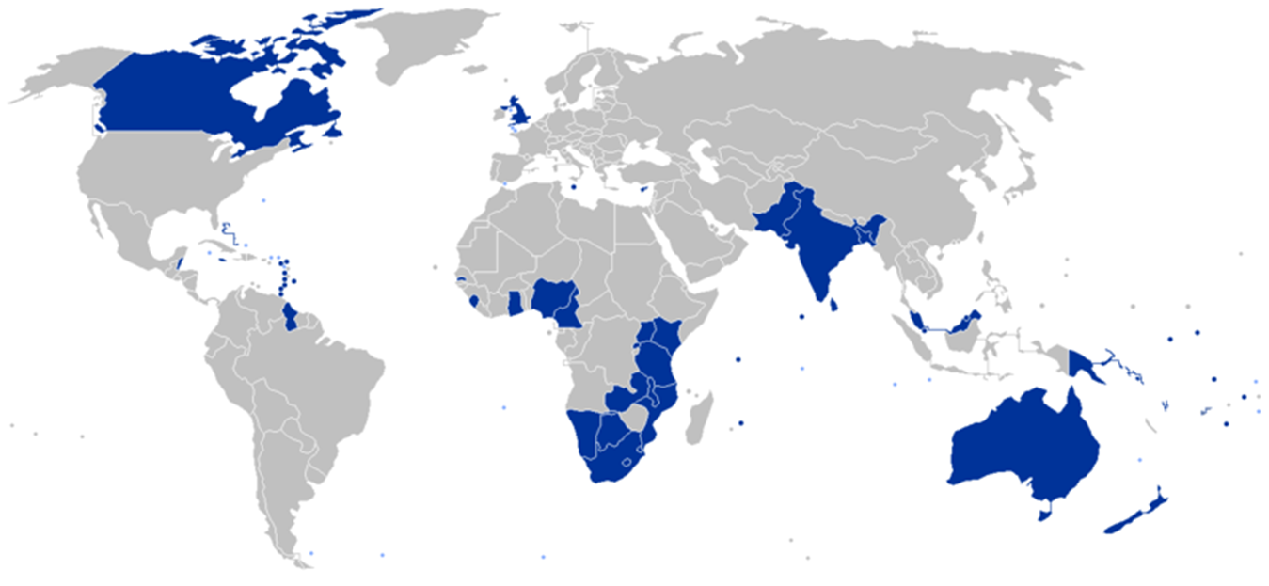

Obr. 1 The Commonwealth of Nations on a map [1]

The Commonwealth of Nations – Member States – American continents
- _____________ is the largest member state of the Commonwealth.
- Considering Central American member states, we can mention __________ or __________.
- __________ is a Commonwealth member state located in the north of South America.
The Commonwealth of Nations – Member States – Asia
- There are also some former territories of the British Empire in Asia which are part of the Commonwealth such as (write 3 countries) _______________, _______________, _______________.
The Commonwealth of Nations – Member States – Australia and Oceania
- _____________ and _____________ are the largest countries
in Australia and Oceania which are the member states of the Commonwealth of Nations.
The Commonwealth of Nations – Member States – Africa
- There are 18 of the member states in Africa e.g.: (write 3 countries) _______________, _______________, _______________.
The Commonwealth of Nations – Member States – Europe
- The _____________, _____________ and _____________ are the Commonwealth member states located in Europe.
The Commonwealth of Nations – fields of activities
- Commonwealth organisations work in a lot of different fields such as _____________ and _____________ development, law, _____________ issues, _____________ and so on.

- The __________________ is the third largest sporting event in the world, which takes place every ___ years and the next one will be held in Scotland in 2014.

KEY TO EXERCISES (ŘEŠENÍ)

The Commonwealth of Nations – Basic Facts
- The Commonwealth of Nations is an intergovernmental organisation that consists of 53 member states, mostly former territories of the past British Empire.
- It was constituted by the London Declaration in 1949.
- It works by intergovernmental consensus.
- The head of the Commonwealth is Queen Elizabeth II.
- Her role includes a number of symbolic functions.
The Commonwealth of Nations – Member States
- As declared in the London Declaration all the member states are "free and equal”.
[Write names for the six countries on the map bellow]
Kenya

Australia
India
South Africa
Canada

New Zealand
Obr. 1 The Commonwealth of Nations on a map [1]

The Commonwealth of Nations – Member States – American continents
- Canada is the largest member state of the Commonwealth.
- Considering Central American member states we can mention Jamaica or
the Bahamas.
- Guyana is a Commonwealth member state located in the north of South America.
The Commonwealth of Nations – Member States – Asia
- There are also some former territories of the British Empire in Asia which are part of the Commonwealth such as (write 3 countries): Possible answers: India, Pakistan, Malaysia, Bangladesh, Sri Lanka and so on.
The Commonwealth of Nations – Member States – Australia and Oceania
- Australia and New Zealand are the largest countries
in Australia and Oceania which are the member states of the Commonwealth of Nations.
The Commonwealth of Nations – Member States – Africa
- There are 18 of the member states in Africa e.g.: (write 3 countries) Possible answers: South Africa, Kenya, Tanzania, Botswana, Cameroon and so on.
The Commonwealth of Nations – Member States – Europe
- The United Kingdom, Malta and Cyprus are the Commonwealth member states located in Europe.
The Commonwealth of Nations – fields of activities
- Commonwealth organisations work in a lot of different fields such as economic and social development, law, environmental issues, education and so on.

- The Commonwealth Games is the third largest sporting event in the world, which takes place every four years and the next one will be held in Scotland in 2014.

References – Pictures (Zdroje obrázků):

- BASTIN8. <i>Wikimedia</i> [online]. 2009 [cit. 2013-12-27]. Dostupné z: http://commons.wikimedia.org/wiki/File:Commonwealth_of_Nations_members_with_territories.png

References and Copyright (Zdroje a autorská práva):

- Commonwealth [online]. 2013 [cit. 2013-12-27]. Dostupné z: http://thecommonwealth.org/
- Wikipedia [online]. 2013 [cit. 2013-12-27]. Dostupné z: http://en.wikipedia.org/wiki/Commonwealth_of_Nations
- Wikipedia [online]. 2013 [cit. 2013-12-27]. Dostupné z: http://en.wikipedia.org/wiki/Commonwealth_Games

