

Datum: 5. 3. 2013
Projekt: Kvalitní výuka
Registrační číslo: CZ.1.07/1.5.00/34.0731
Číslo DUM: VY_22_INOVACE_50
Jméno autora: Mgr. Barbora Studená
Název práce: Invention timeline
Předmět: angličtina
Ročník: 2
Časová dotace: 45 minut
Vzdělávací cíl: Procvičit si trpný rod na konkrétních příkladech z historie vynálezů.
Pomůcky: Pracovní list, psací potřeby.
Poznámka: Studenti pracují samostatně na úkolu číslo 1. a pak ve dvojicích na úkolu 2.
Inovace: Pracovní list, se kterým studenti pracují, jim umožní si procvičit a upevnit novou látku, kterou je trpný rod.

Worksheet Invention timeline Passive voice Past simple
- Put the following inventions in the right order.
1593 |  |  |  |  |  |  | 1971
 | p. cooker |  |  |  |  | laser
Nationality ? (just guess)
 | 1960 | Laser was invented by Theodore Harold Maiman ..............................
 | 1971 | E-mail was invented by Ray Tomlinson …………………
 | 1928 | Antibiotics were invented by Alexander Fleming …………………
 | 1877 | Phonograph was invented by Thomas Alva Edison …………………
 | 1769 | Steam engine was invented by James Watt ………………….
 | 1593 | Thermometer was invented by Galileo Galilei ………………….
 | 1834 | Combine harvester was invented by Hiram Moore ………………….
 | 1679 | Pressure cooker was invented by Denis Papin ………………….
- Grammar: Choose one of the sentences above and change it into passive present perfect. You can make more changes in the sentence.
………………………………………………………………………………………………………………………………………………..
Now again:
A.What was invented by James Watt?.......................................
B. What did Denis Papin work on?...............................................................
C. Mr. Maiman invented laser in…………………………………….
D. When were the antibiotics invented?..................................................................
E. Phongraph was invented by…………………………………………..
F. When did the thermometer originated?...................................................
G. Hiram Moore introduced his new invention in………………………, it was………………………………………..
Grammar: Which or the previous sentences are written in a passive, which are in an active voice?
Active:………………………………………Passive……………………………….
- Your opinion:
Which invention is the most useful?.........................................................................................
Invention saving time is/are……………………energy……………………lives……………………………..
Which invention you thought was invented much earlier?........................................................
Nationality? Could you match the inventors with their nationalities? There are: Italian, American 3x, French, Scot 2x, Jewish American
- Match the names with the pictures of the inventors……………………………………… ………………………………………………………………………………………………..

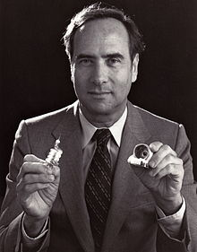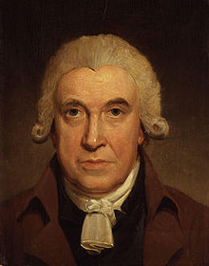
A…………………………….. B…………………………….
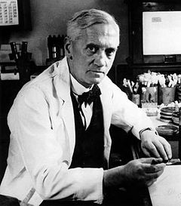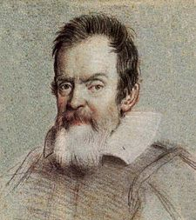
C......................................... D.....................................
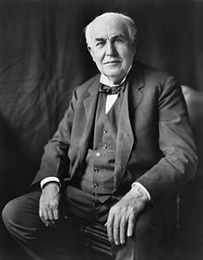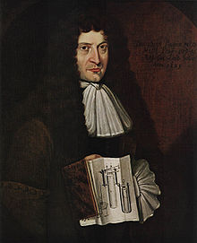
E…………………………………………………. F………………………………………………

Solution:

Worksheet Invention timeline Passive voice Past simple
- Put the following inventions in the right order.
1593 | 1674 | 1764 | 1834 | 1874 | 1928 | 1960 | 1971
Tomlinson | p. cooker | Steam engine | Combine harvester | Photography | Antibiotics | laser | e-mail
Nationality ? (just guess)
 | 1960 | Laser was invented by Theodore Harold Maiman Jewish American
 | 1971 | E-mail was invented by Ray Tomlinson American
 | 1928 | Antibiotics were invented by Alexander Fleming Scot
 | 1877 | Phonograph was invented by Thomas Alva Edison American
 | 1769 | Steam engine was invented by James Watt Scot
 | 1593 | Thermometer was invented by Galileo Galilei Italian
 | 1834 | Combine harvester was invented by Hiram Moore American
 | 1679 | Pressure cooker was invented by Denis Papin French
- Grammar: Choose one of the sentences above and change it into passive present perfect. You can make more changes in the sentence. More possible answers
Now again:
A.What was invented by James Watt? Steam engine
B. What did Denis Papin work on? Pressure cooker
C. Mr. Maiman invented laser in 1960
D. When were the antibiotics invented? 1928
E. Phongraph was invented by T.A.Edison
F. When did the thermometer originated? 1594
G. Hiram Moore introduced his new invention in 1834 it was combine harvester
Grammar: Which or the previous sentences are written in a passive, which are in an active voice?
Active: CFG Passive: ADE
- Your opinion:
Which invention is the most useful? More possible answers
Invention saving time is students’ own answer energy……………………………….. lives………………………..
Which invention you thought was invented much earlier? More possible answers
Nationality? Could you match the inventors with their nationalities? There are: Italian, American 3x, French, Scot 2x, Jewish American
- Match the names with the pictures of the inventors ……………………………………..

Pictures: A Maiman B Watt C Fleming D Galileo E Edison F Papin

Použitá literatura:

SOARS, Liz and John: New Headway, Pre-intermediate – Teacher´s Book, Oxford University Press, Oxford, 2007, ISBN 978-0-19-471585-0.
http://www.history-timelines.org.uk/events-timelines/09-inventions-timeline.htm
Pictures: Wikimedia commons.org

