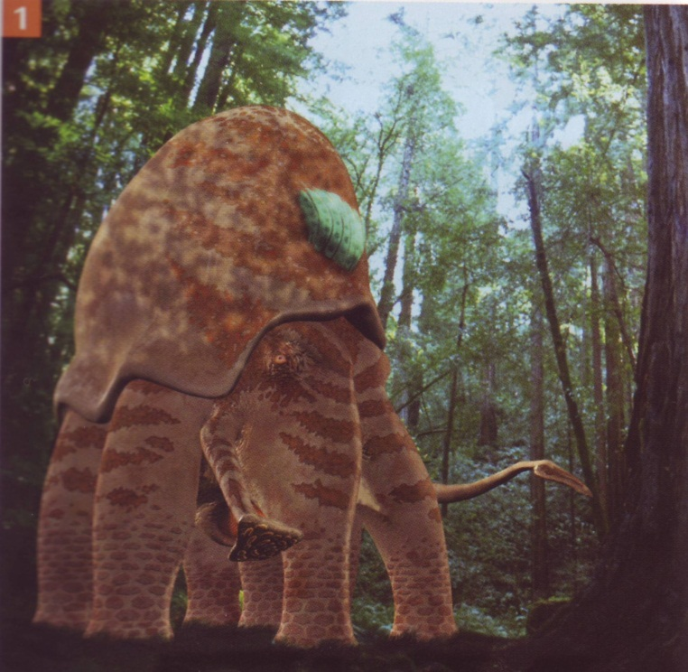
Instruction:
Talk about the animal to your partners. Then write how the animal looks and where it lives. Invent the animal´s name - you can combine other real names. Write how the animal can help people or how it can be dangerous. Be creative and tell more information about the creature.
____________________________________________________________________________________________________________________________________________________________________________________________________________________________________________________________________________________________________________________________________________________________________________________________________________________________________________________________________________________________________________________________________________________________________________________________________________________________________________________________________________________

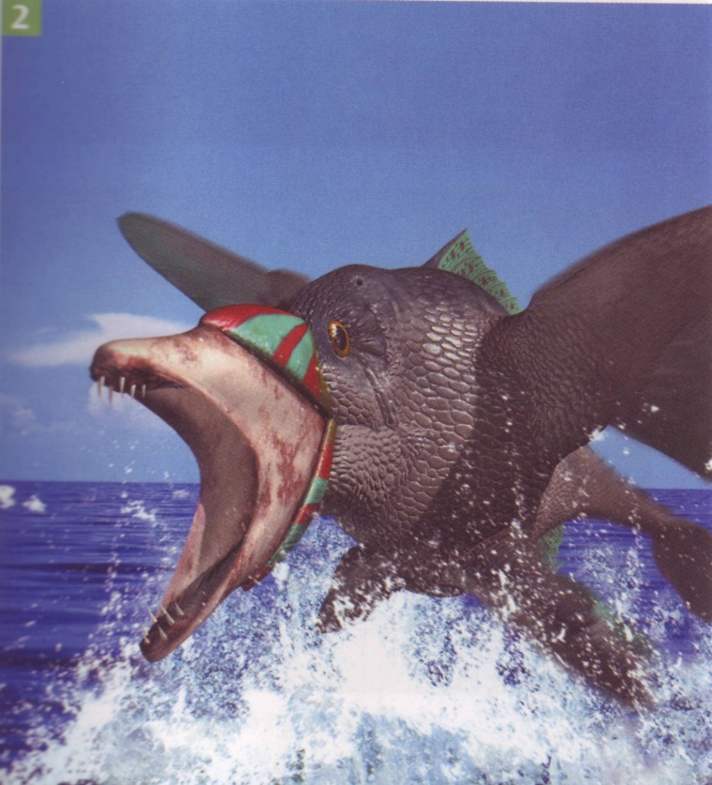
Instruction:
Talk about the animal to your partners. Then write how the animal looks and where it lives. Invent the animal´s name - you can combine other real names. Write how the animal can help people or how it can be dangerous. Be creative and tell more information about the creature.
___________________________________________________________________________________________________________________________________________________________________________________________________________________________________________________________________________________________________________________________________________________________________________________________________________________________________________________________________________________________________________________________________________________________________________________________________________________________________________________

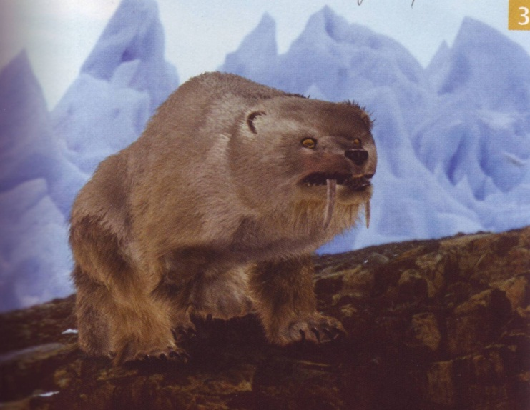
Instruction:
Talk about the animal to your partners. Then write how the animal looks and where it lives. Invent the animal´s name - you can combine other real names. Write how the animal can help people or how it can be dangerous. Be creative and tell more information about the creature.

__________________________________________________________________________________________________________________________________________________________________________________________________________________________________________________________________________________________________________________________________________________________________________________________________________________________________________________________________________________________________________________________________________________________________________________________________________________________________________________________________________________

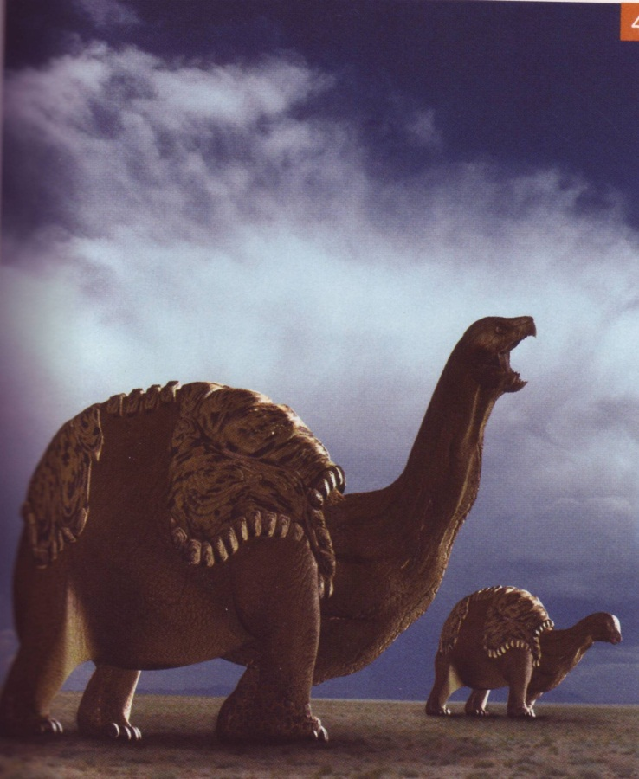
Instruction:
Talk about the animal to your partners. Then write how the animal looks and where it lives. Invent the animal´s name - you can combine other real names. Write how the animal can help people or how it can be dangerous. Be creative and tell more information about the creature.
__________________________________________________________________________________________________________________________________________________________________________________________________________________________________________________________________________________________________________________________________________________________________________________________________________________________________________________________________________________________________________________________________________________________________________________________________________________________________________________________________________________

