

Autor: Mgr. Magda Knapová



WHAT´S THE RESULT? COUNT.
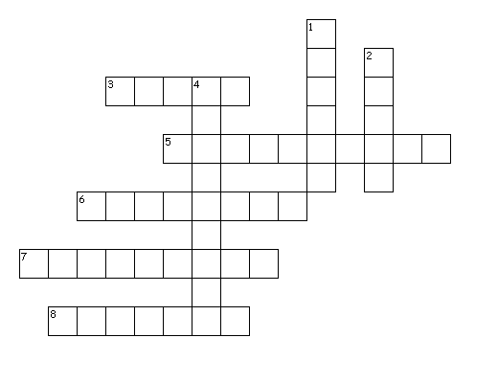
Across
3. 25+25
5. 8x9
6. 3x6
7. 8x8
8. 50+50
Down
1. 100-70
2. 30+30
4. 20+1

