

Autor: Mgr. Magda Knapová



WHAT´S THE TIME?

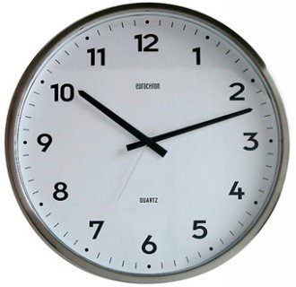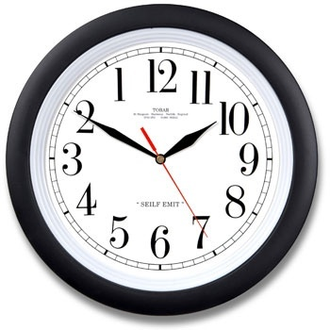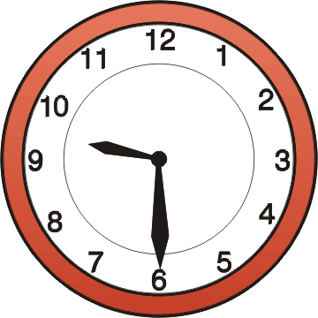
………………………………………………………………………………………………………………………………………………………………………………………………………
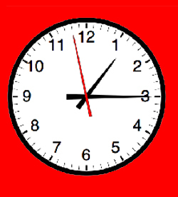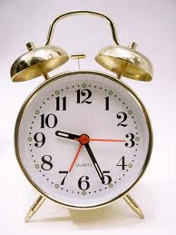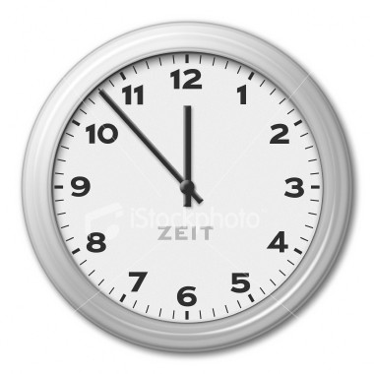

………………………………………………………………………………………………………………………………………………………………………………………………………

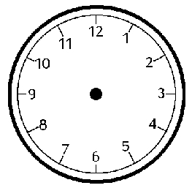

HALF PAST ONE QUARTER TO SIX QUARTER PAST EIGHT

