THE TIME
Autor: | Mgr. Denisa Havlíková
Datum: | Říjen 2011
Ročník: | 6.
Vzdělávací obor: | Anglický jazyk
Anotace: | Pracovní list určený k procvičování času.

WHAT TIME IS IT, PLEASE?

- LOOK AT THE WATCHES. WRITE THE TIMES.

1 2 3

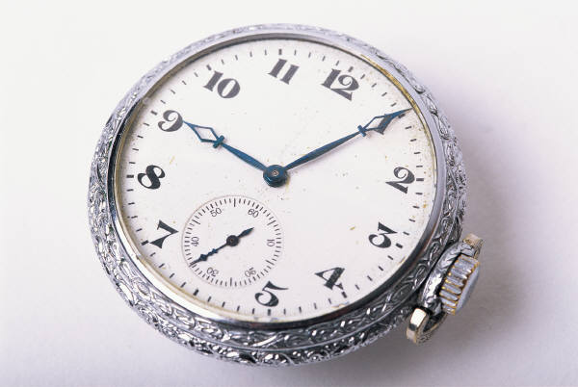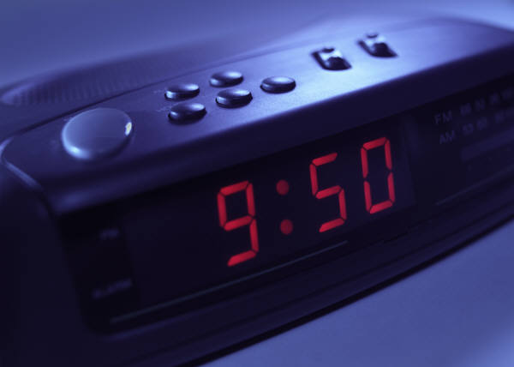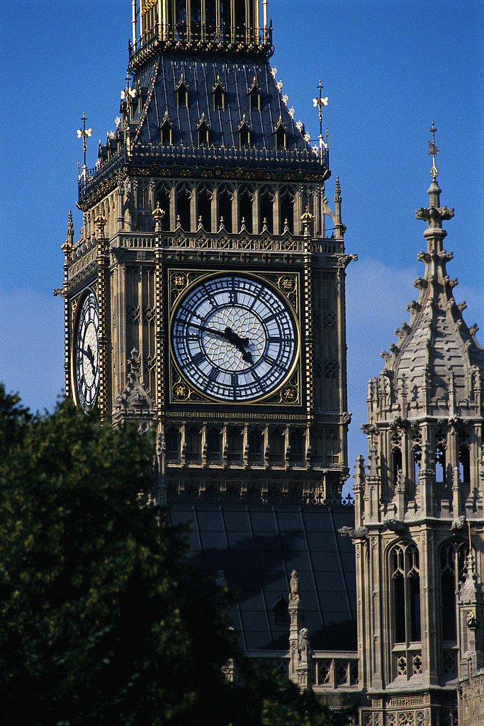

4 5

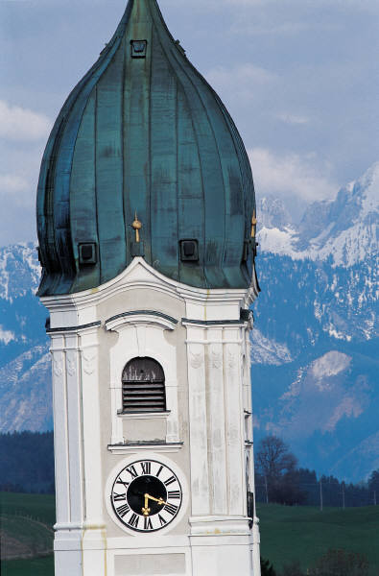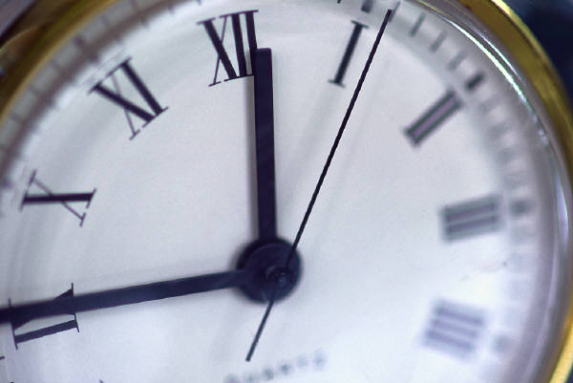

- WRITE THE TIMES.

- IT´S QUARTER PAST TWO =
- IT´S TWENTY – FIVE TO FOUR =
- IT´S TEN TO SIX =
- IT´S HALF PAST ELEVEN =
- IT´S QUARTER TO NINE =

- WRITE THE SENTENCES. USE THE CUES.

- MONDAY – 8:00 – HISTORY TEST.
- TUESDAY – 12:30 – HAVE LUNCH.
- WEDNESDAY – 9:15 – DENTIST.
- THURSDAY – 5:00 – 6:00 – HOMEWORK.
- FRIDAY – 7:30 – CLASS PARTY
- SATURDAY – 3:45 – HANDBALL MATCH
- SUNDAY – 2:20 – SHOPPING

- COMPLETE THE PREPOSITIONS IN, ON, AT.

- …………… THE EVENING
- …………… SATURDAY
- …………… FIVE TO FIVE
- …………… JULY
- …………… NIGHT
- …………… FRIDAY MORNING
- …………… 1 MARCH
- …………… EASTER
- …………… THE PARTY
- ……………ONE O´CLOCK

- DESCRIBE YOUR IDEAL DAY. WHAT WOULD YOU LIKE TO DO?

ZDROJE: Vlastní zdroje autora.
OBRÁZKY: www. microsoft.office.com

