
Název školy: | Střední škola dopravy, obchodu a služeb
Autor: | Mgr. Dana Pokorná
Název projektu: | Zlepšení podmínek výuky
Číslo projektu: | CZ.1.07/1.5.00/34.0661
Název tematické oblasti: | Gramatika a slovní zásoba
Název učebního materiálu | VY-22-PK-04 PASSIVE
Datum vytvoření: | 10. 9. 2012
Datum ověření ve výuce: | 13. 9. 2012
Anotace: | Materiál je určen pro 1. až 4. ročník SŠ; procvičuje, opakuje nebo testuje znalost trpného rodu v přítomném, minulém a budoucím čase na jednom pracovním listu, a tím žákům usnadňuje práci při studiu tohoto gramatického jevu
Metodický pokyn: | Materiál je možno vytisknout a kopírovat jako pracovní list nebo lze použít dataprojektor

Použité zdroje: Archiv autora

Put the sentences into the passive.


- Everybody celebrates Christmas. 15) Alexander G. Bell invented telephone.


________________________________________ _______________________________________
2) We borrow books from the library. 16) Nobody listened to music.

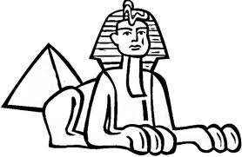
________________________________________ _______________________________________
3) People built pyramids lots of years ago. 17) They water flowers every day.
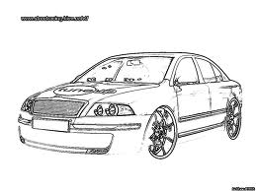
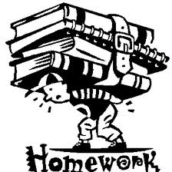
________________________________________ _______________________________________
4) Pupils do homework at home. 18) They make Škoda cars in Czechia.


________________________________________ _______________________________________
- They will build a new bridge next year. 19) Mum bakes delicious cakes.
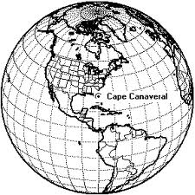

________________________________________ _______________________________________
6) Christopher Columbus discovered America. 20) They will translate his latest novel.

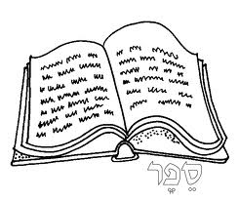
________________________________________ _______________________________________
- Charles Dickens wrote Oliver Twist. 21) He doesn’t understand that letter.

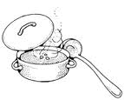
________________________________________ _______________________________________
8) They serve goulash with dumplings. 22) They teach Russian at this school.

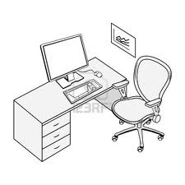
________________________________________ _______________________________________
- They clean the offices every afternoon. 23) They sell only notebooks there.

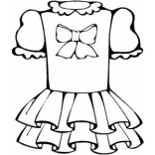
________________________________________ _______________________________________
10) They didn’t buy a new dress. 24) They don’t pronounce that word correctly.
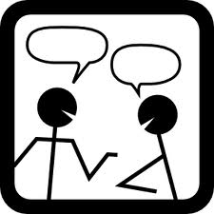

________________________________________ _______________________________________
- We will paint the house in a month. 25) People speak English everywhere.

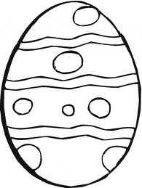
________________________________________ _______________________________________
12) People keep wild animals in the ZOO. 26) People send cards before Easter.
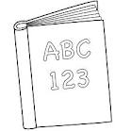

________________________________________ _______________________________________
- He will repair it tomorrow. 27) We practise grammar every lesson.
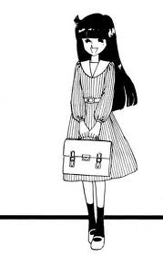
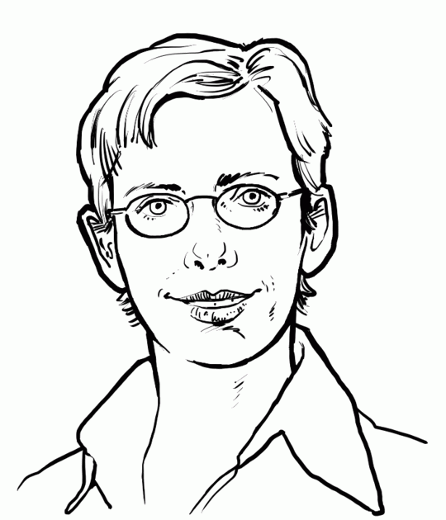
________________________________________ _______________________________________
14) They invited Jane to the party. 28) Children in the UK wear uniforms.
________________________________________ _______________________________________
Put the questions into the passive.

- Will you buy the flowers? 11) When did they close this post office?
________________________________________ _______________________________________
- Do they answer the question? 12) Why did they forget that event?
________________________________________ _______________________________________
- Why do they make the same mistakes? 13) Do you often read any magazines about cars?
________________________________________ _______________________________________
- Do they make whisky in Scotland? 14) Can you pay the bill?
________________________________________ _______________________________________
- Did they win the match? 15) Where did you lose your watch?
________________________________________ _______________________________________
- Will anybody tell the story? 16) Do people drink much water?
________________________________________ _______________________________________
- Did you invite him? 17) How often do you watch TV?
_______________________________________ _______________________________________
- Do people grow any herbs in the gardens? 18) Will you send an e-mail?
_______________________________________ _______________________________________
- Why did they write so many letters? 19) Do people celebrate Easter?
_______________________________________ _______________________________________
- Will they repair the red car? 20) When do you serve lunch?
_______________________________________ _______________________________________

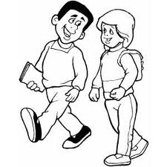

Put the sentences into the passive. KEY
- Everybody celebrates Christmas. 15) Alexander G. Bell invented telephone.
_____Christmas is celebrated.________________ ______Telephone was invented…____________
2) We borrow books from the library. 16) Nobody listened to music.
_____Books are borrowed… _________________ ______Music wasn’t listened to… ___________
3) People built pyramids lots of years ago. 17) They water flowers every day.
_______Pyramids were built …_______________ ______Flowers are watered…_______________
4) Pupils do homework at home. 18) They make Škoda cars in Czechia.
_______Homework is done … ________________ _______Škoda cars are made …_____________
- They will build a new bridge next year. 19) Mum bakes delicious cakes.
_______A new bridge will be built …__________ ______Delicious cakes are baked …__________
6) Christopher Columbus discovered America. 20) They will translate his latest novel.
_______America was discovered …____________ ______His latest novel will be translated …____
7) Charles Dickens wrote Oliver Twist. 21) He doesn’t understand that letter.
________Oliver Twist was written…___________ ______That letter isn’t understood…__________
8) They serve goulash with dumplings. 22) They teach Russian at this school.
________Goulash is served with dumplings._____ _______Russian is taught …________________
- They clean the offices every afternoon. 23) They sell only notebooks there.
________The offices are cleaned…____________ _______Only notebooks are sold…___________
10) They didn’t buy a new dress. 24) They don’t pronounce that word correctly.
________A new dress wasn’t bought.___________ _______That word isn’t pronounced…________
11) We will paint the house in a month. 25) People speak English everywhere.
________The house will be painted…__________ ________English is spoken…_______________
12) People keep wild animals in the ZOO. 26) People send cards before Easter.
________Wild animals are kept…_____________ ________Cards are sent…__________________
- He will repair it tomorrow. 27) We practise grammar every lesson.
________It will be repaired…_________________ ________Grammar is practised…____________
14) They invited Jane to the party. 28) Children in the UK wear uniforms.
________Jane was invited…__________________ _________Uniforms are worn…_____________
Put the questions into the passive.

- Will you buy the flowers? 11) When did they close this post office?
________Will the flowers be bought? __________ ___When was the post office closed?__________
- Do they answer the question? 12) Why did they forget that event?
________Is the question answered? ____________ ___Why was that event forgotten? ___________
- Why do they make the same mistakes? 13) Do you often read any magazines about cars?
________Why are the same mistakes made? _____ ___Are any magazines about cars often read?___
- Do they make whisky in Scotland? 14) Can you pay the bill?
________Is whisky made in Scotland? _________ ___Can the bill be paid? ___________________
- Did they win the match? 15) Where did you lose your watch?
________Was the match won? ________________ ___Where was your watch lost? _____________
- Will anybody tell the story? 16) Do people drink much water?
________Will the story be told? ______________ ____Is much water drunk? __________________
- Did you invite him? 17) How often do you watch TV?
________Was he invited? ___________________ ___How often is TV watched? ______________
- Do people grow any herbs in the gardens? 18) Will you send an e-mail?
________Are any herbs grown in the garden? ____ ____Will an e-mail be sent? ________________
- Why did they write so many letters? 19) Do people celebrate Easter?
________Why were so many letters written? ____ ___Is Easter celebrated? ___________________
- Will they repair the red car? 20) When do you serve lunch?
________Will the red car be repaired? __________ ___When is lunch served? __________________

