

Základní škola, Klášterec nad Ohří,
Krátká 676, okres Chomutov
Název školy: ZŠ Klášterec nad Ohří, Krátká 676
Název materiálu: VY_32_INOVACE_07_42_short answers
Autor: Lenka Špillerová
Číslo projektu: CZ.1.07/1.4.00/21.1115

Anotace: Pracovní list k souhrnnému opakování krátkých opovědí v přítomném čase. Žák si přečte otázku a dopíše k ní krátkou odpověď.

zdroje obrázků:
- www.office.microsoft.com
- http://www.animationlibrary.com/
Can a jump?................................. Can swim ? ....................................
Does a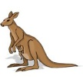have wings? .............................Do 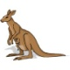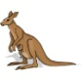live in Australia? ........................
Is a 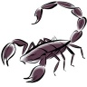dangerous? ..................................Are birds? .......................................
Has a 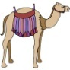got a tail? ............................... Have 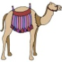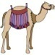got long legs?..............................
Does a eat meat? ............................. Doeat bamboo? ..........................
Has a 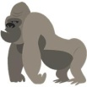 got four legs?..........................Do 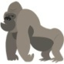have teeth? ..............................
Is a 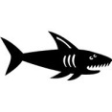a sea animal? .............................. Are fish? .....................................
Does a  live in Australia? ........................Do live in cold places? ................
Is a a bird? ..........................................Can fly? .........................................
Does a  swim? ....................................Dosing? ............................................
Are 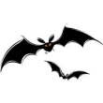red? .......................................... Is a 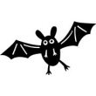a mammal? ........................................
Do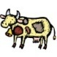live in the zoo? ..............................Does a 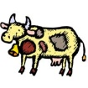drink milk? ................................
Does a 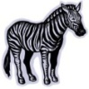live in Africa? ...............................Are pets? ................................
Is a 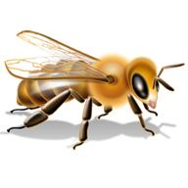an insect? ........................................Do 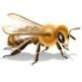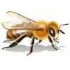have 4 legs? ..........................
Does a 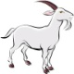live on farms? ........................... Do live in deserts? ..........................
Can a jump? Yes, it can. Can swim ? No, the can´t.
Does ahave wings? No, it doesn´t. Do live in Australia? Yes, they do.
Is a dangerous? Yes, it is. Are birds? No, they aren´t.
Has a got a tail? Yes, it has. Have got long legs? Yes, they have.
Does a eat meat? No, it doesn´t. Doeat bamboo? Yes, they do.
Has a got four legs? Yes, it has. Do have teeth? Yes. they do.
Is a sea animal? Yes, it is. Are fish? Yes, they are.
Does a  live in Australia? No, it doesn´t. Do live in cold places? Yes, they do.
Is a a bird? Yes, it is. Can fly? No, they can´t.
Does a swim? Yes, it does. Dosing? No, they don´t .
Are red? No, they aren´t. Is a a mammal? Yes, it is.
Dolive in the zoo? No, they don´t. Does a drink milk? No, it doesn´t.
Does a live in Africa? Yes, it does. Are pets? Yes, they are.
Is a an insect? Yes, it is. Do have 4 legs? No, they don´t.
Does a live on farms? Yes, it does. Do live in deserts? No, they don´t.

