Název školy: Základní škola Městec Králové

Autor: Mgr. Marcela Kloučková

Název: VY_32_INOVACE_12_Aj6

Téma: Opakování – minulý čas

Číslo projektu: CZ.1.07/1.4.00/21.2313

Anotace: Tento pracovní list obsahuje úkoly zaměřené na procvičení minulého času prostého u pravidelných i nepravidelných sloves.

Datum: 6. 1. 2013

Past Simple (Revision) – Worksheet

A) There are 8 anagrams of verbs. Can you solve them?

Put the verbs into the past tense.

Tick (√) the regular verbs.

Example: eden – need – needed √

peska - tyas –

awnt – ridev –

ritew – tachw –

kame – cyrra –

Find 15 verbs in the word search puzzle and write the past simple of these verbs.
G | O | B | J | S | E | A | G | E | T
K | J | A | R | E | V | A | P | W | E
I | L | F | U | A | S | T | O | P | I
Q | L | D | N | F | J | Z | I | O | B
E | S | I | N | F | E | E | L | S | R
W | A | R | K | S | M | L | S | T | E
M | Z | T | C | E | W | P | E | U | A
P | L | A | Y | C | B | I | E | D | K
Y | D | R | I | N | K | T | M | Y | S
G | Y | M | E | E | T | X | A | D | O

Complete the sentences. Put the verbs in brackets into the past tense.

Example: I lived in Spain in 1999. (live)

Tom ___________ a new motorbike. (buy)

I ___________ a birthday party last Friday. (have)

My parents ___________ in the USA. (work)

Peter and Jane ___________ this photo. (take)

Mrs Smith ___________ her finger. (cut)

We ___________ very happy. (be)

Make these sentences negative.

Example: I went to school yesterday. I didn’t go to school yesterday.

Amy fell off her bike on Friday.

The film started at 6 pm.

I got up at 5 am at the weekend.

Lucy came home early.

They used the computer yesterday.

My brother was in Prague last week.

Make questions in the past simple.

Example: I broke my leg last week. When did you break your leg?

They finished their homework at seven o’clock.

When _____________________________________________?

I met my best friend at the bus stop.

Where _____________________________________________?

Harry sent her a postcard.

What _____________________________________________?

Mr Green arrived on Monday.

When _____________________________________________?

I ate spaghetti and tomatoes because I was hungry.

Why _____________________________________________?

I was at home yesterday.

Where _____________________________________________?

Answer the questions.

What did you do yesterday?

Did you play computer games yesterday?

When did you get up yesterday?
- What did you have for lunch yesterday?
- Where were you last summer?

- What did they do? Use the pictures and make sentences in the past simple.

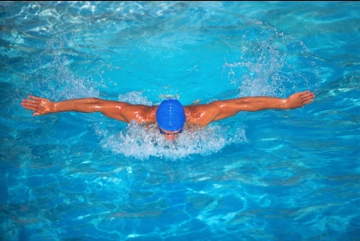
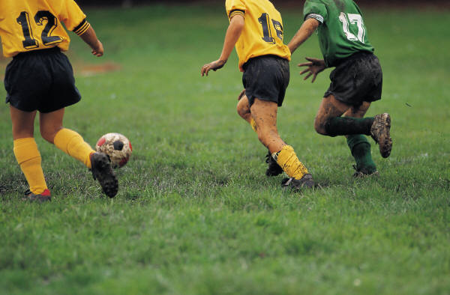

[1] [2] [3]

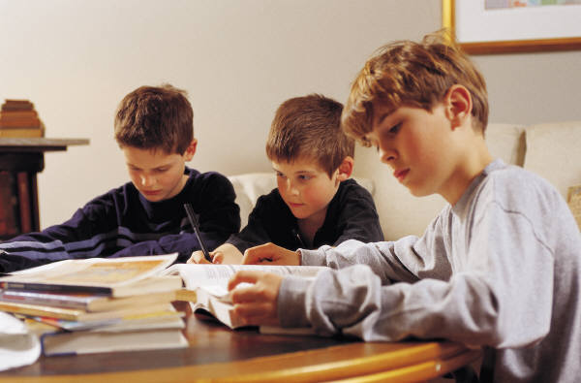
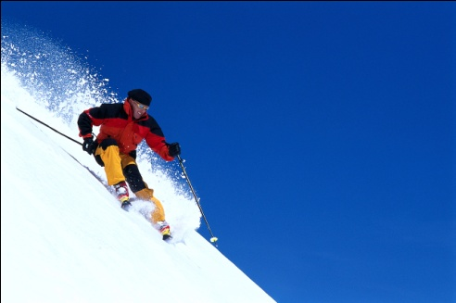
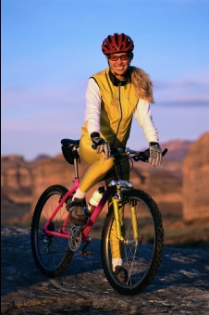

[4] [5] [6]

ANSWER KEY

Past Simple (Revision) – Worksheet

A) There are 8 anagrams of verbs. Can you solve them?

Put the verbs into the past tense.

Tick (√) the regular verbs.

Example: eden – need – needed √

peska - speak – spoke tyas – stay – stayed √

awnt – want – wanted √ ridev – drive – drove

ritew – write – wrote tachw – watch – watched √

kame –make – made cyrra – carry – carried √

Find 15 verbs in the word search puzzle and write the past simple of these verbs.
G | O | B | J | S | E | A | G | E | T
K | J | A | R | E | V | A | P | W | E
I | L | F | U | A | S | T | O | P | I
Q | L | D | N | F | J | Z | I | O | B
E | S | I | N | F | E | E | L | S | R
W | A | R | K | S | M | L | S | T | E
M | Z | T | C | E | W | P | E | U | A
P | L | A | Y | C | B | I | E | D | K
Y | D | R | I | N | K | T | M | Y | S
G | Y | M | E | E | T | X | A | D | O

do – did break –broke drink – drank

get – got go – went eat – ate

feel – felt like – liked meet - met

play – played run – ran see - saw

stop – stopped study – studied swim - swam

Complete the sentences. Put the verbs in brackets into the past tense.

Example: I lived in Spain in 1999. (live)

Tom bought a new motorbike. (buy)

I had a birthday party last Friday. (have)

My parents worked in the USA. (work)

Peter and Jane took this photo. (take)

Mrs Smith cut her finger. (cut)

We were very happy. (be)

Make these sentences negative.

Example: I went to school yesterday. I didn’t go to school yesterday.

Amy fell off her bike on Friday. Amy didn’t fall off her bike on Friday.

The film started at 6 pm. The film didn’t start at 6 pm.

I got up at 5 am at the weekend. I didn’t get up at 5 am at the weekend.

Lucy came home early. Lucy didn’t come home early.

They used the computer yesterday. They didn’t use the computer yesterday.

My brother was in Prague last week. My brother wasn’t in Prague last week.

Make questions in the past simple.

Example: I broke my leg last week. When did you break your leg?

They finished their homework at seven o’clock.

When did they finish their homework?

I met my best friend at the bus stop.

Where did you meet your best friend?

Harry sent her a postcard.

What did Harry send her?

Mr Green arrived on Monday.

When did Mr Green arrive?

I ate spaghetti and tomatoes because I was hungry.

Why did you eat spaghetti and tomatoes?

I was at home yesterday.

Where were you yesterday?

Answer the questions. (Pupils’ own answers)

What did you do yesterday? I …

Did you play computer games yesterday? Yes, I did. / No, I didn’t.

When did you get up yesterday? I got up at …
- What did you have for lunch yesterday? I had … for lunch.
- Where were you last summer? I was …

- What did they do? Use the pictures and make sentences in the past simple.

[1]They played football. [2] He swam. [3] She drank (tea, coffee).

. [4] She rode a bike. [5] He skied. [6]They did their homework.

Zdroje
[1] Football. Office.com [online]. 2013 [cit. 2013-01-03]. Dostupné z: http://office.microsoft.com/cs-cz/images/results.aspx?qu=football&ex=1#ai:MP900262246|
[2] Swim. Office.com [online]. 2013 [cit. 2013-01-03]. Dostupné z: http://office.microsoft.com/cs-cz/images/results.aspx?qu=swim&ex=1#ai:MP900406777|
[3] Drink. Office.com [online]. 2013 [cit. 2013-01-03]. Dostupné z: http://office.microsoft.com/cs-cz/images/results.aspx?qu=drink&ex=1#ai:MP900448527|mt:2|
[4] Bike. Office.com [online]. 2013 [cit. 2013-01-03]. Dostupné z: http://office.microsoft.com/cs-cz/images/results.aspx?qu=bike&ex=1#ai:MP900399534|
[5] Ski. Office.com [online]. 2013 [cit. 2013-01-03]. Dostupné z: http://office.microsoft.com/cs-cz/images/results.aspx?qu=ski&ex=1#ai:MP900399404|mt:2|
[6] Homework. Office.com [online]. 2013 [cit. 2013-01-03]. Dostupné z: http://office.microsoft.com/cs-cz/images/results.aspx?qu=homework&ex=1#ai:MP900308962|

