Název školy: Základní škola Městec Králové

Autor: Mgr. Marcela Kloučková

Název: VY_32_INOVACE_16_Aj6

Téma: Podstatná jména – členy, množství
Stravování

Číslo projektu: CZ.1.07/1.4.00/21.2313

Anotace: Tento pracovní list obsahuje úkoly na procvičení počitatelných a nepočitatelných podstatných jmen, včetně určení množství a používání členů. Slovní zásoba je zaměřena především na stravování.

Datum: 6. 1. 2013

Countable and Uncountable Nouns (Food and Drinks) – Revision
- There are 10 words hidden in the puzzle. Are these words countable (C) or uncountable? (U)
K | B | P | F | O | I | C | U | E | I
O | B | A | D | N | A | H | N | G | M
E | E | W | C | I | I | E | E | G | I
L | A | E | I | O | J | E | B | S | L
G | N | G | H | N | N | S | E | T | K
E | S | W | J | S | D | E | R | E | Q
E | S | A | U | S | A | G | E | S | E
T | U | N | A | H | I | C | I | J | L
Z | S | E | C | O | F | F | E | E | N
A | Y | V | U | I | X | S | O | U | P

- Complete the sentences with some or any.
- You need _____ potatoes.
- We haven’t got _____ cheese.
- Did you buy _____ flour?
- He bought _____ milk.
- Are there _____ carrots?

- A) Complete the sentences with how much or how many.
- Answer the questions.
- ____________ chocolate do you eat in a week?

- ____________ water do you drink in a day?

- ____________ slices of pizza do you usually eat?

- ____________ packets of crisps do you buy in a month?

- Underline the correct answer.
- There isn’t / aren’t any sausages.
- We need some bread / breads.
- Have you got any meat / meats?
- There is / are some water on the table.
- This / these bananas is / are delicious.

- Complete the expressions with a little or a few.
- _________ sugar 4 _________ butter
- _________ meat 5 _________ salt
- _________ strawberries 6 _________ tomatoes

- Complete the sentences with a/an, some or the.
You need ______ tomatoes and ______oil. First, wash ______ tomatoes and slice them with ______ knife. Put ______ oil in ______ frying pan and put ______ tomatoes in ______ oil. Fry ______ tomatoes for ten minutes.

- What can you see in the picture?

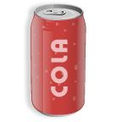
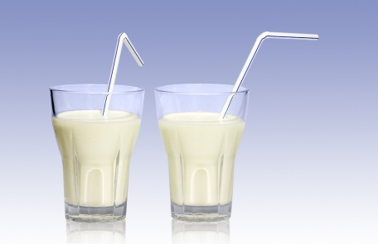

[1] [2] [3]

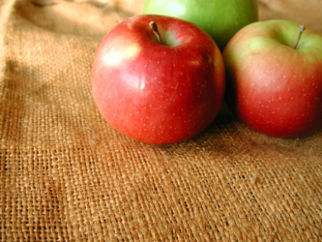
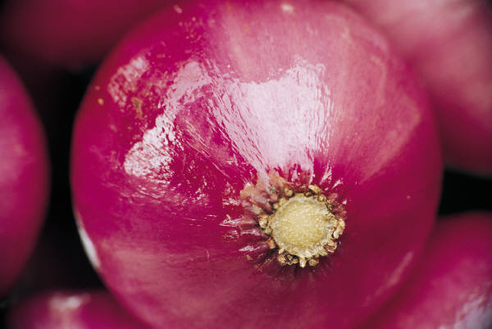
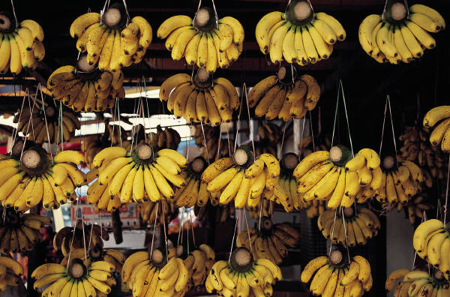

[4] [5] [6]
- Cross the odd word out.
cherries oranges raspberries pears onions
pork beef beans lamb chicken
cucumber pears cabbage potatoes lettuce
peel tray frying pan saucepan bowl

- Translate.
- Potřebujete trochu mléka, mouku a několik pomerančů.

- Máme trochu másla a krajíc chleba? Ne, nemáme žádné máslo, ale máme bochník chleba.

ANSWER KEY
Countable and Uncountable Nouns (Food and Drinks) – Revision
- There are 10 words hidden in the puzzle. Are these words countable (C) or uncountable? (U)
K | B | P | F | O | I | C | U | E | I  bacon – U  beans - C  cheese - U  coffee- U  eggs – C  milk - U  onions - C  sausages - C  soup – U  tuna - U
O | B | A | D | N | A | H | N | G | M
E | E | W | C | I | I | E | E | G | I
L | A | E | I | O | J | E | B | S | L
G | N | G | H | N | N | S | E | T | K
E | S | W | J | S | D | E | R | E | Q
E | S | A | U | S | A | G | E | S | E
T | U | N | A | H | I | C | I | J | L
Z | S | E | C | O | F | F | E | E | N
A | Y | V | U | I | X | S | O | U | P

- Complete the sentences with some or any.
- You need some potatoes.
- We haven’t got any cheese.
- Did you buy any flour?
- He bought some milk.
- Are there any carrots?

- A) Complete the sentences with how much or how many.
- Answer the questions. (Pupils’ own answers.)
- How much chocolate do you eat in a week?
I eat ... in a week.
- How much water do you drink in a day?
I drink ... in a day.
- How many slices of pizza do you usually eat?
I usually eat ... slices of pizza.
- How many packets of crisps do you buy in a month?
I usually buy ... packets of crisps in a month.

- Underline the correct answer.
- There isn’t / aren’t any sausages.
- We need some bread / breads.
- Have you got any meat / meats?
- There is / are some water on the table.
- This / these bananas is / are delicious.

- Complete the expressions with a little or a few.
- a little sugar 4 a little butter
- a little meat 5 a little salt
3 a few strawberries 6 a few tomatoes

- Complete the sentences with a/an, some or the.
You need some tomatoes and some oil. First, wash the tomatoes and slice them with a knife. Put the oil in a frying pan and put the tomatoes in the oil. Fry the tomatoes for ten minutes.

- What can you see in the picture?


[1] a cup of coffee [2] two glasses of milk [3] three tins of cola

[4] two apples [5] an onion [6] many/a lot of bananas

- Cross the odd word out.
cherries oranges raspberries pears onions
pork beef beans lamb chicken
cucumber pears cabbage potatoes lettuce
peel tray frying pan saucepan bowl

- Translate.
- Potřebujete trochu mléka, mouku a několik pomerančů.
You need a little milk, some flower and a few oranges.

- Máme trochu másla a krajíc chleba? Ne, nemáme žádné máslo, ale máme bochník chleba.
Have we got a little butter and a slice of bread? No, we haven’t got any butter but we have got a loaf of bread.
Zdroje

[1] Šálek kávy. Office.com [online]. 2013 [cit. 2013-02-02]. Dostupné z: http://office.microsoft.com/cs-cz/images/results.aspx?qu=%C5%A1%C3%A1lek&ex=1#ai:MP900423117|
[2] Sklenice mléka. Office.com [online]. 2013 [cit. 2013-02-02]. Dostupné z: http://office.microsoft.com/cs-cz/images/results.aspx?qu=sklenice%20ml%C3%A9ka&ex=2
[3] Plechovka koly. Office.com [online]. 2013 [cit. 2013-02-02]. Dostupné z: http://office.microsoft.com/cs-cz/images/results.aspx?qu=plechovka&ex=1#ai:MC900434769|
[4] Jablka. Office.com [online]. 2013 [cit. 2013-02-02]. Dostupné z: http://office.microsoft.com/cs-cz/images/results.aspx?qu=jablko&ex=1#ai:MP900448697|mt:2|
[5] Cibule. Office.com [online]. 2013 [cit. 2013-02-02]. Dostupné z: http://office.microsoft.com/cs-cz/images/results.aspx?qu=cibule&ex=1#ai:MP900289740|
[6] Banány. Office.com [online]. 2013 [cit. 2013-02-02]. Dostupné z: http://office.microsoft.com/cs-cz/images/results.aspx?qu=ban%C3%A1ny&ex=1#ai:MP900227730|mt:2|

