

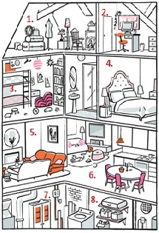
WHAT IS THE NAME OF EACH ROOM?
1 ________________ 2_________________ 3___________________ 4_____________________
5 ________________ 6_________________ 7___________________ 8_____________________
WHAT CAN YOU DO IN EACH ROOM?
I can _________________________________ in the_____________________.
I can _________________________________ in the_____________________.
I ___ _________________________________ in the ____________________.
I ___ _________________________________ in the _____________________.
I ___ _________________________________ in the _____________________.
I __ _________________________________ _in the _____________________.
I _____________________________________ in the _____________________.
I ___ __________________________________ in the _____________________.
I ___ __________________________________ in the _____________________.
I ___ __________________________________ in the _____________________.
make a bed, have a bath, dry a dishes, watch on television, repair my car, have a dinner,
iron my clothes, vaccum the carpet, clean my teeth, sweep the floor

CAN YOU FIND THESE WORDS?
PILLOW, SINK, LAMP, CHAIR, COMPUTER, MIRROR, DOUBLE BED, SOFA, COOKER,
WASHING MACHINE, WARDROBE, PICTURE, LUGGAGE, TOYS, SHOWER, CARPET, SHELF,
FIREPLACE, WINDOW, CUPBOARD,LIBRARY, BIN, DOOR, BEDSIDE TABLE, VASE

FILL IN THE MISSING VOWELS FOR EACH OF THE FOLLOWING WORDS.
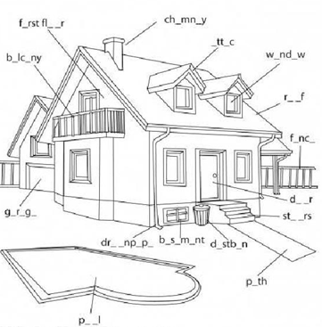

CITACE:
Parts of the house. In: Islcollective [online]. 2013 [cit. 2013-05-22]. Dostupné z: https://www.google.cz/search?q=parts+of+the+house&client=firefox-a&hs=vdb&rls=org.mozilla:en-US:official&source=lnms&tbm=isch&sa=X&ei=jyidUcT1Icz2sgaajYGYBg&ved=0CAoQ_AUoAQ&biw=1280&bih=671#client=firefox-a&hs=xdb&rls=org.mozilla:en-US%3Aofficial&tbm=isch&sa=1&q=parts+of+the+house+isl+collective&oq=parts+of+the+house+isl+collective&gs_l=img.3...35728.38812.0.38928.15.15.0.0.0.0.99.1218.15.15.0...0.0...1c.1.14.img.6Hz8xJPz9x0&bav=on.2,or.r_qf.&bvm=bv.46751780,d.Yms&fp=39c08580f929dce1&biw=1280&bi
The Nine Rooms of Happiness. In: Ninerooms [online]. 2013 [cit. 2013-05-23]. Dostupné z: https://www.google.cz/search?hl=cs&tbs=simg:CAESWxpZCxCo1NgEGgQIAwgKDAsQsIynCBowCi4IARII4wfMB9UH1wcaIOpmXZnnn2tF28yHx6N422-8w8ZwaGH81rjfgZhhIW8UDAsQjq7-CBoKCggIARIEOh7syQw&q=nine+rooms+of+happiness&tbm=isch&sa=X&ei=i-edUcmbMMK57Ab9tIHYBA&ved=0CDgQsw4&biw=1280&bih=885#imgrc=urSkCD79BU0kDM%3A%3BcgZgKItvGEmACM%3Bhttp%253A%252F%252Fwww.self.com%252Fimages%252Fhealth%252F2010%252F03%252Fnine-rooms-house-hear118.jpg%3Bhttp%253A%252F%252Fwww.self.com%252Fhealth%252F2010%252F03%252Fhow-to-plan-your-nine

