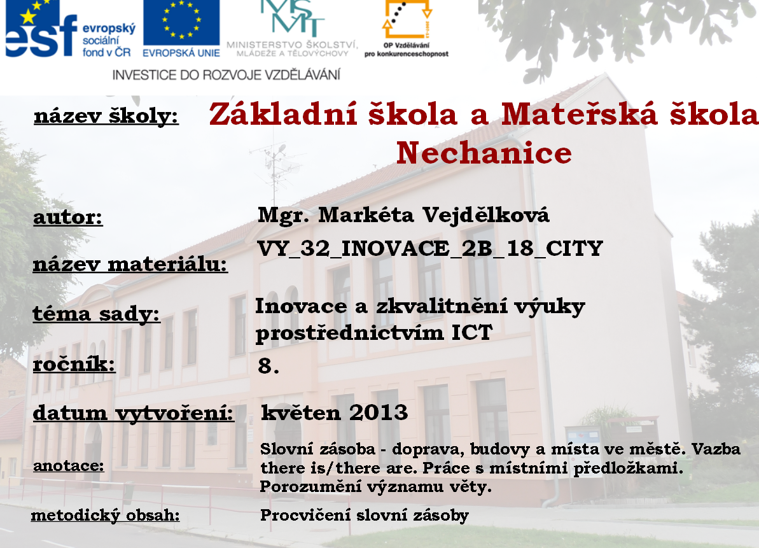

- Find the means of transport and cross it vertical and horizontal.
h | e | l | i | c | o | p | t | e | r
m | t | r | u | c | k | r | w | f | a
o | f | c | b | b | o | a | t | b | m
t | r | a | i | n | b | m | a | u | b
o | p | r | k | x | j | l | x | s | u
r | l | z | e | m | s | h | i | p | l
b | a | s | c | o | o | t | e | r | a
i | n | p | r | c | v | a | n | e | n
k | e | b | a | l | l | o | o | n | c
e | s | u | b | w | a | y | k | c | e

- With the prepositions in the box below, make sentences like the following examples:

I can see -> I can see a post office near the park.
There is / are -> There are trees by the park.
The … is /are -> The bench is inside the park.
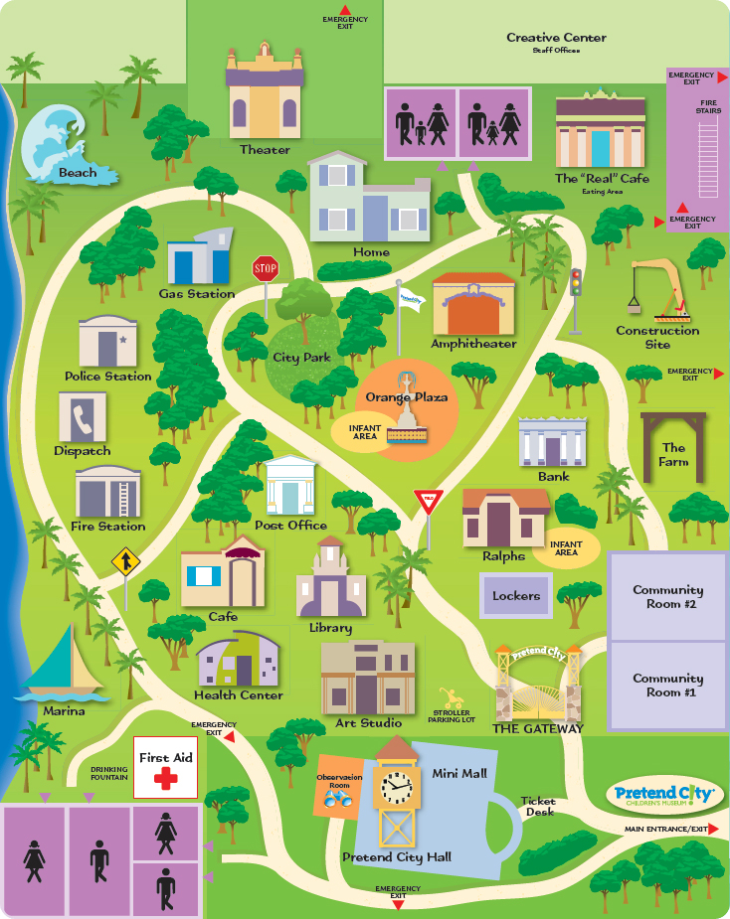
Prepositions :
in the middle of between in behind above by
near under next to oppossite on inside beside among

Write the sentences.
__________________________________________________________________________________________________________________________________________________________________________________________________________________________________________________________________________________________________________________________________________
__________________________________________________________________
__________________________________________________________________

- Complete the gaps with words below.

a building where you can put or take out money, take a loan _________________
a building where you go to see a film _________________
a place where you can park a car ___________________
a place where people go when they are very ill or when they are injured _______________
a building with many rooms for guests where you can stay over night _________________
a building or a room where you can read a book or borrow it ____________________
a building where you can post letters, parcels ___________________
the building where children and young people go in order to study __________________
a large building with many shops inside _____________________
a place where you can have a meal ____________________

restaurant cinema school car park bank post office hotel hospital shopping mall

CITACE:
Fun Activities and Attractions to Entertain Your Kids After-School. In: Urbansitter [online]. 2013 [cit. 2013-05-22]. Dostupné z: https://www.google.cz/search?q=in+the+city+map+worksheets&client=firefox-a&hs=CIn&rls=org.mozilla:en-US:official&source=lnms&tbm=isch&sa=X&ei=PP6YUYXjJYHXtQb57IGIAg&ved=0CAoQ_AUoAQ&biw=1280&bih=671#client=firefox-a&hs=FIn&rls=org.mozilla:en-US%3Aofficial&tbm=isch&sa=1&q=simple+city+map+for+kids&oq=city+map+for+kids&gs_l=img.1.1.0i19j0i5i19l3.9464.15360.0.16556.17.17.0.0.0.0.84.1229.17.17.0...0.0...1c.1.14.img.lHpTrdmVe6I&fp=1&biw=1280&bih=671&bav=on.2,or.r_qf.&cad=b&sei=BSydUe3QFMestAbUiIDgBg&im

