Číslo projektu | CZ.1.07/1.5.00/34.0479
Číslo materiálu | VY_32_INOVACE_ZDENEK_SITAR_PLANY DO BUDOUCNA_CZECH HOBBIES_09
Název školy | Střední škola služeb, obchodu a gastronomie Hradec Králové
Ročník | 2.
Vzdělávací oblast | Jazykové vzdělávání
Vzdělávací obor | Anglický jazyk
Tematický okruh | Tématické okruhy k profilové části maturitní zkoušky
Téma | Czech hobbies
Jméno autora | Mgr. Zdeněk Sítař
Vytvořeno dne | 25.1.2013
Metodický popis (anotace) | Pracovní list Word. Příprava k 3. části ústní zkoušky na téma Czech Hobbies. Materiál je podkladem pro samostatnou prezentaci k danému tématu.
Czech hobbies

A Look at these pictures. What hobbies do they show?
Obr.1 | 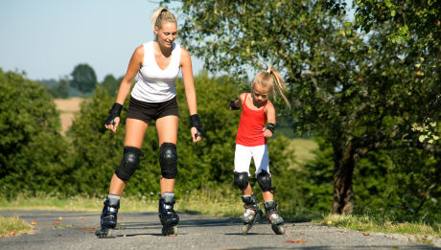 | Obr.2 | 
Obr.3 | 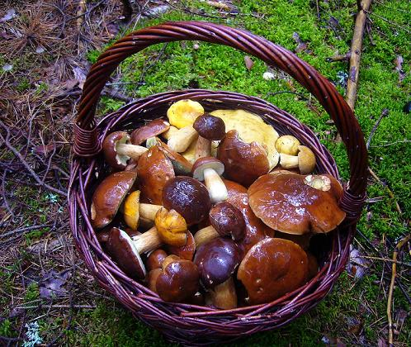 | Obr.4 | 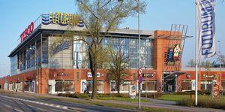

B Complete these short extracts with the words from the boxes above.
OPPORTUNITY DELICIOUS PICK MUSHROOMS SPORT

We really love_____ and the Czechs use every_____ to go to the forest and ____ them, especially in the autumn. We think they are _____ and know how to make tasty meals of them. Picking mushrooms is like a national _____, indeed.
POPULAR AVERAGE HANG AROUND PACKED MALLS

If you come to an_____ shopping centre in an average Czech town on Saturday afternoon, it will probably be ____ with shoppers. Large shopping_____, which are built on edges of towns are very _____ places with families and teenagers, who just love to ______ and do window-shopping.

TRADITION KEEN DIY ENJOY

Czechs are very_____ on doing-it-yourself. This has had a long _____ which goes back to the Communist age. We really _____ building our own appliances or working with wood. _____ stores such as BAUHAUS make a huge profit every year.
ENJOYED AGES ROUTES IN-LINE OPENED

_____ skating, a new sports activity is _____ by all kinds of people. New inline skating_____ are being _____ all over the country as more and more people of all _____ want to spend their free time skating.

TEACHER’S NOTES
KEY TO EXERCISES
A
1 in-line skating
2 shopping /doing-it-yourself
3 mushrooming/picking mushrooms
4 shopping

B
OPPORTUNITY DELICIOUS PICK MUSHROOMS SPORT

We really love MUSHROOMS and the Czechs use every OPPORTUNITY to go to the forest and PICK them, especially in the autumn. We think they are DELICIOUS and know how to make tasty meals of them. Picking mushrooms is like a national SPORT, indeed.
POPULAR AVERAGE HANG AROUND PACKED MALLS

If you come to an AVERAGE shopping centre in an average Czech town on Saturday afternoon, it will probably be PACKED with shoppers. Large shopping MALLS which are built on edges of towns are very POPULAR places with families and teenagers, who just love to HANG AROUND and do window-shopping.
TRADITION KEEN DIY ENJOY

Czechs are very KEEN on doing-it-yourself. This has had a long TRADITION which goes back to the Communist age. We really ENJOY building our own appliances or working with wood. DIY stores such as BAUHAUS make a huge profit every year.
ENJOYED AGES ROUTES IN-LINE OPENED

IN-LINE skating, a new sports activity is ENJOYED by all kinds of people. New inline skating ROUTES are being OPENED all over the country as more and more people of all AGES want to spend their free time skating.

Použité zdroje

Použité obrázky
Pokud není uvedeno jinak, použitý materiál je z vlastních zdrojů autora

Obr .1: AUTOR NEUVEDEN. www.life123.com [online]. [cit. 25.1.2013]. Dostupný na WWW: 1. http://www.life123.com/sports/inline-skateboards/inline-skates/inline-skating-how-to-ride-inline-skates.shtml
Obr.2: AUTOR NEUVEDEN, Autor Neuveden. www.svetliky-rwa.cz [online]. [cit. 25.1.2013]. Dostupný na WWW: http://www.svetliky-rwa.cz/stresni-svetliky-reference.php
Obr. 3: AUTOR NEUVEDEN. www.kempkaprik.cz [online]. [cit. 25.1.2013]. Dostupný na WWW: http://www.kempkaprik.cz/Houbareni.htm
Obr. 4: AUTOR NEUVEDEN. www.cbre.co.uk [online]. [cit. 25.1.2013]. Dostupný na WWW: http://www.cbre.co.uk/cz_en/services/pam/pam_imgs_styles/cz_cs_futurum_hradec_kralove.pdf



