VY_22_INOVACE_AJR.04

- Autor: Martina Majtánová
- Datum vytvoření: říjen 2011
- Ročník: II. stupeň (7. – 8. ročník)
- Vzdělávací oblast: Jazyk a jazyková komunikace
- Vzdělávací obor: Anglický jazyk
- Tematický okruh: Reálie
- Téma: Geografie Velké Británie


1 The United Kingdom of Great Britain and Northern Ireland
There are 4 _____________in the UK – England, Scotland, Wales and Northern Ireland.The ______________is more than 60 million people.
In Scotland, there is the highest ________________– Ben Nevis and The Loch Ness____________.
London is the ____________of the UK. It’s very large city, about 7 million ___________live here. There is the_____________ Thames.
You can travel to Europe by plane, by boat and by train or car through the Channel _______________under the sea.
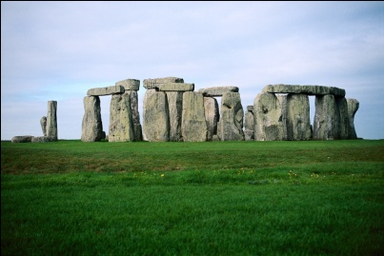

2 The United Kingdom of Great Britain and Northern Ireland
There are 4 ___________in the UK – England, Scotland, Wales and Northern Ireland.
In Scotland, there is the highest_______________- Ben Nevis.
London is the _____________of the UK. It’s very large city, about 7 million people live here. There is the____________ Thames.
You can travel to Europe by plane, by boat and by train or car.

Anotace
- Pracovní list navazuje na prezentaci DUM AJR.03
- Cíl: žák prokáže základní znalosti o geografii Velké Británie a doplní text obecnými geografickými pojmy, poté se text naučí
- PL má 2 verze, jednodušší verze 2 je určena pro žáky s poruchami učení
- Obr. [cit. 2011 -10-21]. Dostupný pod licencí Microsoft Office2010 na www.office.microsoft.com

Řešení
The United Kingdom of Great Britain and Northern Ireland
There are 4 countries in the UK – England, Scotland, Wales and Northern Ireland.The population is more than 60 million people.
In Scotland, there is the highest mountain – Ben Nevis and the Loch Ness Lake.
London is the capital of the UK. It’s very large city, about 7 million people live here. There is the river Thames.
You can travel to Europe by a plane, by a boat and by train or car through the Channel Tunnel under the sea.

